

**MANUFACTURING & MACHINING LABORATORY**

This lab allows you aimed at providing an introduction to the Know-how of common processes used in industries for manufacturing parts by removal of material in a controlled manner. Auxiliary methods for machining to desired accuracy and quality will also be covered. The emphasis throughout the laboratory course will be on understanding the basic features of the processes rather than details of I constructions of machine, or common practices in manufacturing or acquiring skill in the operation of machines. Evidently, acquaintance with the machine is desirable and the laboratory sessions will provide adequate opportunity for this the list of courses offered.

| **Sr.No.** | **Course** | **Duration/Hrs.** |
| --- | --- | --- |
| 1 | Creo for Production Engineers | 60 |
| 2 | Specialization program in PLM – Windchill | 50 |
| 3 | NC Milling Programming and Machining | 60 |

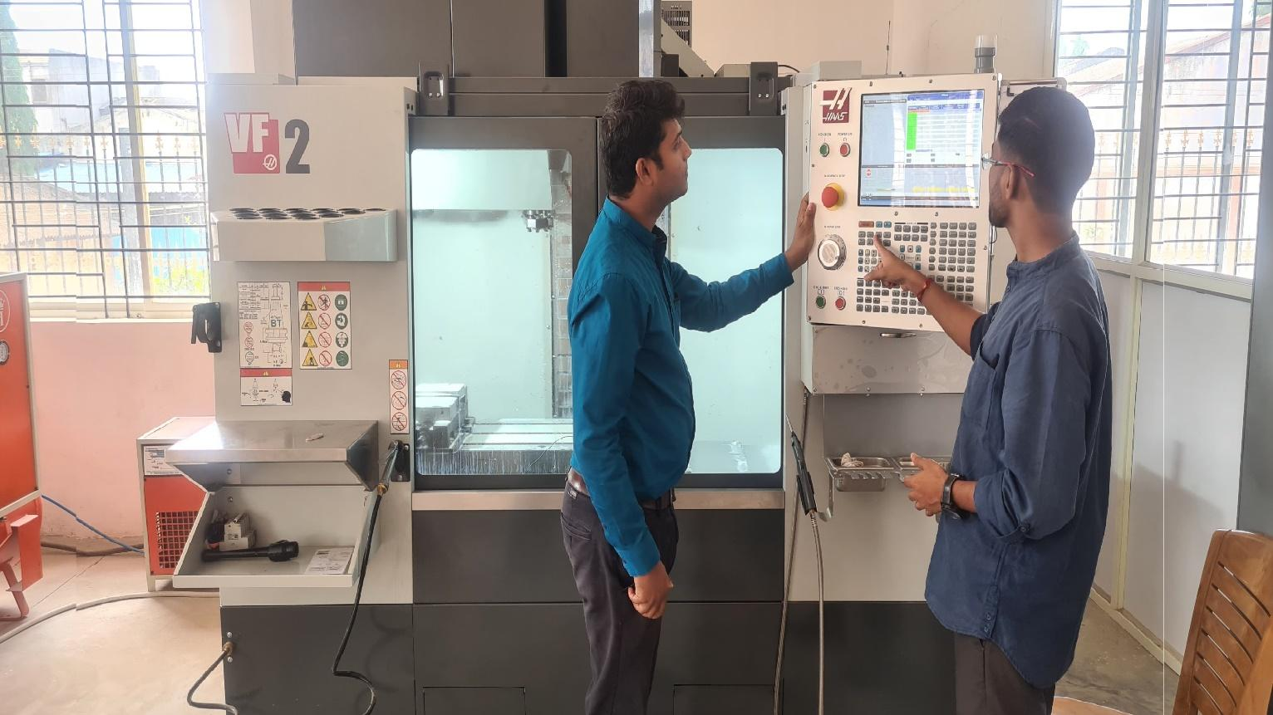

**CREO FOR PRODUCTION ENGINEERS**

| Sr.No | Domain | Course Title | Total Duration (Hrs) |
| --- | --- | --- | --- |
| 1 | CAM | Creo for Production Engineer | 60 |

**SOFTWARE PACKAGES:-**

* **PTC Creo**
* **PTC Windchill**

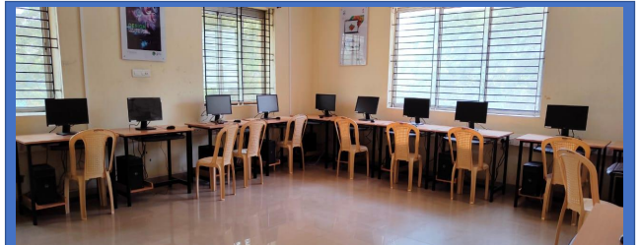

# Contents:-

1. **Introduction to the Creo Parametric Basic Mold Process** **7**
   * 1. Creo Parametric Basic Mold Process 7
     2. Exercise 1: Creo Parametric Basic Mold Process 9
2. **Design Model Preparation** 25
   * 1. Understanding Mold Theory 26
     2. Preparing Design Models for the Mold Process 27
     3. Creating Profile Rib Features 28
     4. Creating Drafts Split at Sketch 30
     5. Creating Drafts Split at Curve 31
     6. Creating Drafts Split at Surface 32
3. **Design Model Analysis 33**
   * 1. Analyzing Design Models Theory 33
     2. Performing a Draft Check 34
     3. Performing a Section Thickness Check 36
     4. Performing a Thickness Check 37
4. **Mold Models 40**
   * 1. Creating New Mold Models 40
     2. Analyzing Model Accuracy 41
     3. Locating the Reference Model 43
     4. Assembling the Reference Model 45
     5. Creating the Reference Model 48
     6. Redefining the Reference Model 47
     7. Analyzing Reference Model Orientation 48
     8. Analyzing Mold Cavity Layout 51
     9. Analyzing Variable Mold Cavity Layout 54
     10. Analyzing Variable Mold Cavity Layout Orientation 56
     11. Calculating Projected Area 59
     12. Exercise 1 : Creating the Shower Head Mold Model 60
5. **Work pieces 64**
   * 1. Creating Display Styles 64
     2. Creating a Work piece Automatically 66
     3. Creating a Custom Automatic Work piece 68
     4. Creating and Assembling a Work piece Manually 70
     5. Reclassifying and Removing Mold Model Components 72
6. **Mold Volume Creation 74**
   * 1. Surfing Terms 74
     2. Understanding Mold Volumes 76
     3. Sketching Mold Volumes 78
     4. Creating Sliders Using Boundary Quilts 80
     5. Sketching Slider Mold Volumes 83
     6. Creating Reference Part Cutout 85
     7. Sketching Lifter Mold Volumes 87
     8. Exercise 1 : Sketching Lifter Mold Volumes 88
     9. Replacing Surfaces and Trimming to Geometry 94
     10. Sketching Insert Mold Volumes 97
7. **Parting Surface Creation 99**
   * 1. Analyzing Surface Editing and Manipulation Tools 99
     2. Merging Surfaces 102
     3. Creating a Shadow Surface 104
     4. Exercise 1 : Creating Parting Surfaces using Shadow Surfaces 107
     5. Creating a Parting Surface Manually 114
     6. Creating Saddle Shutoff Surfaces 115
     7. Creating Fill Surfaces 117
     8. Extending Curves 119
     9. Filling Loops 121
     10. Creating Shut Offs 123
     11. Exercise 2 : Creating Parting Surfaces Manually 125
8. **Splitting Mold Volumes 137**
   * 1. Splitting the Workpiece 137
     2. Splitting Mold Volumes 140
     3. Splitting Volumes Using Multiple Parting Surfaces 147
     4. Blanking and Unbalnking Mold Items 149
     5. Analyzing Split Classification 151
     6. Exercise 1 : Splitting the Shower Head Mold 153
     7. Exercise 2 :Splitting the Mouse Mold 161
9. **Mold Component Extraction 167**
   * 1. Extracting Mold Components from Volumes 167
     2. Applying Start Models to Mold Components 169
     3. Exercise 1 : Extracting Shower Head Mold Components 171
     4. Exercise 2 : Extracting Mouse Mold Components 174
10. **Filling and Opening the Mold 177**
    * 1. Creating a Molding 177
      2. Opening the Mold 178
      3. Draft Checking a Mold Opening Step 180
      4. Interference Checking a Mold Opening Step 182
      5. Viewing Mold Information 183
      6. Exercise 1 : Opening Shower Head Mold Model 184
11. **Introduction to Manufacturing 197**
    * 1. Manufacturing Process overview 197
12. **Creating Manufacturing Models 199**
    * 1. Creating Manufacturing Models 199
13. **Using Work piece models 200**
    * 1. Using Work piece models 200
      2. Exercise 1:Creating a work piece with inherited feature 201
14. **Creating and Using NC Model Assemblies 205**
    * 1. Creating and Using NC Model Assemblies 205
15. **Using Manufacturing Parameters 207**
    * 1. Understanding Manufacturing Parameter Concepts 207
      2. Configuring Parameter Values 208
      3. Using Site Parameter Files 209
16. **Creating Face Milling Sequences 211**
    * 1. Basic Face Milling 211
      2. Lateral Control Face Milling Parameters 212
      3. Depth Control Face Milling Parameters 214
      4. Entry and Exit Face Milling Parameters 214
      5. Exercise 1 : Creating Face Milling Sequences 215
17. **Creating Volume Milling Sequences 221**
    * 1. Basic Volume Milling 221
      2. Exercise 1 : Creating Volume Milling Sequences : Extrude and Trimming 222
      3. Volume Milling With Mill Windows 225
      4. Exercise 2 : Creating Volume Milling Sequences with Mill Windows 226
      5. Scanning Volume Milling Parameters 228
      6. Depth and Lateral Control Volume Milling Parameters 230
      7. Stock Allowance Volume Milling Parameters 231
      8. Gathering Mill Volumes 231
      9. Modifying Volume Milling Toolpaths 233
      10. Exercise 3 : Creating Cut Notions Using Volume Milling Cut 234
18. **Creating** **and Post-Processing CL Data Files 238**
    * 1. Creating and Post-Processing CL Data Files 238
19. **Introduction to the Creo Parametric**

**Basic Mold Process**

#### Module Overview:

In this module, you learn about the basic mold process that is typically used to take a part from its design stage to the creation of its mold. This simplified process is used at most companies; however, your specific company process may differ. The process is explained in further detail throughout the course modules.

#### Objectives:

After completing this module, you will be able to:

* Run a draft check on a design model.
* Create a new mold model and assemble the reference model and workpiece.
* Create a slider mold volume for undercut geometry.
* Create the mold parting surface using a skirt surface.
* Create the mold components by splitting the mold volumes and generating the cavity components.
* Create mold features by creating a runner in the mold model.
* Fill and open the mold by creating a molding and performing a mold opening analysis.

1. **Creo Parametric Basic Mold Process**

### Preparing and Analyzing Design Models

When you create a mold for a design model, you should first inspect the model and analyze it to verify that it is indeed ready to be molded. Typically, the reference model geometry that you use for a mold model is derived from the design model. You can analyze the design model and reference model for adequate draft features and consistent thickness, adding draft features if necessary. It is critical that the final reference model has sufficient draft so that it can be cleanly ejected from the mold.

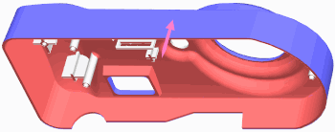

Figure 1 – Analyzing a Design Model

### Creating the Mold Model

Start the mold design by creating a mold manufacturing model. Creo Parametric automatically creates the mold assembly when you create the mold manufacturing model. The mold manufacturing model is also referred to as the *Mold Model*. Next, you assemble the reference model, which can be either the design model that is to be molded or a new model derived from the design model. You can account for the contraction of the molding part during cooling in the molding process by applying a shrinkage factor to the reference model. You also create or assemble the workpiece that represents the full volume of all the mold components that are needed to complete the mold model.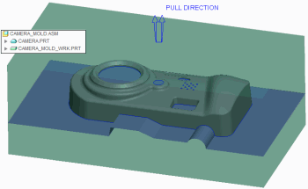

Figure 2 – Creating the Mold Model and Parting Surface

### Creating Mold Volumes

You can create mold volumes manually using sketch-based features. A mold volume is a three-dimensional, enclosed surface quilt with no mass in the workpiece of a mold model. You can also manually create a special type of mold volume called a *slider*. Creo Parametric can also create one automatically by calculating undercut areas in the mold model.

### Creating Parting Surfaces

You can create parting surfaces for the mold model using the skirt surface technique. The skirt surface technique requires parting lines that you create by using silhouette curves. You can use the parting surfaces to split the workpiece into separate mold volumes later in the mold design process. You can also create parting surfaces manually.

### Creating Mold Components

You can split the workpiece volume into one or more mold volumes based on the parting surfaces. The main mold volumes are classified into *core* and *cavity*. Once the desired mold volumes are created and split, you can create the mold components, including sliders, from the mold volumes. The mold components are fully functional parts that you can open and modify in the Part mode of Creo Parametric. You can also machine the components using Creo NC.

### Creating Mold Features

You can create regular and user-defined assembly features to facilitate the molding process. Regular features include mold-specific features such as waterlines, runners, and ejector-pin clearance holes. You can also create user- defined features from regular cuts and slots that are placed on mold models to create sprues.

### Filling and Opening the Mold

You can create the molding component that represents the filled mold cavity. Creo Parametric creates the molding component automatically by determining the volume remaining in the workpiece after extracting the mold components.

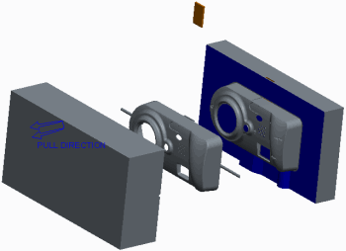

Figure 3 – Filling and Opening the Mold

You can then define the steps for the mold-opening process for every component in the mold model except the reference model and workpiece. During the mold opening analysis, you can determine whether there is interference with any static components for each of the steps that you define.

# Excercise1: Creo Parametric Basic Mold Process



#### Objectives

* Prepare and analyze a design model for manufacturing.
* Create a mold model.
* Create mold volumes.
* Create a parting surface.
* Create mold components.
* Create mold features.
* Fill and open the resulting mold.

You are a design engineer in a camera company. You have been provided with the front housing of a new camera design and are tasked with creating the manufacturing mold for

it. You know from previously received models that you must first prepare and analyze the design model to verify that it can be manufactured.

Once you have verified that the design model can be manufactured using a mold, you can create the mold model and mold volumes. You can then create the mold-parting surface and mold components. Finally, you can fill and open the resulting mold.

#### 1. Step 1. Prepare and analyze a design model for manufacturing.

1. Enable only the following Datum Display types: .
2. In the ribbon, select the **Applications** tab.
3. Click **Mold/Cast** from the Engineering group to toggle from the standard application to the Mold application.Mold/Cast 

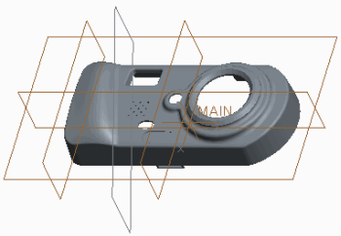

Figure 1

1. Click **Draft Draft ** from the Analysis group.
2. To perform a draft check, do the following:

* In the model tree, select CAMERA.PRT.
* In the Draft Analysis dialog box, clear the **Use the pull direction** check box.
* Click in the Direction collector and select datum plane TOP.
* Type **0.5** as the value for the Draft angle and press ENTER.

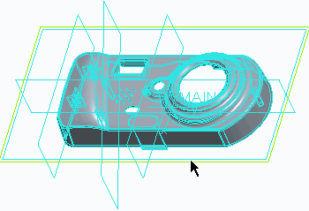

Figure 2

1. In the Color Scale dialog box, click **Expand Expand **.
2. Edit the number of colors to **3**.

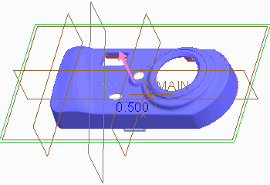 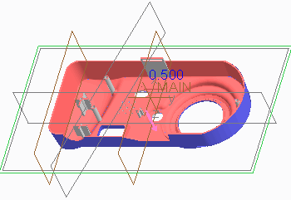

Figure 3 Figure 4



* + *The positive draft areas appear in blue and the negative draft areas in red. The vertical walls appear in gray. This demonstrates that the part is fully drafted and is ready to be*

*used in creating a mold model.*

1. Click **OK** from the Draft Analysis dialog box.Close 
2. Click **Close** from the Quick Access toolbar.

#### 2. Step 2. Create the camera mold model.

1. Click **New New ** from the Quick Access toolbar.
2. In the New dialog box, do the following:

* Select **Manufacturing** as the Type.
* Select **Mold cavity** as the Sub-type.
* Type **camera_mold** as the Name.
* Clear the **Use default template** check box and click **OK**.
* Select the **mmns_mfg_mold** template.
* Click **OK**.

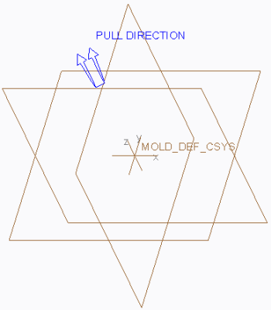

Figure 5

1. Click **File > Options** and select the **Configuration Editor** category.

* Click **Add**.
* Type **enable_absolute_accuracy** in the Option name field.
* Select **yes** as the Option value and click **OK > OK > No**.

1. Select **Locate Reference Model** from the Reference Model types drop-down menu in the Reference Model & Workpiece group to assemble the reference model.Locate Reference Model 
2. In the Open dialog box, select CAMERA.PRT and click **Open**.
3. In the Create Reference Model dialog box, select **Same model** as the Reference model type and click **OK**.
4. Specify the mold cavity layout by doing the following:

* Click **Reference Model Origin Reference Model Origin ** from the Layout dialog box and select the MAIN coordinate system in the CAMERA.PRT sub-window.
* Click **Preview** and notice how the reference model is assembled and oriented.

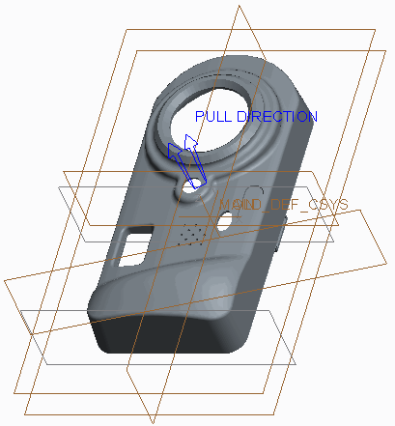

Figure 6

1. In the Layout dialog box, select **Rectangular** as the Layout.

* Select **X-Symmetric** as the Orientation.
* Type **120** as the X Increment value and **150** as the Y Increment value.
* Click **Preview**.
* Notice that a pattern of reference models, symmetric about the X-axis, are assembled to create a multi-cavity mold.

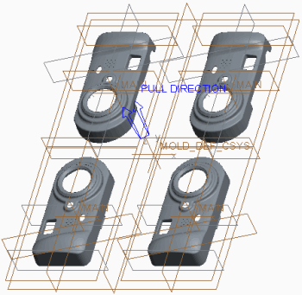

Figure 7

1. In the Layout dialog box, select **Y-Symmetric** as the Orientation and click **Preview**.
2. Notice that a pattern of reference models, symmetric about the Y-axis, are assembled to create a multi-cavity mold.
3. Select **Single** as the Layout to create a single-cavity mold and click **OK**.
4. In the Warning message window, click **OK** to accept the change in the absolute accuracy value.

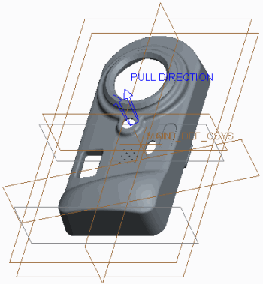

Figure 8

1. Apply shrinkage to the reference model by doing the following:

* Select **Shrink by scale Shrink by scale ** from the Shrinkage types drop-down menu in the Modifiers group.
* In the model tree, click the node for CAMERA.PRT to expand it and select the PRT_CSYS_DEF coordinate system.
* Type **0.005** as the Shrink Ratio in the Shrinkage By Scale dialog box and press ENTER.
* Click **Apply Changes** .Apply Changes 

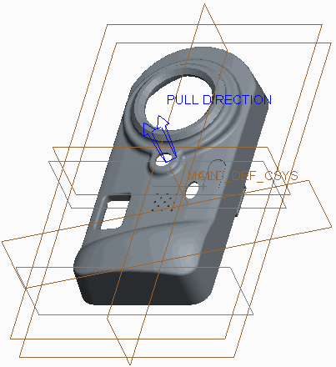

Figure 9

1. Select **Automatic Workpiece Automatic Workpiece ** from the Workpiece types drop-down menu in the Reference Model & Workpiece group to create an automatic workpiece.
2. In the Automatic Workpiece dialog box, do the following:

* Select the MOLD_DEF_CSYS coordinate system from the graphics window as the Mold Origin.
* Type **20** for the negative, and type **20** for the positive X direction values.
* Type **30** for the negative, and type **30** for the positive Y direction values.
* Type **20** for the negative, and type **20** for the positive Z direction values.
* Click **OK**.

1. Disable **Plane Display** and **Csys Display** .Plane Display  Csys Display 

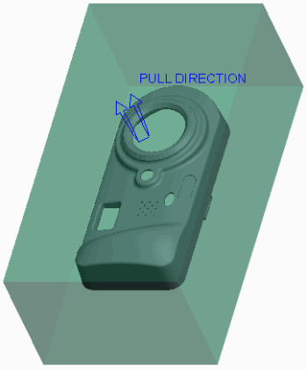

Figure 10

1. Select CAMERA_MOLD_WRK.PRT.
2. In the ribbon, select the **View** tab.
3. Click the Model Display group drop-down menu and select **Component Display Style > Wireframe**.
4. Select the **Mold** tab.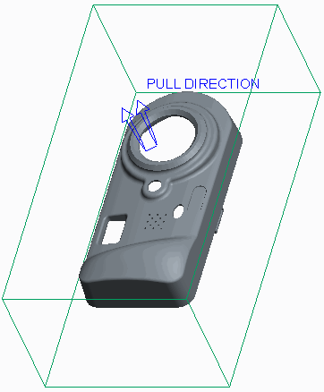

Figure 11

#### 3. Step 3. Create slider mold volumes.

1. Select **Mold Volume Mold Volume ** from the Mold Volume types drop-down menu in the Parting Surface & Mold Volume group to create the slider volume.
2. To rename the mold volume feature, do the following:

* Click **Properties Properties ** from the Controls group.
* Type **Slider** as the Name of the mold volume in the Properties dialog box and press ENTER.

1. Click **Slider Slider ** from the Volume Tools group.
2. In the Slider Volume dialog box, do the following:

* Click **Calculate Undercut Boundaries Calculate Undercut Boundaries ** .
* Press CTRL and select **Quilt 1** and **Quilt 2** from the Exclude column.
* Click **Include Boundary Surfaces** to add the selected quilts to the Include column for slider calculation.Include Boundary Surfaces 
* Click **Select Projection Plane Select Projection Plane ** and select the right surface of the workpiece.

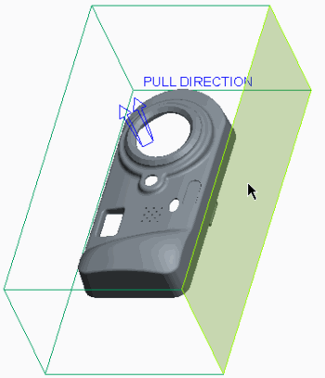

Figure 12

1. Click **Apply Changes** from the Slider Volume dialog box.Apply Changes 
2. Click **OK** from the Controls group.OK 

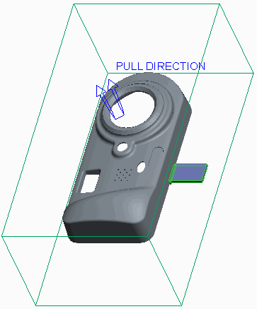

Figure 13

#### 4. Step 4. Create a parting surface.

1. Click **Silhouette Curve** from the Design Features group to automatically create parting line curves.Silhouette Curve 
2. In the Silhouette Curve dialog box, click **Preview** to observe the silhouette curves automatically created at all edges of the mold model.

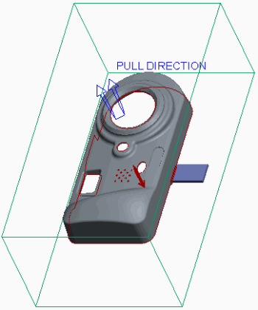

Figure 14

1. Notice that some adjustments need to be made to the automatic parting line curves.
2. In the Silhouette Curve dialog box, double-click **Slides**.

* Select the slider volume from the graphics window.
* Click **Done/Return** from the menu manager.

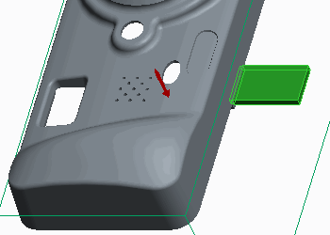

Figure 15

1. In the Silhouette Curve dialog box, double-click **Loop Selection**.

* Select the **Chains** tab.
* Select chain **4–1** and click **Lower** to move the curve from the upper edge to the lower edge of the hole.
* Click **OK** from the Loop Selection dialog box.

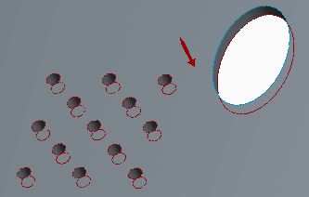

Figure 16

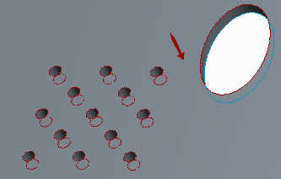

Figure 17

1. Click **OK** from the Silhouette Curve dialog box to complete the parting line.

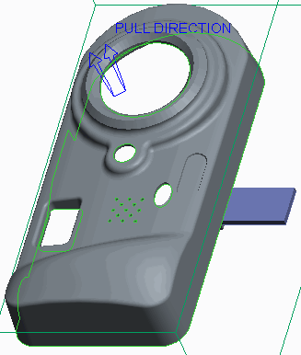

Figure 18

1. Click **Parting Surface Parting Surface ** from the Parting Surface & Mold Volume group.Skirt Surface 
2. Click **Skirt Surface** from the Surfacing group to create an automatic parting surface.
3. Select the work piece.
4. Select the silhouette curve.

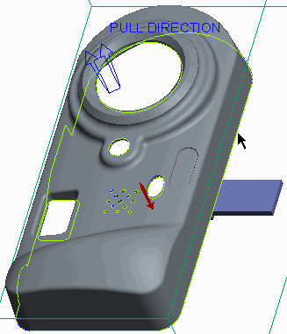

Figure 19

1. Click **Done** from the menu manager.
2. In the Skirt Surface dialog box, double-click **Extension**.
3. In the Extension Control dialog box, select the **Extension Directions** tab.

* Click **Add**.
* Press CTRL and select the two vertices.

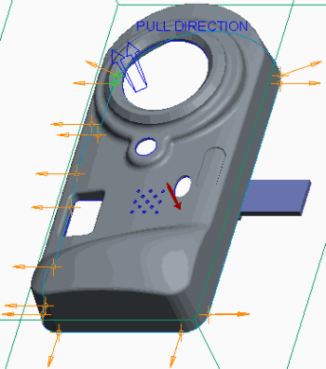

Figure 20

1. Click **OK** from the Select dialog box.
2. Click **Done** from the menu manager.
3. Query-select the left surface of the work piece as the normal plane.
4. Click **Okay** from the menu manager.
5. Click **OK** to close the Extension Control dialog box.
6. Click **OK** from the Skirt Surface dialog box.
7. Click **OK** from the Controls group to complete the parting surface.OK 

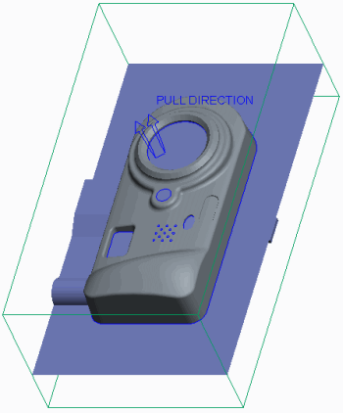

Figure 21

#### 5. Step 5. Create the mold components. Volume Split

1. Select **Volume Split** from the Mold Volume types drop-down menu in the Parting Surface & Mold Volume group to split the work piece into mold volumes.
2. Click **Two Volumes > All Wrkpcs > Done** from the menu manager.
3. Select the slider and click **OK** from the Select dialog box.

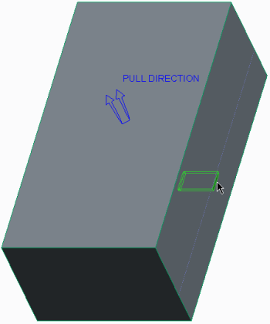

Figure 22

1. Click **OK** from the Split dialog box.
2. In the Properties dialog box, type **main_vol** as the Name of the first volume and press ENTER.
3. In the Properties dialog box, type **slider_vol** as the Name of the second volume and press ENTER.

Volume Split 

1. Click **Volume Split** to split the main volume into core and cavity inserts.

##### Click Two Volumes > Mold Volume > Done .

1. In the Search Tool dialog box, do the following:

* Select **Quilt: F11(MAIN_VOL)** from the list of items found.
* Click **Add Item** to add the selected quilt to the list of items selected.Add Item 
* Click **Close**.

1. Select the parting surface (you may have to use query select) and click **OK** from the Select dialog box.

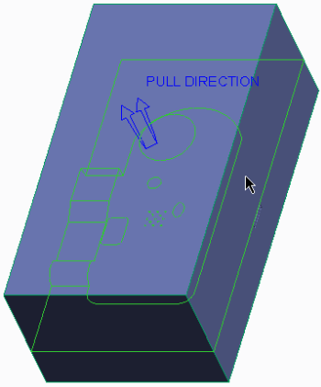

Figure 23

1. Click **OK** from the Split dialog box.
2. In the Properties dialog box, type **core** as the Name of the first volume (the lower half) and press ENTER.
3. In the Properties dialog box, type **cavity** as the Name of the second volume (the upper half) and press ENTER.
4. Select **Cavity insert Cavity insert ** from the Mold Component types drop-down menu in the Components group.
5. In the Create Mold Component dialog box, press CTRL and select CAVITY, CORE, and SLIDER.

* Click **OK**.

1. Notice that the mold components appear as individual solid parts in the model tree.

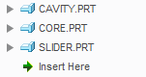

Figure 24

1. In the model tree, right-click CORE.PRT and select **Open** .Open 

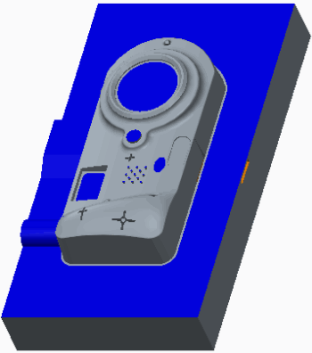

Figure 25

1. Click **Close** .Close 
2. In the ribbon, select the **View** tab.
3. Click **Mold Display Mold Display ** from the Visibility group.
4. Select the **Mold** tab.
5. In the Blank and Unblank dialog box, press CTRL and select CAMERA, CAMERA_MOLD_WRK, and CORE from the Visible Components list and click **Blank**.

* Click **Parting surface Parting surface ** as the Filter.
* Select PART_SURF_1 and click **Blank**.
* Click **Volume Volume ** as the Filter.
* Select SLIDER_VOL and click **Blank**.
* Click **OK**.

1. In the model tree, right-click SILH_CURVE_1 and select **Hide Hide **.

#### 6. Step 6. Create a runner mold feature. Runner

1. Click **Runner** from the Production Features group.
2. Click **Half Round** from the menu manager.
3. Type **3** as the runner diameter and press ENTER.
4. Query-select the bottom surface as the Sketching Plane and click **Okay > Default** from the menu manager.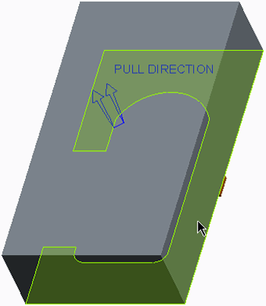

Figure 26

1. Click **Sketch View Sketch View ** from the In Graphics toolbar.
2. Select datum plane MOLD_RIGHT and the top and bottom edges as references, and click **Close** from the References dialog box.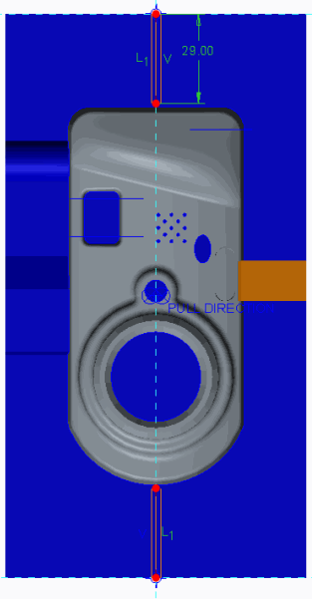
3. Click **Line Chain** and sketch two lines of equal length.Line Chain 
4. Click **One-by-One One-by-One ** and edit the length to **29**.

Figure 27

1. Click **OK** .OK 
2. Press CTRL+D and select CAVITY.PRT as the intersected component.
3. Click **OK** from the Intersected Components dialog box.
4. Click **OK** from the Runner dialog box.

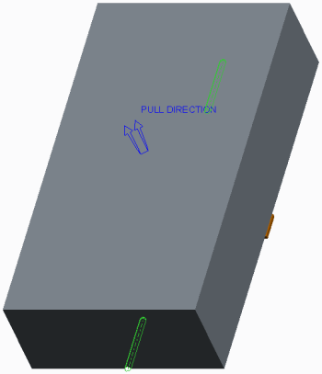

Figure 28

1. In the model tree, right-click CORE.PRT and select **Unblank**.

#### 7. Step 7. Fill and open the mold.

1. Click **Create Molding Create Molding ** from the Components group to create the molding.
2. Type **camera_molding** as the Part name and press ENTER.
3. Press ENTER to accept the default Mold Part Common Name.

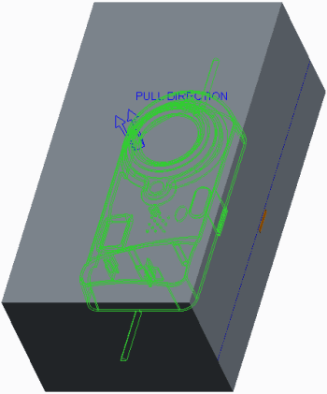

Figure 29

1. Click **Mold Opening Mold Opening ** from the Analysis group to perform a mold-opening analysis.
2. Click **Define Step > Define Move** from the menu manager.
3. Select SLIDER.PRT.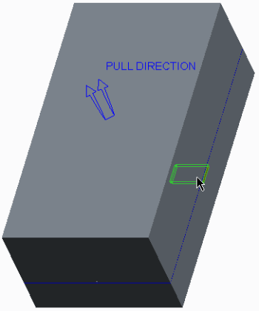

Figure 30

1. Click **OK** in the Select dialog box.
2. Select the edge to define the direction of the move.

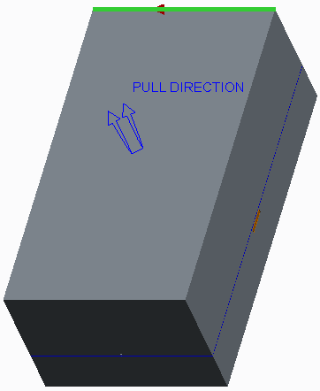

Figure 31

1. Type **-100** as the translation value and press ENTER.
2. Click **Done** from the menu manager.
3. Click **Define Step > Define Move** from the menu manager.
4. Select CAVITY.PRT.

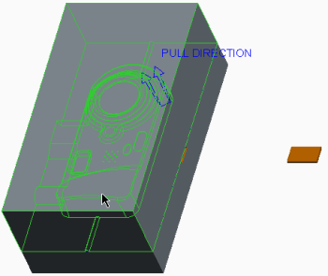

Figure 32

1. Click **OK** in the Select dialog box.
2. Select the edge to define the direction of the move.

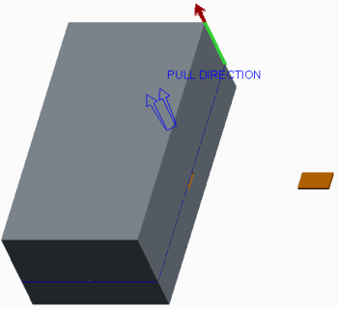

Figure 33

1. Type **100** as the translation value and press ENTER.
2. Click **Done** from the menu manager.
3. Click **Define Step > Define Move** from the menu manager.
4. Select CORE.PRT.

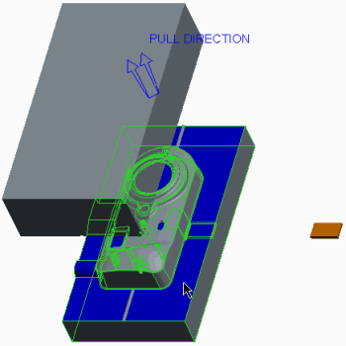

1. Click **OK** in the Select dialog box.
2. Select the edge to define the direction of the move. Figure 34

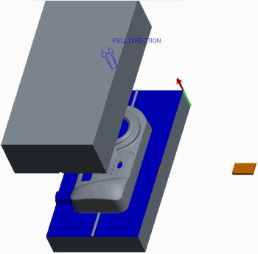

Figure 35

1. Type **-100** as the translation value and press ENTER.
2. Click **Done** from the menu manager.

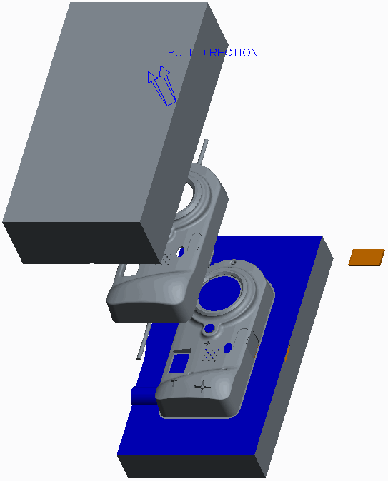

1. Click **Done/Return** from the menu manager.
2. Click in the background to de-select all items.
3. Click **Regenerate Regenerate ** from the Quick Access toolbar. Figure 36
4. Click **Save Save ** from the Quick Access toolbar and click **OK** to save the model.
5. Click **File > Manage Session > Erase Current**, then click **Select All Select All ** , and click **OK** to erase the model from memory.

# Design Model Preparation

#### Module Overview:

It is not uncommon for designers to hand off design models without drafts or ribs because they do not know enough about mold design in order to make decisions about parting surfaces and pull direction, and they may not be comfortable with specifying draft angles or creating ribs. The reference model geometry for a mold model is derived from the corresponding design model geometry. Consequently, the mold designer may have to prepare the design model so that a mold can be created from it.

In this module, you learn the basics of mold design and how to prepare a design model for the mold process.

#### Objectives:

After completing this module, you will be able to:

* Define the main components of a mold.
* Specify the names of the various paths used to flow material into the mold.
* Recall the items typically required of a design model to create a robust mold and part.
* Create a robust mold model by creating profile rib features.
* Apply your knowledge of what makes a robust mold by defining draft and splitting it using various techniques.

1. **Understanding Mold Theory**

### Understanding Manufacturing Mold Theory

From a manufacturing point of view, in its simplest form, a mold consists of a *core* and *cavity* which are split at a *parting line*. The core is the convex feature side of the mold that enters an opposing cavity when the mold is closed. The cavity is the concave feature side of the mold into which an opposing core enters when the mold is closed. An example of a mold core and cavity is

shown in Figure 2. 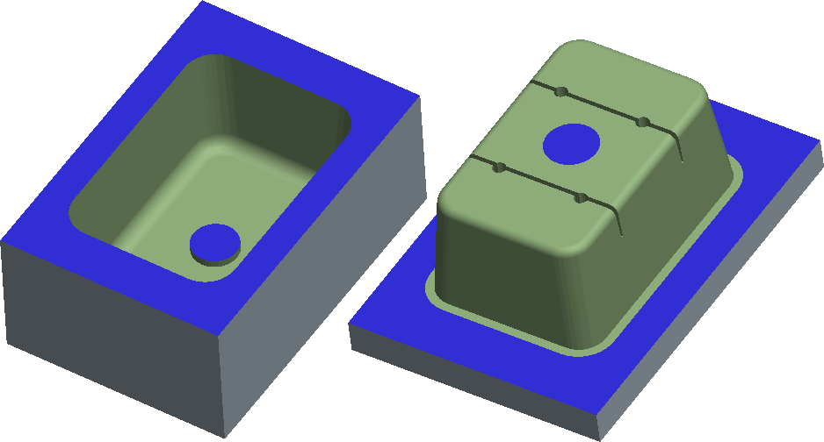

Figure 2 – Mold Core and Cavity

The void between the closed core and cavity is filled with a material such as plastic. This material-filled void becomes the resulting part when it solidifies.

For the material to find its way into the void, there must be various chambers and paths created in the mold. These chambers are defined as follows:

* Sprues – The route the plastic material takes from the point where it enters the mold until it reaches the runners. When solidified, it remains attached to the part via one or more runners and is typically removed in finishing.
* Runners and gates – Channels machined into the mold that direct the plastic material from the sprue into the mold cavity.

In Figure 3, you can see the sprue, runners, and gates attached to the four molded pucks.

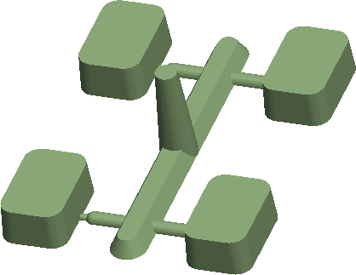

Figure 3 – Sprue and Runner Design

Once the material solidifies, the part can be removed from the mold. To aid in ejecting the part, mold components called *ejector pins* are often designed into the mold. The sizes and arrangement of the pins are selected to minimize the impact on the part design.

### Understanding CAD Mold Theory

From a CAD point of view, a designer typically hands off a completed or nearly completed Creo Parametric design model to a mold designer. The mold designer then takes the design model and uses it to create a *Reference model* within Creo Para metric’s Mold mode. The mold designer uses the Reference model to create the resulting mold core and cavity components which create the void of the Reference model. The mold core and cavity components split at a location called the *parting surface*, which the mold designer must determine.

Once the mold designer creates the mold components in Creo Para metric’s Mold mode, he or she can use the Expert Mold Base Extension to create the entire mold base layout.

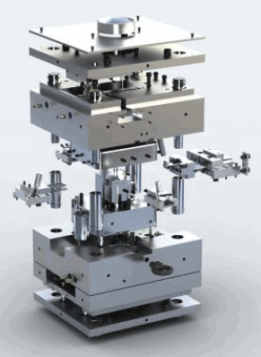

Figure 1 – Mold baseg Layout Created in EMX

The Expert Moldbase Extension, or EMX, uses a 2-D process-driven GUI to guide the mold designer toward the optimal design. It uses a catalog of standard components (DME, HASCO, FUTABA, PROGRESSIVE, STARK, and so on), or customized components. Figure 1 shows a completed moldbase that was developed with the Expert Moldbase Extension.

Mold Design using Creo Parametric focuses only on the creation of the mold

## Preparing Design Models for the Mold Process

Even though the design model you receive may be a valid design model, you may not be able to use the model to create a robust mold. The following items are typically required of the design model to create a robust mold and part:

* Draft — Facilitates the removal of the part from the mold.
* Uniform thickness — Areas of a part that are thicker than others can result in sink zones or warping when cooling occurs.
* Ribs — Add strength and rigidity to the molded part.
* Ejector pin “pads” — Sufficient material is needed for the full diameter of an ejector pin at the location where it pushes against the resulting part to eject it from the mold.

These items may not be present in the design model when you receive it because the design engineer does not know where the parting surface or ejector pins will be located in the mold.

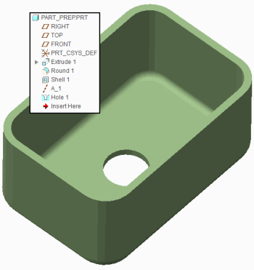

Figure 1 – Original Design Model

Therefore, you must prepare the design model for the mold process by adding the necessary features needed to make a mold from the model.

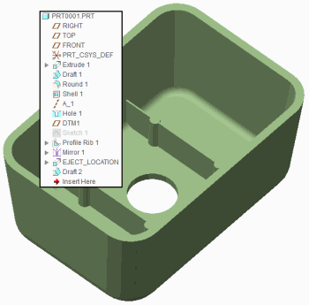

Figure 2 – Design Model Prepared for Molding

### Guidelines for Proper Design Model Preparation

The following guidelines indicate how to properly prepare a design model for molding.

* Try to create models that are of uniform thickness to prevent sink zones or warping in the resulting molded part.
* Create ribs that are approximately half the model's wall thickness to prevent sink. Apply draft to the rib walls if they are “vertical” faces. Vertical faces are those that are vertical with respect to how the mold opens. In Figure 2, two ribs have been created and draft has been applied.
* Be aware of the need to accommodate ejector pins in your design model for proper ejection from the mold. Create ejector pin “pads” at these locations in the model where the ejector pins push against the model to eject it. In Figure 2, four ejector pin pads have been created.
* Apply draft in the proper direction at least 0.5 degrees on all “vertical” faces. Draft has been applied to all faces that are vertical with respect to how the mold opens.
* When creating Draft features in Creo Parametric, either reorder them to be created before any related rounds or insert them before the rounds. This practice results in a more robust Creo Parametric model. In Figure 2, the draft has been inserted before the adjacent rounds.

components and does not cover the Expert Moldbase Extension.

## Creating Profile Rib Features

Ribs are typically used to strengthen parts. A profile rib feature is similar to an extruded protrusion, except that it requires an open section sketch.

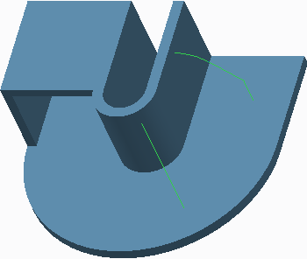

Figure 1 – Viewing Open Sketches

The rib also conforms to existing planar or cylindrical geometry when it is extruded. After you select an open section sketch and set a thickness, Creo Parametric automatically creates the profile rib feature by merging it with your model. The system can add material above or below the sketch, and the thickness can be applied on either side, or be symmetric about the sketch.

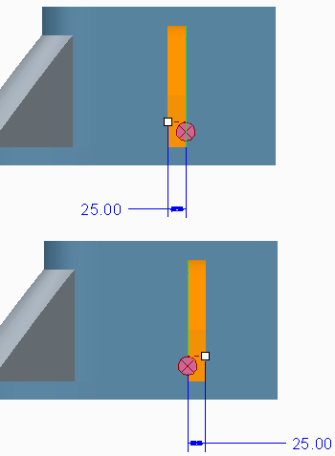

Figure 2 – Editing the Side that Thickens

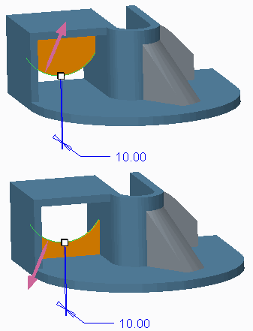

Figure 3 – Flipping Which Side the Rib is Created

The **Profile Rib Profile Rib ** enables you to create rib features in less time than it would take for you to create and sketch a protrusion.

1. **Creating Drafts Split at Sketch**

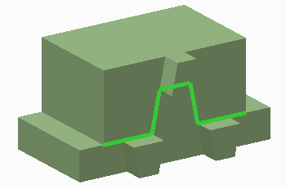

Figure 1 – Viewing Sketch

You can specify a sketch to be used as the split object. This enables you to create custom split lines. When you select an existing sketch as the split object, it becomes linked. However, you can unlink the sketch if desired. You can also define a new sketch. If the sketch does not lie on the draft surface, Creo Parametric projects it onto the draft surface in the direction normal to the sketching plane. The sketch in Figure 1 was used as the Split object for the draft in Figure 2.

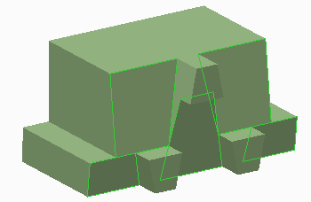

Figure 2 – Draft Split at Sketch

## PROCEDURE - Creating Drafts Split at Sketch

##### Close Window Erase Not Displayed

 Draft\Split-Sketch  DRAFT_SPLIT-SKETCH.PRT

**Task 1:** Create a draft split at a sketch.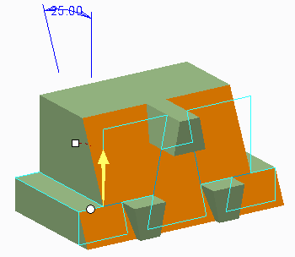

| 1. Disable all Datum display types. 2. Select **Draft**  from the Draft types drop-down menu.    * Select the large, front surface containing the sketch. 3. Right-click and select **Draft Hinges**.    * Select the top surface of the left rectangular “step.” 4. Drag the angle so the upper draft portion goes into the model. |
| --- |
| 1. In the dashboard, select the **Split** tab.    * Select **Split by split object** as the Split option.    * Select sketch SPLIT_SKETCH.    * Select **Draft second side only** as the Side option. 2. Drag the angle so the draft goes into the model. 3. Click **Preview Feature** . |
| 1. Click **Resume Feature**  . 2. In the dashboard, select the **Split** tab.    * Select **Draft first side only** as the Side option. 3. Click **Preview Feature** . |
| 1. Click **Resume Feature**  . 2. In the dashboard, select the **Split** tab.    * Select **Draft sides independently** as the Side option.    * Edit both draft angles to **7** so the draft goes into the model. 3. Click **Complete Feature** . |

This completes the procedure.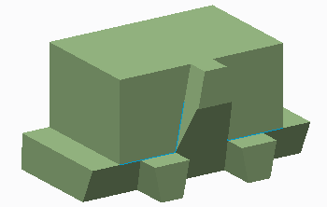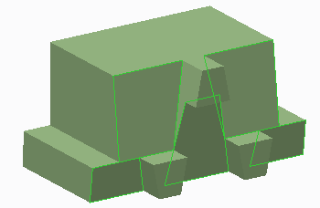

## Creating Drafts Split at Curve

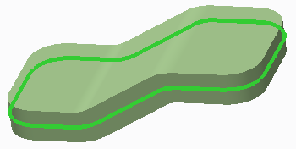

Figure 1 – The Datum Curve

You can create a draft that splits at a “waistline” curve. This causes the material at the curve to remain constant. The curve shown in Figure 1 was used as the draft hinge. The draft was then split at this draft hinge to create the resulting geometry in Figure 2.

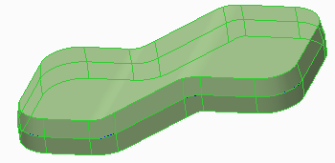

Figure 2 – Draft Split at Datum Curve

If you specify a curve as the draft hinge, you must also specify a separate pull direction reference.

1. **Creating Drafts Split at Surface**

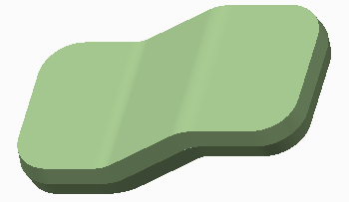

Figure 1 – Draft Split at Surface

You can create a draft that splits at a “waistline” surface, causing material at the surface to be added, as shown in Figure 1. This type of draft enables you to select additional draft hinges. To select a second hinge, you must first split the draft surfaces. The model remains the same size at both draft hinge locations. In Figure 2, the selected surface is used as the split object. Once this split object was defined, a second draft hinge was able to be added, as shown in Figure 3.

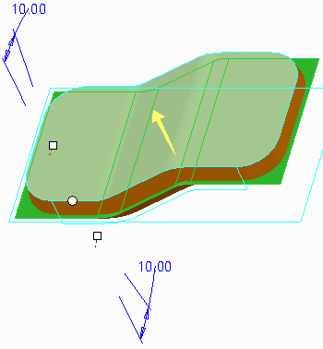

Figure 2 – Splitting the Draft at Surface

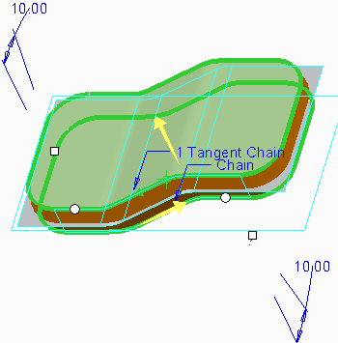

Figure 3 – Selecting Multiple Draft Hinges

# Design Model Analysis

#### Module Overview:

Creo Parametric enables you to analyze the design model for key elements such as proper draft and thickness before creating the mold model. These tools help you ensure that the design model is acceptable to begin mold creation.

In this module, you perform draft and thickness checks on design models.

#### Objectives:

After completing this module, you will be able to:

* Understand the different types of analyses you can perform on a design model.
* Perform a draft check on a design model.
* Perform a section thickness check on a design model.
* Perform a thickness check on a design model.

# Analyzing Design Models Theory

You can perform analyses on design models before creating the mold model. Analysis tools enable you to ensure that the design model is acceptable for mold creation. You can perform the following types of analyses on design models:

* Draft check

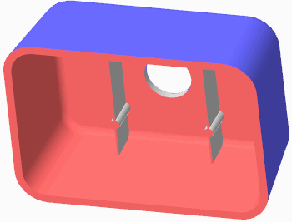

Figure 1 – Draft Check

* Thickness check
* Section Thickness check

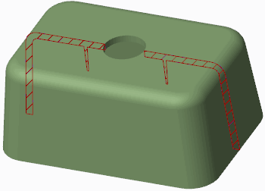

Figure 2 – Section Thickness Check

You usually use these analysis tools before the mold is created, but you can also use them at almost any point during the mold process, including:

* Parting line creation – If the parting line location is modified slightly you can perform a draft check to verify that the model is still properly drafted.
* Parting surface creation – Again, if the parting surface is modified you can perform a draft check to verify that the model is still properly drafted.
* Mold component creation – You can perform a thickness check on components other than the design model. You can perform a thickness check on the core or cavity component to verify that it has sufficient thickness to handle the stress during the molding part creation.

# Performing a Draft Check

You can use draft checking to determine whether the design model has the correct surfaces drafted and suitable draft angles to facilitate the mold-opening process as well as the removal of the molding component. To perform the draft check,

click **Draft Draft ** from the Analysis group if in Mold mode, or click **Draft Draft ** from the

Inspect Geometry group in the Analysis tab if in Part mode.

You must specify the following references to perform a draft check:

* Surface – Specifies the surfaces for which the draft analysis is to be run. You can select surfaces or quilts individually, or select the part node in the model tree to select all solid geometry.
* Direction – Specifies the direction to be used for the draft analysis. Usually, the pull direction is the direction in which the mold opens. If in a mold model, the system automatically uses the pull direction by default, but you can also specify your own direction reference.

You must also specify the following options:

* Draft angle – Enables you to specify the desired draft angle to check for.
* Sample – Enables you to specify how the plot resolution is calculated. Options include Quality, Number, and Step.
* Quality – Adjusts the quality of the plot.

When you perform a Draft analysis, the system produces a color plot of the draft angles. Based on the coloring, you can identify areas that do not have sufficient draft angles, or incorrect direction draft angles.

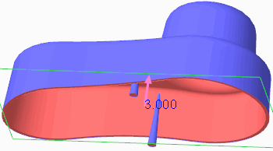

Figure 1 – Incorrectly Drafted Pegs

There are two different types of color plots you can display:

* **3-Color Plot 3-Color Plot ** – Displays a three color plot in the graphics window. Sufficient positive draft angles appear in blue, sufficient negative draft angles appear in red, and insufficient angles appear in white.

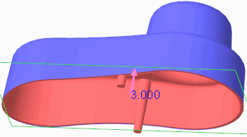

Figure 2 – Peg Geometry Updated for Correct Draft

* **Rainbow Plot Rainbow Plot ** – Displays the color scale as a rainbow plot.

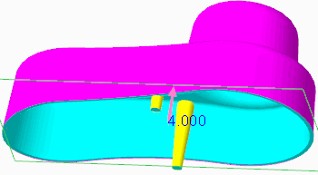

Figure 3 – Rainbow Plot

You can specify the number of colors to display, and whether the color scale is shown as continuous

or non-continuous

# Performing a Section Thickness Check

### Performing a Section Thickness Check on a Model

You can perform a thickness check on a model by selecting the Analysis tab in the ribbon, and then clicking **Section Thickness Section Thickness ** from the Model Report group. You can measure thickness using either of the following methods:

* Select one or more planes through which the thickness is measured. You can press CTRL to select multiple planar references.

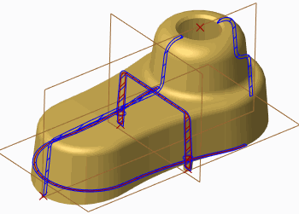

Figure 1 – Displaying Section Thickness Cross-Sections Through Selected Planes

* Select references to create incremental cross-section slices through which thickness is measured.

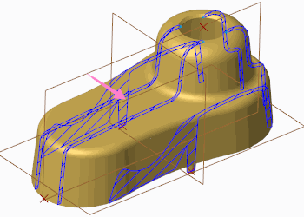

Figure 2 – Displaying Section Thickness Cross-Sections Through Slices

To create these incremental slices, you must specify the following references:

* From slices – This specifies the start point of slicing. You can select either vertices or datum points for this reference.
* To slices – This specifies the end point of slicing. Again, you can select either vertices or datum points for this reference.
* Direction – This specifies the direction of slicing. If necessary, you can click the direction arrow in the graphics window to flip the direction of slicing to point between the From Slices and To Slices references.

Once you have specified the correct slicing references, you can specify the following options:

* Use number of slices – This specifies the number of slices to be created between the selected references.
* Offset – The incremental offset value that separates each cross-sectional slice.

The Slices reference collectors become grayed out if you select a Plane reference to perform the thickness check.

You can configure the system to perform the following two thickness checks at each specified reference:

* Maximum – Checks for maximum thickness. The system performs a maximum thickness check based on the value you have specified.
* Minimum – Checks for minimum thickness. The system performs a minimum thickness check based on the value you have specified.

The Thickness dialog box displays the results for each thickness cross-section location. When you select a result in the dialog box, the thickness cross-section displays in the graphics window. The Thickness dialog box also indicates whether the thickness at each cross-section surpassed the minimum or maximum thicknesses specified.

### Performing a Section Thickness Check in a Manufacturing Model

You can also perform a section thickness check in the mold model by clicking **Section**

Section Thickness 

**Thickness** from the Analysis group in the Mold tab. Because the section thickness check occurs within the context of an assembly, you must specify the part that the thickness check is to be performed on.

Once the part is specified, the thickness check is similar to that of the model analysis thickness check, although the interface is slightly different. You can either select one or more planes through which to measure the thickness, or you can have the system create slices based on selected references. The system can check for both maximum and minimum thickness based on the specified thickness value you provide, and the results appear in the Model Analysis dialog box similar to those of the Thickness dialog box.

# Performing a Thickness Check

You can perform a 3-D thickness check on a part model to check for maximum or minimum thickness violations. The thickness check reduces the time to analyze wall thickness of complicated parts.

The **Thickness Thickness ** option is available in multiple places in the Creo Parametric user interface:

* In Part mode:
* In the Analysis tab, within the Model Report group.
* In Mold mode:
* In the Mold tab, within the Analysis group.
* In the Analysis tab, within the Model Report group.
* In the Analysis tab, within the Mold Analysis group.

In the Measure dialog box, you can measure thickness within all solid geometry or individually selected surfaces. You can specify the following:

* Minimum thickness value – Checks for minimum thickness. The system performs a minimum thickness check based on the value you have specified. Areas that violate the minimum thickness specified (areas where the thickness is less than the specified value) highlight in the model in purple.

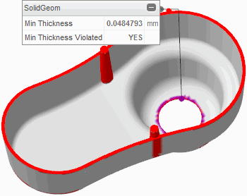

Figure 1 – Viewing Min and Max Thickness Violations

* Maximum thickness value – Checks for maximum thickness. The system performs a maximum thickness check based on the value you have specified. Areas that violate the maximum thickness specified (areas where the thickness is more than the specified value) highlight in the model in red.
* Minimum thickness color – Specify a different minimum thickness color than the default purple.
* Neutral color – Specify a different neutral color than the default gray.
* Maximum thickness color – Specify a different maximum thickness color than the default red.
* Tolerance – Specify the allowable error for the calculation.
* Use post-processing – Selecting this check box causes the system to post process the results to improve quality and accuracy.

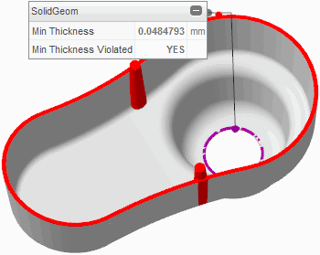

Figure 2 – Viewing Post Processed Min and Max Thickness Violations

Minimum thickness results display in the graphics window within an on-screen panel. You can drag this panel as well as collapse it. You can restore it by clicking its on-screen icon.

You can also view minimum thickness results by expanding the Results area of the Measure dialog box. You can copy and paste the contents of this Results table to other programs such as spreadsheet applications.

You can save the measurement by clicking **Save Analysis Save Analysis ** from the Measure dialog box. Save the measurement as either of the following types:

* Feature – Enables you to save the measurement as a feature in the model tree.
* Analysis – Enables you to save the measurement for future use. You can specify a unique name for the measurement analysis so you can easily identify it at a later time.

You can retrieve the saved analysis by clicking **Saved Analysis Saved Analysis ** from the Manage group in the Analysis tab.

### Measurement Options

Within the Measure dialog box, you can edit various options by clicking **Measure Options Measure Options **. The following options are available:

* Units by Model – Units are the same as those of the model.
* Length Units – Specify the desired length units from a drop-down list.
* Decimal Places – Specify the number of decimal places displayed for measurements.
* Show Feature Tab – Displays the Feature tab in the Measure dialog box, enabling you to specify regeneration order as well as create parameters for a given measurement.
* Use automatic compute – Automatically computes the new measurement if different references are selected for measuring.
* Panel display – You can toggle panels to either hide or display them in the graphics window. You can also toggle panels by collapsing them or expanding them.

# 4. Mold MODELS

1. **Creating New Mold Models**

A mold model is the model you work on while in Mold Cavity Design mode, or Mold mode. The mold model, which has a file extension of .asm, contains the following:

* A reference model.
* One or more workpieces that represent the overall size of cavity inserts.
* Several mold components that represent cavity inserts.
* One molding component that represents the product of the molding process.

*The remainder of this course focuses on the creation of these items.*

You can create new mold models within Creo Parametric either by using File > New, or by clicking **New New ** . You can type the name of the mold and decide whether to use a default template or a template at all. Unless you select the Empty template, the new mold displays in the graphics window with some default datum features.

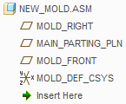

Figure 1 – New Mold Model Tree

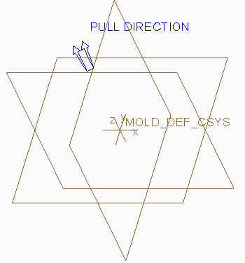

Figure 2 – New Mold Model

### Using Templates

You should create new mold models using a template. Mold templates are similar to part and assembly templates in that they enable you to create a new mold with predefined general information. Your company has probably created customized templates, as they contain your company's standards. Using a template to create a new mold is beneficial because it means that regardless of who created it, the mold contains the same consistent set of information, including:

* Datums – Most templates contain a set of default datum planes and a default coordinate system, all named appropriately.
* Default Pull Direction – The direction in which the mold opens.
* Layers – When every mold, part, and assembly contains the same layers, it is easier to manage both the layers and items on the layer.
* Units – Most companies have a company standard for units in their molds. Creating every mold with the same set of units ensures that mistakes are not made.
* Parameters – Every mold can have the same standard metadata information.
* View Orientations – Having every mold contain the same standard view orientations aids the molding process.

### Modifying the Default Pull Direction

The default pull direction is visible on the model as a double set of arrows, as shown in Figure 2. It is used as a default direction for all mold-specific features and analysis depending on the pull direction. You can toggle the pull direction display on and off by

clicking **Pull Direction Display Pull Direction Display ** from the In Graphics toolbar. You can also change

the direction of the default pull direction by clicking **Pull Direction Pull Direction ** from the Design Features group in the ribbon. The reference you select causes the pull direction to become perpendicular to that reference. Keep in mind that if you modify the default pull direction within a mold model created using a template, you should rename the datum planes appropriately.

The pull direction value is not parametric. This means that features built before resetting the default pull direction use the earlier direction value. They are not updated when you reset the default pull direction. Therefore, it is recommended that you do not modify the pull direction after a certain point in the mold process.

1. **Analyzing Model Accuracy**

* One of the most important factors affecting the mold design process is model accuracy. Creo Parametric provides the following types of accuracy settings:
* Relative – This type of accuracy is specified as a fraction of the longest diagonal of the bounding box of a model. The default relative accuracy is 0.0012.
* Absolute – This type of accuracy improves the matching of models of different sizes or different accuracies (for example, imported models created on another system). To avoid potential problems when adding new features to a model, it is recommended that you set the reference model to absolute accuracy before adding additional parts to the model. Absolute accuracy is useful when you are doing the following:
* Copying geometry from one mold to another during core operations.
* Designing models for manufacturing and mold design.
* Matching accuracy of imported geometry to its destination model.

You can match the accuracies of a set of models in one of the two following ways:

* Give them all the same absolute accuracies.
* Designate the smallest model as the base model, and assign its accuracy to the other models.

### Automatically Controlling Accuracy

You can perform the following steps to automatically set the correct accuracy when creating mold models:

* Set the configuration file option enable_absolute_accuracy to yes.
* Create a new mold model. It receives a default (absolute) accuracy value.
* Add the first reference model. If a discrepancy exists between the assembly model accuracy and reference model accuracy, the system issues a warning and prompts you to confirm changing the assembly model accuracy, as shown in Figure 1.

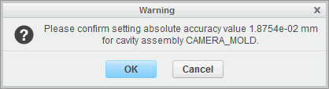

Figure 1 – Confirmation for Automatically Changing Accuracy

If you accept, then Creo Parametric switches the assembly model accuracy from relative to absolute, and sets it to the value corresponding to the accuracy of the reference model. If you do not accept, the system warns you that there is an accuracy conflict, and generates a text file with a *.acc file extension in the working directory.

* Create the mold workpiece using the automatic workpiece creation functionality. The accuracy of the workpiece is automatically set to be the same as the accuracy of the assembly model.

### Implications and Guidelines of Changing Accuracy

When you change the accuracy of a model you are changing the computational accuracy of geometry calculations. The accuracy of a mold model is relative to the size of the resultant molding component. The valid range for accuracy is 0.01 to 0.0001, and the default value is 0.0012. However, the configuration file option, accuracy_lower_bound, can override the lower boundary of this range. The specified values for the lower boundary must be between 0.000001 and 0.0001. If you increase the accuracy, the regeneration time also increases. Use the default accuracy unless you need to increase it. In general, you should set the accuracy to a value less than half the ratio of the length of the smallest edge on the model to the length of the largest diagonal of a box that would contain the model. Use the default accuracy until you have a reason not to do so.

### Situations for Changing Accuracy

The following are situations that may cause you to have to change accuracy:

* Placing a small feature on a model.
* Intersecting two models of very different size. For the two models to be compatible, they must have the same absolute accuracy. To achieve this, estimate each model size, and multiply each by its respective current accuracy. If the results differ, enter a value for the accuracy of the models that yields the same results for each. You might need to increase the mold accuracy of the larger model by entering a smaller decimal number. For example, if the size of the smaller model is 100 and the accuracy is .01, the product of these numbers is 1. If the size of the larger model is 1000 and the accuracy is .01, the product of these numbers is 10. Change the accuracy of the larger model to .001 to yield the same product.

When an accuracy conflict exists, the system warns you in the Message Log and generate a *.acc file that is saved in the working directory. You can view this text file to determine where the conflict exists and modify the accuracies accordingly. The contents of an accuracy file are shown in Figure 2.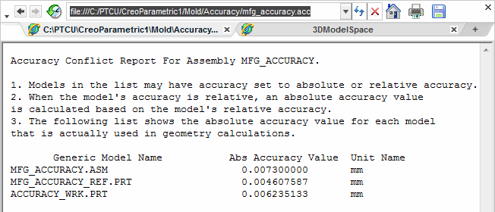

Enlarge Image

Figure 2 – Viewing an Accuracy Conflict

1. **Locating the Reference Model**

### Reference Model Background

The first component you typically assemble in the mold model is the reference model. The reference model usually represents the part that is to be molded.

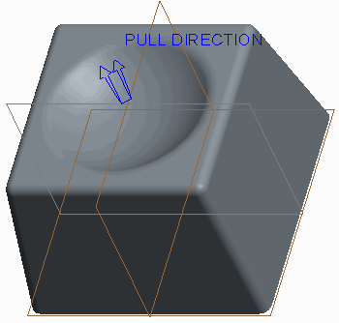

Figure 1 – Reference Model Located into Mold Model

The reference model is needed to imprint corresponding geometry on mold components. The geometry imprinted into the mold components becomes the *mold cavity*.

The reference model geometry for a mold model is derived from the corresponding design model geometry. The design model may not always contain all necessary design elements such as drafts, fillets, and shrinkage that are required for the mold design process. Sometimes the design model contains design elements that require post- molding machining. These elements should be changed on the reference model to suit the mold design process.

### Locating the Reference Model

Locating the reference model is one of three methods available for inserting the reference model into the mold model, and is the most versatile of the three. The reference model icon that displays in the model tree is different than that of a conventional part model, regardless of the method used to insert it.

You can use **Locate Reference Model Locate Reference Model ** to assemble a pre-existing model as the reference model into the mold model. This option enables you to further select a pre- defined Layout and Orientation for the reference model.

When locating the reference model, you can specify the Reference model type:

* Merge by reference – Creo Parametric copies design model geometry into the reference model using an External Merge feature. Only the geometry, datum planes, and layers are copied from the design model. If a layer with one or more datum planes associated with it exists in a design model, the layer, its name, display status, and the datum planes are copied from the design model to the reference model. Any changes made to the reference model do NOT affect the original design model. The default name for the new reference model created with this method is <MOLD_MODEL_NAME>_REF.PRT. For example, if the mold model is CAMERA_MOLD.PRT, the new reference model is CAMERA_MOLD_REF.PRT. Any changes made to the original design model automatically propagate to the reference model.
* Same model – Creo Parametric uses the design model as the reference model. The reference model is the design model. Therefore, any changes made to this reference model do affect the design model, as you are actually modifying the original design model. As a result, you cannot rename this reference model when it is the same model as the original design model.
* Inherited – The reference model inherits all geometry and feature information from the design model using an External Inheritance feature. You can specify the geometry and the feature data that you want to modify on the inherited reference model without changing the original design model. Inheritance provides greater freedom to modify the reference model without changing the design model. Any changes made to the reference model do not affect the design model. Similar to the Merge by Reference method, the default name for the new reference model created with this method is <MOLD_MODEL_NAME>_REF.PRT. Again, any changes made to the original design model automatically propagate to the reference model.

Figure 2 – Model Trees for Merge by Reference, Same Model, and Inherited Reference Model Types

If you have absolute accuracy enabled, the system prompts you to confirm the accuracy change that needs to occur to properly match the mold model accuracy to the reference model accuracy.

When the reference model is located into the mold model, the resulting geometry in the graphics window looks the same, regardless of the method used to create the reference model. You must expand the model tree to determine the method used.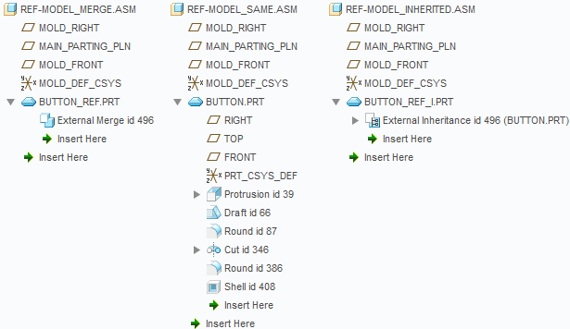

**iv. Assembling the Reference Model**

### Reference Model Background

The first component you typically assemble in the mold model is the reference model.

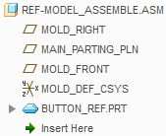

Figure 1 – Viewing the Reference Model in the Model Tree

The reference model usually represents the part that is to be molded. The reference model is needed to imprint corresponding geometry on mold components. The geometry imprinted into the mold components becomes the *mold cavity*.

The reference model geometry for a mold model is derived from the corresponding design model geometry. The design model may not always contain all necessary design elements such as drafts, fillets, and shrinkage that are required for the mold design process. Sometimes the design model contains design elements that require post- molding machining. These elements should be changed on the reference model to suit the mold design process.

### Assembling the Reference Model

Assembling the reference model is one of three methods available for inserting the reference model into the mold model. The reference model icon that displays in the model tree is different than that of a conventional part model, regardless of the method used to insert it.

You can use **Assemble Reference Model Assemble Reference Model ** to assemble a pre-existing model as the reference model into the mold model. This option enables you to use conventional Assembly mode placement constraints to assemble the reference model.

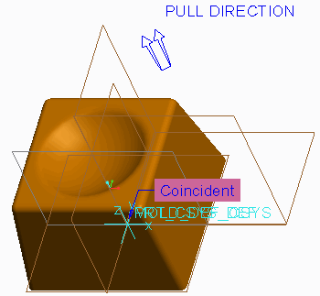

Figure 2 – Assembling the Reference Model using Constraints

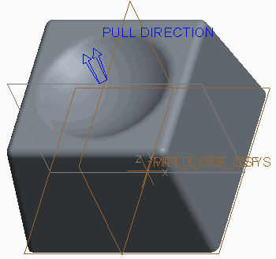

Figure 3 – Viewing the Assembled Reference Model

Unlike the Locate Reference Model option, you cannot further specify a Layout and Orientation.

*You can redefine the reference model, however, to specify a Layout and Orientation.*

Similar to the Locate Reference Model option, you can specify the Reference model type:

* Merge by reference – Creo Parametric copies design model geometry into the reference model using an External Merge feature. Only the geometry, datum planes, and layers are copied from the design model. If a layer with one or more datum planes associated with it exists in a design model, the layer, its name, display status, and the datum planes are copied from the design model to the reference model. Any changes made to the reference model do NOT affect the original design model. The default name for the new reference model created with this method is <MOLD_MODEL_NAME>_REF.PRT. For example, if the mold model is CAMERA_MOLD.PRT, the new reference model is CAMERA_MOLD_REF.PRT. Any changes made to the original design model automatically propagate to the reference model.
* Same model – Creo Parametric uses the design model as the reference model. The reference model is the design model. Therefore, any changes made to this reference model do affect the design model, as you are actually modifying the original design model. As a result, you cannot rename this reference model when it is the same model as the original design model.
* Inherited – The reference model inherits all geometry and feature information from the design model using an External Inheritance feature. You can specify the geometry and the feature data that you want to modify on the inherited reference model without changing the original design model. Inheritance provides greater freedom to modify the reference model without changing the design model. Any changes made to the reference model do not affect the design model. Similar to the Merge by Reference method, the default name for the new reference model created with this method is

<MOLD_MODEL_NAME>_REF.PRT. Again, any changes made to the original design model automatically propagate to the reference model.

If you have absolute accuracy enabled, the system prompts you to confirm the accuracy change that needs to occur to properly match the mold model accuracy to the reference model accuracy.

When the reference model is assembled into the mold model, the resulting geometry in the graphics window looks the same, regardless of the method used to create the reference model. You must expand the model tree to determine the method used.

**V. Creating the Reference Model**

### Reference Model Background

The first component you typically assemble in the mold model is the reference model.

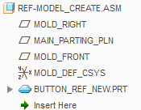

Figure 1 – Viewing the Reference Model in the Model Tree

The reference model usually represents the part that is to be molded. The reference model is needed to imprint corresponding geometry on mold components. The geometry imprinted into the mold components becomes the *mold cavity*.

The reference model geometry for a mold model is derived from the corresponding design model geometry. The design model may not always contain all necessary design elements such as drafts, fillets, and shrinkage that are required for the mold design process. Sometimes the design model contains design elements that require post- molding machining. These elements should be changed on the reference model to suit the mold design process.

### Creating the Reference Model

Creating the reference model is one of three methods available for inserting the reference model into the mold model and offers the least flexibility. The reference model icon that displays in the model tree is different than that of a conventional part model, regardless of the method used to insert it.

Create Reference Model 

You can use **Create Reference Model** to create a new model on-the-fly and assemble it as the reference model into the mold model using conventional Assembly mode placement constraints.

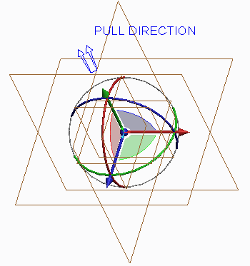

Figure 2 – Assembling the Reference Model using Constraints

This option is similar to creating a new component in Assembly mode. In fact, the same creation options are available:

* Copy from existing – Creates a copy of an existing model. This could be an existing design model or an empty template of your company standards.

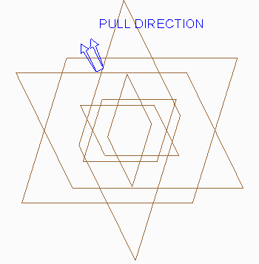

Figure 3 – Reference Model Created from Empty Template

* Locate default datums – Creates the model and enables you to locate the default datums in the assembly.
* Empty – Creates the model without geometry or datum features.
* Create features – Creates the model using existing assembly references.

With this method you cannot specify the Reference model type. There are also no pre- defined options available for Layout or Orientation, and there are no further locating options or accuracy matching.

**Vi. Redefining the Reference Model**

You can redefine the reference model by selecting **Locate Reference Model Locate Reference Model ** from the Reference Model types drop-down menu in the Reference Model & Workpiece group and then clicking Redefine from the menu manager. You can redefine the following items related to the reference model:

* Reference model orientation – You can adjust the reference model origin and orientation within the mold model. You can do this by either adjusting the reference model coordinate system or the mold model's coordinate system.
* Mold cavity layout – You can adjust the quantity and layout of the mold cavities created within the mold model.
* Mold cavity layout orientation – You can adjust the orientation of the mold cavities created within the mold model.

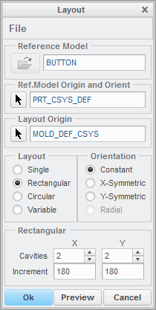

Figure 1 – Layout Dialog Box when Redefining Reference Model

*You cannot change the current reference model to a different reference model.*

*You can perform these functions on reference models that were located or assembled, but not reference models that were directly created in the mold model.*

### Switching Reference Model Methods

If you have located or assembled the reference model using the Same Model method, you cannot redefine the method to switch it to Merge by reference or Inherited. Conversely, if you located or assembled the reference model using either Merge by reference or Inherited, you cannot redefine the method to Same Model. In either of these cases you must delete the reference model from the mold model and recreate it.

You can switch the reference model creation method back and forth between Merge by reference and Inheritance, however. You can do this by editing the definition of the External Merge or External Inheritance feature within the reference model, depending on the type of creation method used. You can then toggle the inheritance on or off in the dashboard. Keep in mind that in switching back and forth you will lose any geometry that was varied in the inheritance feature, and the resulting geometry may change, potentially causing other geometry to fail.

## Vii. Analyzing Reference Model Orientation

You can modify the orientation of the reference model in the mold model. When you select the reference model to be added to the mold model, the system selects a coordinate system from the reference model and assembles it to a coordinate system from the mold model.

### Modifying the Reference Model Orientation

You can modify the reference model orientation within the mold model either by specifying a different mold layout coordinate system or by specifying a different reference model coordinate system.

There are two different methods that you can use to specify a different coordinate system in the reference model:

* Standard – Enables you to select a different, existing, coordinate system in the reference model. A separate window opens that contains the reference model, enabling you to select the coordinate system, as shown in Figure 1.

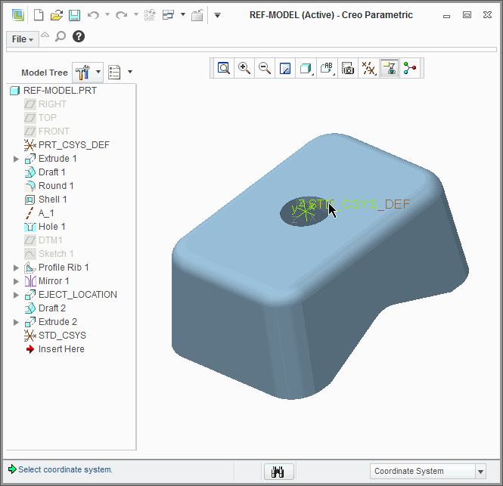

Figure 1 – Using Standard Orientation

* Dynamic – A separate window opens that contains the reference model. However, a new coordinate system called REF_ORIGIN is created in the reference model, and you can dynamically reorient this coordinate system so that it will line up properly with the mold layout coordinate system. In the separate window that contains the reference model, the X, Y, and Z-directions of the REF_ORIGIN coordinate system are displayed, and the positive Z-direction is the same as the PULL DIRECTION in the mold model. Also, the Parting Plane displays to show you a surface perpendicular to the pull direction. Figure 2 shows the REF_ORIGIN coordinate system orientation and Parting Plane and the resulting orientation in the mold model.

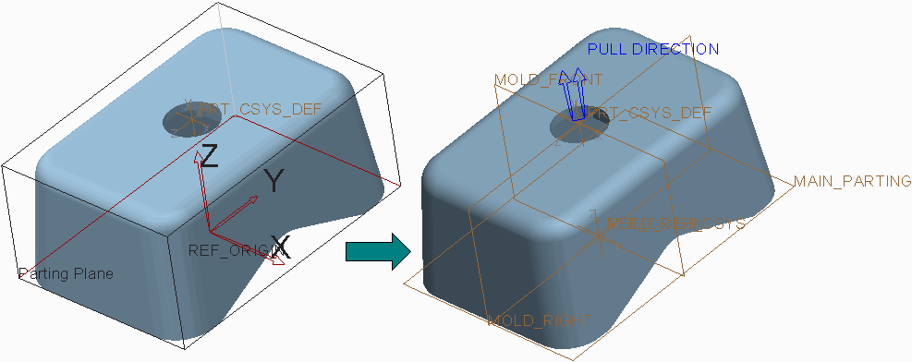

Figure 2 – Using Dynamic Orientation

You can dynamically adjust the coordinate system orientation in the reference model window, and the parting plane also adjusts dynamically. The following options are available for adjusting the REF_ORIGIN coordinate system orientation:

* Rotate – Enables you to rotate the REF_ORIGIN coordinate system about the X, Y, and Z axes, either by typing a value or by dragging a slider.
* Translate – Enables you to translate the REF_ORIGIN coordinate system in the X, Y, and Z directions, either by typing a value or by dragging a slider. You can also click Midpoint to automatically translate the parting plane to a midpoint of the model in that direction.

o Move to a point – Enables you to move the REF_ORIGIN coordinate system origin to a specified point in the reference model. There are two options available:

* Selection – Enables you to select a vertex, datum point, or other coordinate system as the new coordinate system origin.
* Model center – Moves the coordinate system origin to the model center.
* Align an axis – Enables you to align the X, Y, or Z Axis of the REF_ORIGIN coordinate system to a specified datum plane, curve, edge, axis, or other coordinate system.

### Reference Model Dynamic Orientation Options

When you are dynamically reorienting the REF_ORIGIN coordinate system, the following additional options are available within the Reference Model Orientation dialog box:

* Projected area – Determines the area projected onto the Parting Plane as defined by the current orientation of the reference model in the mold model. The Projected Area is calculated based on the current orientation after Update is clicked.
* Undo/Redo – Enables you to undo or redo the last action performed.
* Draft check – Enables a draft angle to be specified and performs a draft check on the reference model's current orientation by clicking Shade. This shades the model like a conventional draft check with the three colors blue, magenta, and yellow.



Figure 3 – Draft Check

* Bounding box information – Provides positive and negative distances from the model origin to the edges of the bounding box. This information updates as the part is moved and cannot be edited.

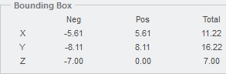

Figure 4 – Bounding Box Information

**Viii. Analyzing Mold Cavity Layout**

You can create a mold model that contains multiple cavities. When you create a multiple- cavity layout in the mold model, the system creates a pattern of the reference model to create the multiple cavities.

The following layout options are available:

* Single – Places a single cavity, or single instance, of the reference model in the mold model. A Single cavity layout is shown in Figure 1.

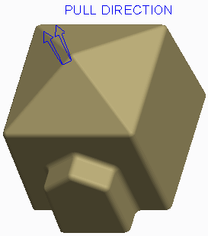

Figure 1 – Single Cavity Mold Model Layout

* Rectangular – Places the reference model in a rectangular layout in the mold model. A Rectangular cavity layout is shown in Figure 2.

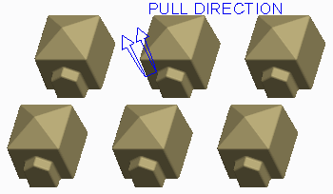

Figure 2 – Rectangular Cavity Mold Model Layout

The following options are available for the Rectangular layout:

* Cavities – Specifies the number of cavities, or number of pattern instances of the reference model, in the X and Y directions. You can either edit the number or use the up and down arrows to increase or decrease the number of cavities in each direction.
* Increment – Specifies the distance between origins of reference models in the X and Y directions.

The X and Y directions are determined by the mold model coordinate system's X and Y axes.

* Circular – Places the reference model in a circular layout in the mold model. A Circular cavity layout is shown in Figure 3.

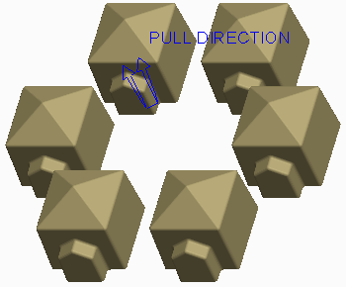

Figure 3 – Circular Cavity Mold Model Layout

The following options are available for the Circular layout:

* Cavities – Specifies the number of cavities, or number of pattern instances of the reference model, in the mold model.
* Radius – Specifies the radius value around which the cavities are placed.
* Start Angle – Specifies the angular distance in degrees about the mold model's Z-axis that the first reference model's origin is placed. You can specify a negative value.
* Increment – Specifies the angular distance between cavities in degrees.
* Variable – Enables you to place the reference model according to a user-defined pattern table.

**iX. Analyzing Variable Mold Cavity Layout**

You can create unique cavity layouts using the Variable layout option. When you select the Variable option, the existing cavity layout is converted to the Variable format, and the Variable table appears in the Layout dialog box. Each pattern instance (reference model) displays in the left-most column, and the variables that vary orientation are displayed in the right columns, as shown in the figures. At this point, you can adjust the orientation for each pattern member independently of the others.

The following orientation options are available for each pattern instance in the Variable table:

* **Reference Rotation Reference Rotation ** — Rotates the reference model (pattern instance) about its origin.
* **X-Translation X-Translation ** — Translates the reference model along its positive or negative X- axis.
* **Y-Translation Y-Translation ** — Translates the reference model along its positive or negative Y- axis.
* **Layout Rotation Layout Rotation ** — Rotates reference model about mold layout origin.

Of these four options, the Y-Translation and Layout Rotation options are not always available, depending upon which layout was converted to Variable. The Layout Rotation option is only available for a layout converted from Circular, as shown in Figure 1.

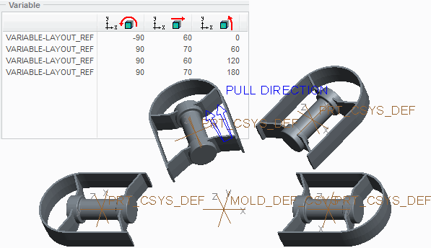

Figure 1 – Variable Cavity Converted from Circular Layout

The Y-Translation option is only available for a layout converted from Single or Rectangular, as shown in Figure 2.

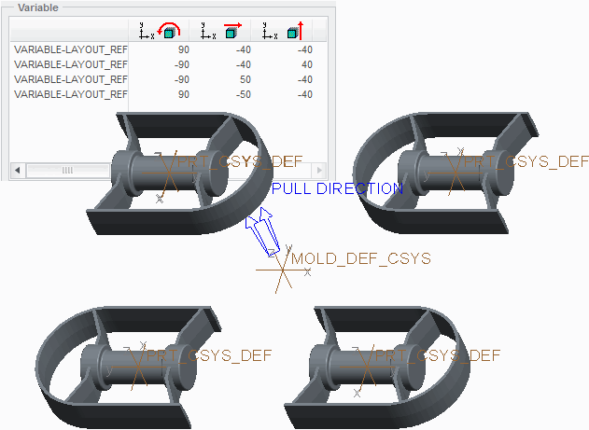

Figure 2 – Variable Cavity Converted from Single Layout

Additional Variable cavity layout options include the following:

* Highlight — When this check box is selected, any pattern instance selected in the Variable table highlights in the graphics window.
* Add — Enables you to add a new pattern instance to the layout. The new pattern instance member is inserted immediately following the pattern instance that is selected when the Add button is clicked.
* Remove — Enables you to remove an existing pattern instance from the layout. To remove a pattern instance, select it in the Variable table and click Remove.

**X. Analyzing Mold Cavity Layout Orientation**

You can adjust the orientation of the cavities in a multi-cavity layout. Examples of reasons why cavity adjustment may be necessary include the following:

* More optimum layout for sprue and runner placement is required.
* More uniform cooling of parts is needed.
* Manufacturing feasibility of the mold design layout.

Consider each of the mold cavity layouts and their respective options for orientation.

### Modifying Layout Orientation in a Single Cavity

Because there is only a single cavity, no further orientation adjustments are available. The Orientation options become grayed out in the Layout dialog box. Rather, you can adjust the cavity orientation in the layout by switching coordinate systems or dynamically adjusting the REF_ORIGIN coordinate system.

### Modifying Layout Orientation in a Rectangular Cavity

The following Orientation options are available for the Rectangular cavity layout:

* Constant – Cavities are arranged to all point in the same direction.
* X-Symmetric – Cavities are mirrored about the mold model's X-axis. That is, the cavities are arranged so that they appear in the same orientation when looking out from a plane that runs along the mold model's X-axis. X-Symmetric orientation is shown in the left image of Figure 1.

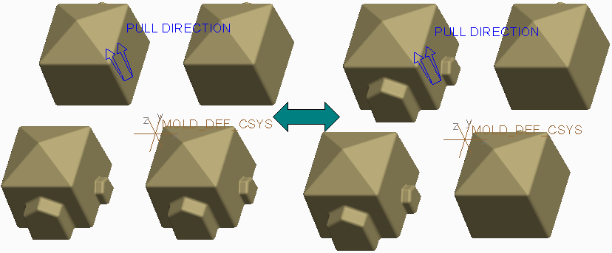

Figure 1 – Rectangular Layout, X-Symmetric versus Y-Symmetric Orientation

* Y-Symmetric – Cavities are mirrored about the mold model's Y-axis. That is, the cavities are arranged so that they appear in the same orientation when looking out from a plane that runs along the mold model's Y-axis. Y-Symmetric orientation is shown in the right image of Figure 1.

### Modifying Layout Orientation in a Circular Cavity

The following Orientation options are available for the Circular cavity layout:Constant – Cavities are arranged to all point in the same direction, as shown in the left image of Figure 2.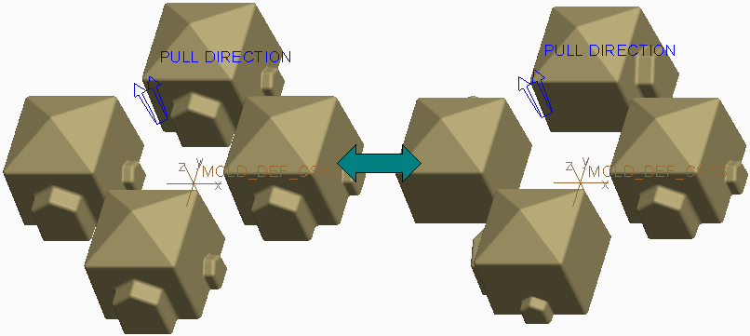

Figure 2 – Circular Layout, Constant versus Radial Orientation

* Radial – Cavities are fanned about the mold model's origin. That is, the cavities are arranged so that they appear in the same orientation when looking out radially from the mold model origin. Radial orientation is shown in the right image of Figure 2.

**Xi. Calculating Projected Area**

You can calculate the projected area of the reference model to help calculate the clamping force needed to keep a mold set closed during operation. To calculate the projected area, you can click **Projected Area Projected Area ** from the Analysis group. This opens the Measure dialog box.

In the Measure dialog box, you must specify the following items:

* Entity – Specifies the entity that is to be projected. You can select the following entity types:
* All Ref Parts – This is the default Entity selection.
* Surface
* Quilt
* Facets
* Projection Direction – Specifies the direction that the Entity is projected. You can specify any of the following projection direction references:
* Default Pull Direction – This is the default Projection Direction.
* None
* Plane – Enables you to select a plane that the direction is perpendicular to.
* Line/Axis – Enables you to select a line or axis as the direction.
* Coordinate System – Enables you to select a coordinate system. Once you select the coordinate system, you must specify which coordinate axis defines the direction.
* View Plane – Uses the current viewing plane as the projection reference.

Once you have defined the entity and projection direction, you can click Compute to calculate the projected area of the entity.

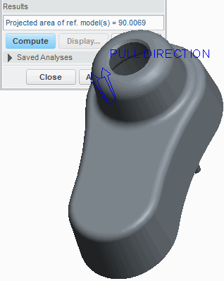

Figure 1 – Calculating Projected Area

The selected entity is projected onto an imaginary plane that is perpendicular to the projection reference, as shown in Figure 2.

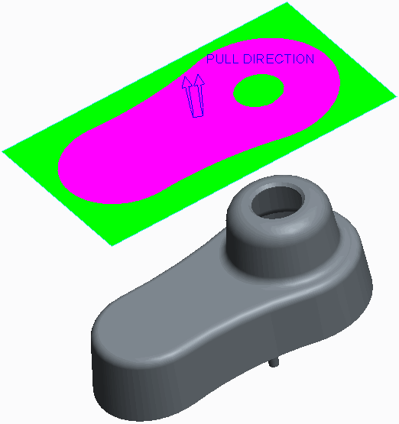

Figure 2 – Illustration of Projected Area The area of this projection is calculated.

# exercise: Creating the Shower Head Mold Model





#### Objectives

* Create a new mold model.
* Assemble the reference model.
* Modify the mold cavity layout.

#### Scenario

In this exercise, you create a new shower head mold model by assembling a multi-cavity reference model. You have already analyzed the design model and verified that the model is sufficient for molding.

#### 1. Task 1. Inspect the shower head model that is to be molded.

1. Enable only the following Datum Display types: 
2. Spin the design model and inspect it.

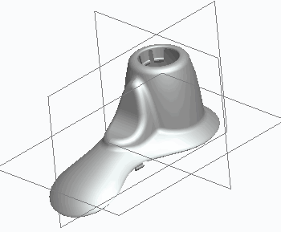

Figure 1

1. Click **Close** from the Quick Access toolbar.Close 

#### 2. Task 2. Create a new shower head mold model.

1. Click **New New ** from the Quick Access toolbar.

* Select **Manufacturing** as the Type.
* Select **Mold cavity** as the Sub-type.
* Type **shower_head_mold** as the Name.
* Clear the **Use default template** check box and click **OK**.

1. In the New File Options dialog box, select **mmns_mfg_mold** as the Template.

* Click **OK**.

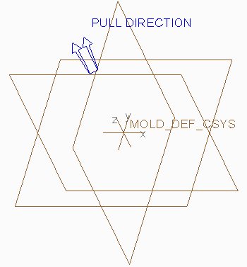

Figure 2

#### Task 3. Create and assemble the reference model.

1. Click **File > Options** and select the **Configuration Editor** category.

* Click **Add**.
* Type **enable_absolute_accuracy** in the Option name field.
* Select **yes** as the Option value and click **OK > OK**.

1. Select **Locate Reference Model Locate Reference Model ** from the Reference Model types drop-down menu in the Reference Model & Workpiece group to assemble the reference model.
2. In the Open dialog box, double-click SHOWER_HEAD.PRT to open it.
3. In the Create Reference Model dialog box, select **Inherited** as the Reference model type and click **OK**.
4. In the Layout dialog box, click **Reference Model Origin Reference Model Origin ** and click **Dynamic** from the menu manager.
5. In the Reference Model Orientation dialog box, select **Rotate** as the Coordinate System Move option, and select **Y** as the Axis.

* Type **-180** as the Value and click **OK**.

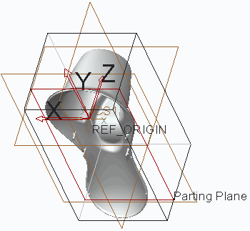

Figure 3

1. In the Layout dialog box, select **Rectangular** as the Layout.

* Edit the Number of Cavities in the X and Y directions to **2**, if necessary.
* Edit the X Increment to **120**.
* Edit the Y Increment to **250**.
* Click **Preview**.

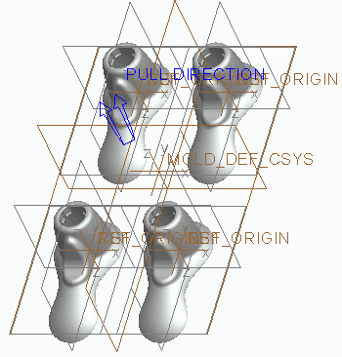

Figure 4

1. In the Layout dialog box, edit the Orientation to **X-Symmetric**.

* Edit the Y Increment to **150**.
* Click **OK**.

1. Click **OK** from the Warning dialog box to accept the accuracy change.
2. Click **Done/Return** from the menu manager.
3. Disable **Plane Display Plane Display  **.

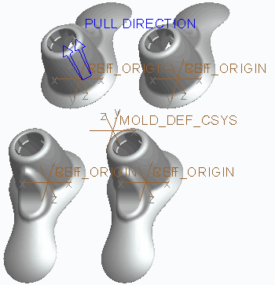

Figure 5

1. Click **Save Save ** from the Quick Access toolbar and click **OK** to save the model.
2. Click **File > Manage Session > Erase Current**, then click **Select All** and **OK** to erase the model from memory.Select All 

# 5. Workpieces

#### Module Overview:

Once you have created the mold model, you can create and assemble the workpiece. The workpiece represents the full volume of all the mold components that are needed to create the completed mold model. You can also apply style states to the workpiece to make them transparent within the mold model.

In this module, you learn how to create and assemble workpieces in a mold model.

#### Objectives:

After completing this module, you will be able to:

* Explain the different display styles you can apply to components when creating style states.
* Create a workpiece automatically.
* Create a custom automatic workpiece.
* Create and assemble a workpiece manually.
* Reclassify mold model components.

1. **Creating Display Styles**

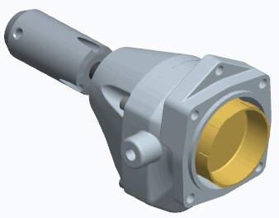

Figure 1 – Original Model

The display of models in a Creo Parametric session are controlled by the four following display options: Wireframe, Hidden Line, No Hidden, and Shaded. You can also assign display styles to individual components in an assembly that can be used regardless of those overall session settings.

Use the Style tab in the view manager to create display styles for your assembly. You can assign one of the following display styles to components in an assembly:

* Wireframe – Shows front and back lines equally.
* Hidden Line – Shows hidden lines in ghost tones.
* No Hidden – Does not show lines behind forward surfaces.
* Shaded – Shows the model as a shaded solid.
* Transparent – Shows the model as a transparent solid.
* Blank – Does not show the model.

You can apply existing display styles to sub-assemblies using the By Display tab. When you select a sub-assembly from the model tree, the available display styles for that sub- assembly display in the By Display tab, enabling you to specify the desired one.

You can also modify component display styles without using the view manager. You can select desired models in the graphics window, model tree, or search tool and click the Model Display group drop-down menu and select Component Display Style to assign a display style to the selected models. You can store these temporary edits with a new display style or update them to an existing one.

After you define the default style, it appears each time the model is opened.

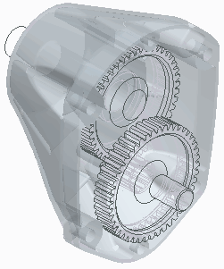

Figure 2 – Viewing a Display Style

### Uses of Display Styles

You use display styles to do the following:

* Increase system performance by either blanking components from display or limiting the number of components being calculated for hidden line display.
* Create and save display settings used in presentations or other common situations where it is helpful to change the display of components within an assembly.

*You cannot use display styles in drawing view.*

*Blanked components are not removed from session memory; they are only removed from display. For this reason, you cannot use display styles to reduce the amount of memory required to open and work with an assembly. You reduce the required memory using simplified reps.*

* + 1. **Creating a Workpiece Automatically**

Once you assemble the reference model into the mold model, you typically create and assemble the workpiece next. The workpiece is a model that represents the full volume of all the mold components (cavity, core, and inserts) that are needed to create the final mold model. The workpiece icon that displays in the model tree is different than that of a conventional part model and the reference model, which is shown in Figure 1.

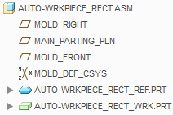

Figure 1 – Viewing the Workpiece in the Model Tree

The workpiece displays transparent green in the graphics window.

To automatically create a workpiece, select **Automatic Workpiece Automatic Workpiece ** from the Workpiece types drop-down menu. The workpiece is automatically assembled to the

specified Origin coordinate system using the **Coincident** assembly constraint, and the accuracy is automatically set to match that of the reference model.Coincident 

To create an automatic workpiece, you must specify the following items:

* Mold Origin – The Mold Origin is a mold model coordinate system from which directions are determined for workpiece creation.
* Shape – The shape determines the shape of the workpiece. The system creates a workpiece with the minimum dimensions that the reference model fits in, within the specified shape. The following options are available:
* Standard Rectangular – This creates a rectangular workpiece using **Create Rectangular Workpiece Create Rectangular Workpiece **, which is shown in Figure 2.

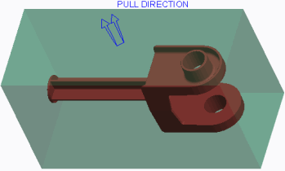

Figure 2 – Standard Rectangular Workpiece

* Standard Round – This creates a round-shaped workpiece using **Create Round Workpiece Create Round Workpiece **, which is shown in Figure 3.

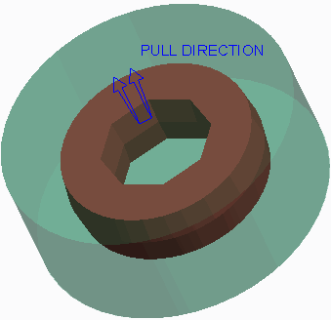

Figure 3 – Standard Round Workpiece

* Custom – Custom creates a custom-shaped workpiece using **Create Custom Workpiece Create Custom Workpiece **.
* Units – This specifies the system of units for the workpiece. You can select inches or millimeters.
* Offsets – This enables you to specify the offset values to add to the dimensions of the workpiece, based on the mold origin. The offsets depend on the shape of the workpiece that you have selected. You can specify each offset individually, or specify all offsets uniformly. The following offset options are available:
* X-direction – This adds material in the positive or negative X-direction. This offset is available for only the Standard Rectangular shape and some custom shapes.
* Y-direction – This adds material in the positive or negative Y-direction. This offset is available for only the Standard Rectangular shape and some custom shapes.
* Z-direction – This adds material in the positive or negative Z-direction.
* Radial – Radial adds material in the positive radial direction.
* Uniform Offsets – This adds material in the positive and negative X-, Y-, and Z- directions, and Radial, where applicable.
* Overall Dimensions – The overall dimensions get updated when you specify offset values. However, you can also specify the overall dimensions, and the offset values get updated automatically. You can manually specify the X and Y dimensions for rectangular and custom workpieces, and the Diameter for rounded workpieces, to customize the workpiece size. You can manually specify the Z Cavity and Z Core dimensions for all workpieces to customize the size.
* Translate Workpiece – This enables you to specify the translation values for the X- and Y-directions to position the workpiece around the reference model.

You can modify the default Workpiece Name. The Workpiece Name is the name of the workpiece component as it displays in the model tree. By default, its name is of the format *<MOLD-MODEL-NAME>_WRK*, which is shown in Figure 1.

* + 1. **Creating a Custom Automatic Workpiece**

In addition to a Standard Rectangular and Standard Round automatic workpiece, you can also create a custom workpiece. A custom automatic workpiece enables you to add flanges to the top and bottom of the workpiece. It also enables you to add rounds or chamfers to the vertical workpiece edges.

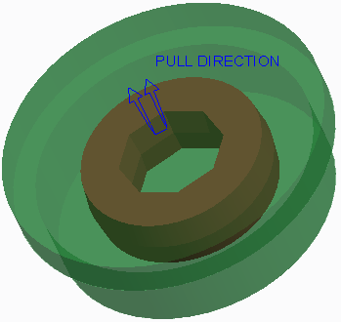

Figure 3 – bar_top_flange Custom Workpiece

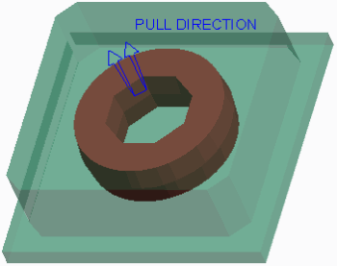

Figure 2 – chamf_CHAMF_xy_bot_flange Custom Workpiece

The process is the same as creating a rectangular or round workpiece.

To create a custom automatic workpiece, you can use the **Create Custom Workpiece Create Custom Workpiece ** option in the Automatic Workpiece dialog box, and then select the desired shape in the drop-down list below it. The default shape for a custom workpiece is BLOCK_XY_FLANGES, as shown in Figure 1.

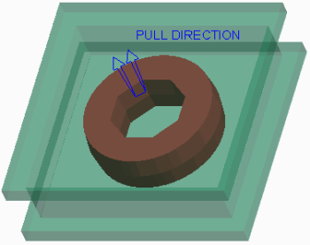

Figure 1 – block_xy_flanges Custom Work piece However, the following shapes are also available:

* BLOCK_00_FLANGES
* BLOCK_00_BOT_FLANGE
* BLOCK_CHAMF_00_FLANGES
* CHAMF_CHAMF_00_BOT_FLANGE
* BLOCK_ROUND
* BLOCK_ROUND_00_TOP_FLANGE
* BAR_FLANGES
* BAR_BOT_FLANGE
* BLOCK_00_TOP_FLANGE
* BLOCK_CHAMF
* BLOCK_CHAMF_00_TOP_FLANGE
* BLOCK_CHAMF_00_BOT_FLANGE
* BLOCK_ROUND_00_FLANGES
* BLOCK_ROUND_00_BOT_FLANGE
* BAR_TOP_FLANGE

*The 00 value in the shapes above represent the X, Y, or XY direction.*

You can use the offsets available for the rectangular and round automatic workpiece for a custom workpiece.

## Creating and Assembling a Workpiece Manually

### Creating a Workpiece Manually

You can create a workpiece manually using either of the following methods:

* Create the workpiece within the mold model by selecting **Create Workpiece** from the Workpiece types drop-down menu in the Reference Model & Workpiece group. The Component Create dialog box appears, and you must provide the name of the workpiece component as it displays in the model tree.Create Workpiece 

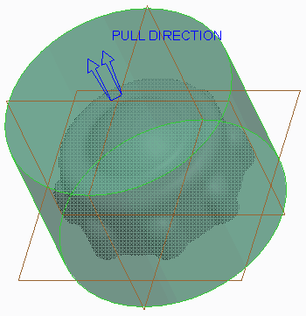

Figure 2 – Creating a Workpiece within the Mold Model

* Create the workpiece outside the mold model as a conventional part model.

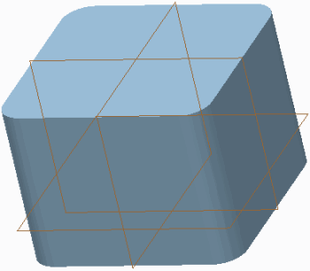

Figure 1 – Part Model

When the part model is needed as the workpiece in the mold model, you can assemble it as a component into the mold model and designate it as the workpiece.

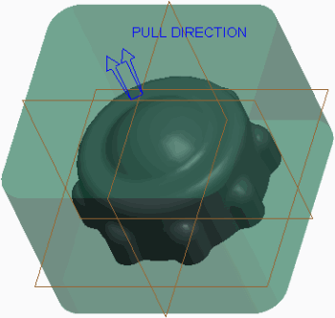

Figure 3 – Part Model Asswmbled as workpiece

When creating the workpiece manually, you can use any of the conventional part modeling feature techniques available when creating a regular part model. For example, you can use Extrude features, Revolve features, Hole features, Sweep features, and Blend features.

### Assembling a Manually Created Workpiece

If the workpiece is created in the mold model, it is already designated as the workpiece upon its creation. It must then be properly assembled into the mold model.

If you create a part model outside of the mold and want to use it as the workpiece in a mold model, you must assemble it into the mold model and designate it as the workpiece. You can do this by selecting **Assemble Workpiece Assemble Workpiece ** from the Workpiece types drop-down menu in the Reference Model & Workpiece group.

You can assemble the workpiece into the mold model using any of the available assembly constraints including **Default** , **Coincident** , **Distance Distance **, **Angle Offset Angle Offset **, **Parallel** , and **Normal Normal **.Coincident Parallel 

### Considerations When Creating and Assembling a Workpiece Manually

Keep the following in mind when creating and assembling a workpiece manually:

* If you manually create a workpiece and assemble it into the mold model, you need to match the workpiece accuracy to that of the reference model.Keep the location of where the workpiece is split in mind. You can create a datum plane or coordinate system at this location to aid in the assembly process later.

### Best Practices

It is a best practice to create an automatic workpiece whenever possible. When an automatic workpiece is created, Creo Parametric automatically sets the accuracy of the workpiece model to that of the reference model. If a manual workpiece is created and assembled into the mold model, you must manually modify the workpiece accuracy so that it matches the reference model.

1. **Reclassifying and Removing Mold Model Components**

### Reclassifying Mold Model Components

You can switch the classification of components within the mold model.

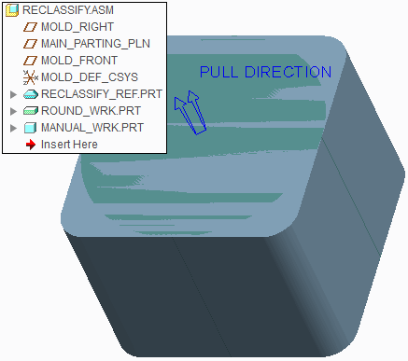

Figure 1 – Mold Model Before Reclassification

Reclassifying mold components is a great way to switch which component is used as the workpiece. Each of the following component types can be reclassified to any of the other types:

* Workpiece — The mold model uses the selected component as a workpiece. In Figure 2, the rectangular mold base component has been reclassified as a workpiece.

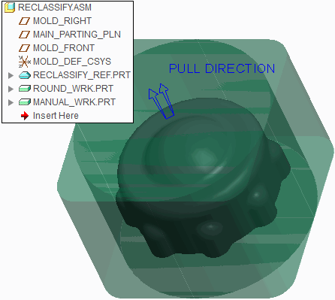

Figure 2 – Mold Base Component Reclassified to a Workpiece

* Mold Base Component — The mold model uses the selected component as a mold base component. In Figure 3, the round workpiece has been reclassified as a mold base component.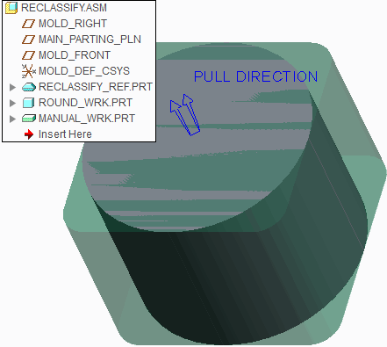

sFigure 3 – Mold Model After Reclassification

* Mold Component — The mold model uses the selected component as a mold component.

The following are some points to keep in mind when reclassifying mold model components:

* You cannot reclassify the reference model.
* You cannot reclassify a different model to become a reference model.
* The mold model can contain multiple workpieces. In Figure 2, a mold base component has been reclassified as a workpiece, causing there to be two workpieces in the mold model.

### Removing Mold Model Components

You can remove components from the mold model in any of the following ways:

* Select the component, right-click, and select **Delete Delete ** .
* Select the component, and press DELETE.
* Select the component and select **Delete Delete ** from the Delete types drop-down menu in the Operation group.

*The* ***Undo Undo *** *and* ***Redo Redo *** *operations are not available if you remove components from the mold model.*

**6. Mold Volume Creation**

#### Module Overview:

Once the reference model and workpiece have been assembled into the mold model you must create mold volumes within the mold model. Mold volumes are surfaces that locate a closed volume of space in the workpiece, and are ultimately used to create the final mold core, cavity, and slider components.

In this module, you learn which mold volumes are in a mold model and how to create them.

#### Objectives:

After completing this module, you will be able to:

* Understand and explain some of the basic surfacing terms.
* Understand what mold volumes are and explain their characteristics.
* Sketch mold volumes.
* Create sliders using boundary quilts.
* Sketch sliders.
* Create a reference part cutout.
* Sketch lifter and insert mold volumes.
* Replace surfaces and trim to geometry.

## Surfacing Terms

Surface modeling terms are used throughout this course. Therefore, they are important to understand.

* Surface – Surfaces are infinitely thin, non-solid features used to aid in the design of highly complex and irregular shapes. Notice that surfaces are shown using orange and purple highlighting on the edges when viewed in wireframe display, as in Figure 1.

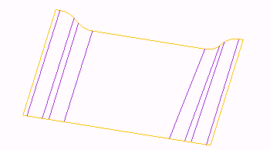

Figure 1 – Viewing a Surface

* Orange denotes outer or one-sided edges.
* Purple denotes inner or two-sided edges, since they border two surface patches. In Creo Parametric, the term surface can be used for any of the following:
* Quilts – A quilt may consist of a single surface or a collection of surfaces. A quilt

represents a patchwork of connected surfaces. A multi-surface quilt contains information describing the geometry of all the surfaces that compose it, and information on how these surfaces are joined or intersected, such as the models shown in Figure 1 and Figure 2.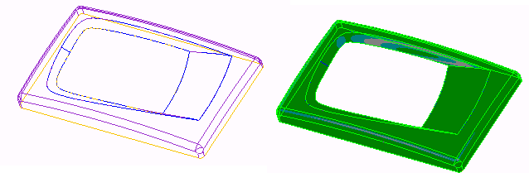

Figure 2 – Surface Quilt

* Surface Patch – If you create a surface feature, which is made of several segments, the surface is created with multiple patches, as in Figure 1.
* Solid Surfaces – A face of a solid feature, such as the solid model shown in Figure 3.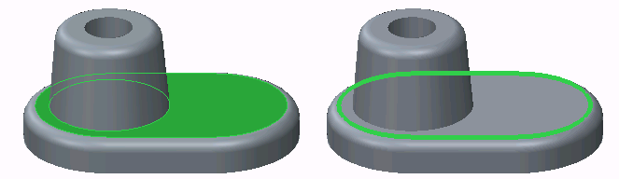

Figure 3 – Solid Surface and Edge

* Datum Planes – A planar datum feature that extends infinitely but is represented by a rectangular border.
* Edge – An edge is the boundary of a solid, as in Figure 3 or a surface, as in Figure 4.

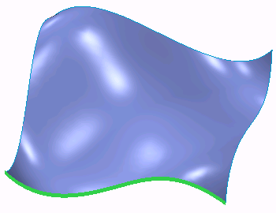

Figure 4 – Surface Edge

Surface edges can be one-sided or two-sided depending on the presence of adjacent surface geometry.

## Understanding Mold Volumes

A mold volume consists of surfaces that locate a closed volume of space within the workpiece. Because the mold volume is comprised of surfaces, it has no solid material. Creating mold volumes is an intermediate step to creating the final extracted mold components. Mold volumes are ultimately used to create the final solid extracted mold components. Figure 2 shows three different mold volumes.

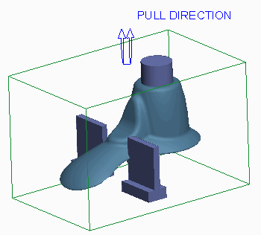

Figure 2 – Mold Volumes Shade

Because the mold volumes are surfaces, they appear magenta when the model display is set to something other than shading, as shown in Figure 3.

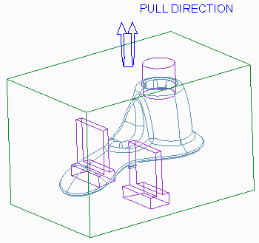

Figure 3 – Mold Volumes No Hidden

The following is some general information regarding mold volume creation:

* A mold volume can add or remove material.
* A mold volume is created as an assembly level protrusion or cut within the mold model.
* You can sketch mold volumes.
* A mold volume can be trimmed or split using other surfaces.
* Mold volume creation is an iterative process. You can create mold volumes at any time after the workpiece is assembled but before the final solid mold components are extracted.

A mold volume displays in the model tree with a different icon than that of the reference model and workpiece, as shown in Figure 1.

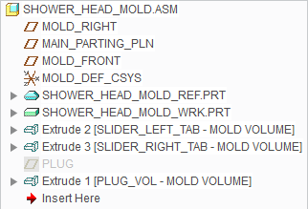

Figure 1 – Model Tree of Mold Model

*Because mold volumes are created within the workpiece, it is beneficial to create a style state that sets the workpiece to wireframe when creating mold volumes. This enables you to more clearly see inside the workpiece, yet it still makes the workpiece and its surfaces available if they need to be selected as references. The workpiece in the figures is set to wireframe.*

### Renaming Mold Volumes

When you create a mold volume, it is a best practice to rename it to something that helps you recognize it within the model tree. To rename a mold volume, you can click **Properties Properties ** from the Controls group after starting the mold volume creation

tool. You can also right-click in the graphics window and select Properties. This causes the Properties dialog box to appear, which enables you to edit the mold volume name. In Figure 1, notice that the mold volumes have been renamed.

### Applying Finishing Features

You can add draft and round features to a mold volume in the same manner in which you add to any other solid part. This enables you to customize the mold volume. It is used to create the solid mold component.

## Sketching Mold Volumes

You can create a mold volume by sketching its shape.

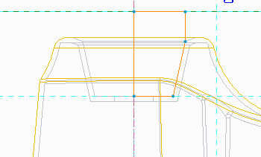

Figure 1 – Sketching a Mold Volume

Consider the following guidelines when sketching mold volumes:

* The mold volume is a set of surfaces.
* You can use most sketch-based features within Mold mode to create a mold volume. Feature tools you can use include:

Extrude 

* **Extrude** — Extrudes a sketch section to a specified depth in the direction normal to the sketching plane.
* **Revolve Revolve ** — Revolves a sketched section by a specific angle around an axis of rotation.
* **Sweep Sweep ** — Sweeps a sketched section along a specific trajectory. Create constant section sweeps or variable section sweeps.
* Blend tool — Creates a straight or smooth blended volume by connecting several sketched sections.
* **Swept Blend Swept Blend ** — Sweeps a blend section along a specified trajectory.
* Use Quilt — Creates a volume by referencing a surface or quilt.
* Depending on the tool used and the desired mold volume, it can be beneficial to use the workpiece surfaces as sketching planes for the mold volumes.
* The sketch must be closed.

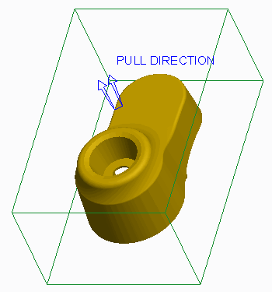

Figure 2 – Mold Model with No Mold Volumes

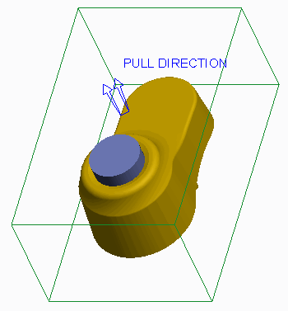

Figure 3 – Mold Model with Mold Volume

1. **Creating Sliders using Boundary Quilts**

### What is a Slider?

A slider is a mold component that helps account for undercuts in the reference model geometry. Undercuts are features in the reference model that would prevent a conventional core-and-cavity mold from opening after the molded part has solidified. Sliders “slide” in from the sides to account for these undercuts to keep the mold from locking when opening and closing, or destroying the part. The action of these sliders is called *side action*.

### Creating Sliders using Boundary Quilts

In Creo Parametric, a slider is a special type of mold volume that can be used to ultimately create the slider mold component. One of the ways you can create sliders in Creo Parametric is by using boundary quilts. To create a slider mold volume using

boundary quilts, you must select **Mold Volume Mold Volume ** from the Mold Volume types drop-

Slider 

down menu in the Parting Surface & Mold Volume group and then click **Slider** from the Volume Tools group. This launches the Slider Volume dialog box.

The Slider Volume dialog box displays the reference part found in the mold model. If the mold model contains more than one reference model, you must specify which one is to be used for the calculation.

You can also specify the pull direction. The system utilizes the mold model's pull direction as the default Pull Direction, but you can specify a different pull direction by selecting any of the following references:

* Plane — Makes the pull direction perpendicular to the specified plane.
* Curve, Edge, or Axis — Makes the pull direction follow the selected curve, edge, or axis.
* Coordinate System — Makes the pull direction follow the specified axis of the selected coordinate system.

Once the pull direction has been defined, you can click **Calculate Undercut Boundaries Calculate Undercut Boundaries ** from the Slider Volume dialog box. This causes the system to perform a geometry check for undercut areas in the reference model. The system performs the check by shining a light on the reference model in the pull direction. The areas where light does not reach are the undercuts, which are also known as black volumes. These areas would cause the mold to lock on opening or closing. Therefore, a slider is required in these areas.

The system creates boundary quilts in the areas where the undercuts occur and displays them in the Exclude column of the Slider Volume dialog box. You can select each boundary quilt and perform the following operations on each quilt:

* Mesh — Meshes the boundary surface in the graphics window. In Figure 1, the boundary surface is meshed.

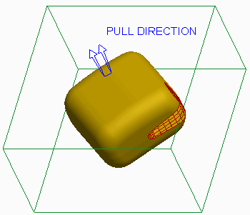

Figure 1 – Meshing a Boundary Quilt

* Shade — Shades only the boundary surface in the graphics window, temporarily hiding all other geometry.

You can then add each quilt that you want to become a slider mold volume to the Include column of the Slider Volume dialog box. The system automatically extrudes the slider mold volume based on the boundary quilt. A completed slider mold volume is shown in Figure 2.

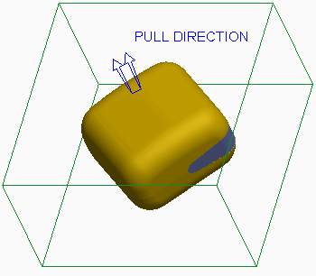

Figure 2 – Slider Mold Volume

### Specifying the Projection Plane

Optionally, you can specify a projection plane for each slider mold volume. The system extends the extruded slider volume up to the specified projection plane, in the direction normal to the plane. In Figure 3, the right surface of the workpiece was specified as the projection plane.

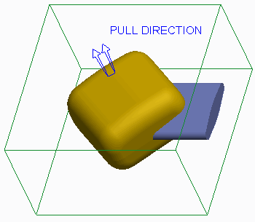

Figure 3 – Slider Mold Volume Projected to Workpiece Surface The resulting slider mold volume is projected up to this surface.

1. **Sketching Slider Mold Volumes**

You can also sketch slider mold volumes. The following are reasons to sketch slider mold volumes:

* Shape – When calculated undercut boundaries are used, the resulting slider mold volume takes on the shape of the undercut geometry. If the shape is not desired for manufacturing, or it cannot be manufactured, a slider mold volume can be sketched to account for the undercut geometry. In Figure 1, the shape created by calculating undercut boundaries is not as conducive to manufacturing as the sketched slider mold volume in Figure 2.

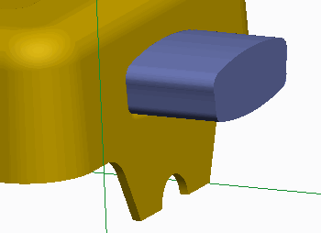

Figure 1 – Undesired Slider Result

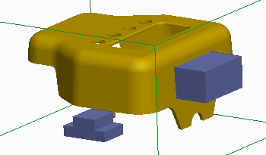

Figure 2 – Sketched Slider Mold Volumes

* Size – Since the slider mold volume created by calculating undercut boundaries takes on the shape of the undercut, the slider mold volume may be too small for manufacturing, as shown in Figure 3.

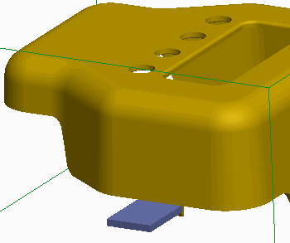

Figure 3 – Slider Volume too Small

Consequently, you can sketch a larger slider mold volume that accounts for the undercut, as shown in Figure 2.

* Result – Depending on the reference model geometry, sometimes the slider mold volume obtained by calculating undercut boundaries cannot be created, or the slider mold volume does not entirely account for undercut geometry. In Figure 1, the slider does not properly account for the round feature, and thus a sketched mold volume was created in Figure 2.

### Guidelines for Sketching Sliders

When creating slider mold volumes using sketch-based features, consider the following guidelines:

* You can still initially calculate the undercut boundaries for the reference model even when you are sketching the slider mold volumes. The analysis helps you determine the locations in the mold model where sliders will be required and helps ensure that you have accounted for all undercut geometry.
* Ensure that the sketch you create accounts for the entire undercut geometry. That is, make sure that the entire undercut geometry is contained within the resulting sketched slider mold volume. It can be beneficial to utilize the sides of the undercut geometry as sketching references.
* Because the slider is simply a special type of mold volume, you can use any sketch- based feature that is available for sketching the conventional mold volume on the slider mold volume.
* Because the slider is a mold volume, the sketch must be closed.

1. **Creating a Reference Part Cutout**

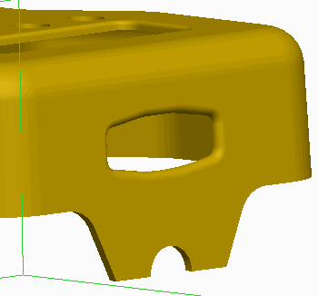

Figure 1 – Reference Model

You can create a reference part cutout on a mold volume by selecting **Reference Part Cutout Reference Part Cutout ** from the Trim To Geometry types drop-down menu in the Volume Tools group. A reference part cutout enables you to remove any overlapping reference model geometry from the mold volume. The volume of the reference model is subtracted from the mold volume. This is a very useful feature because the mold volume will then match the reference model geometry. A reference part cutout enables you to create a mold volume that completely encompasses the desired area of the reference model and then create a reference part cutout feature.

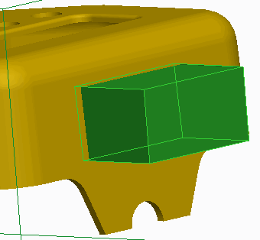

Figure 2 – Mold Volume Created

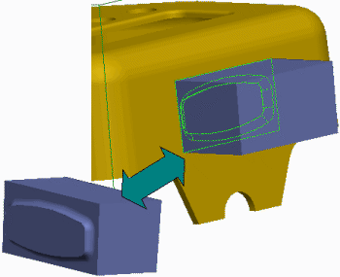

Figure 3 – Reference Part Cutout Created

Creating a reference part cutout is not a requirement when creating mold volumes. The reference model geometry is automatically cut out of the mold volumes when the volumes are split (this happens later in the process). Creating a reference part cutout is a great method to determine if the reference geometry can successfully be cut out during the split process. It can also help you visualize whether or not you have created a mold volume that captures the desired reference model geometry.

The reference part cutout option is only available if you are creating a volume or if you are redefining the volume. The resulting reference part cutout feature displays in the model tree as a feature called *Refpart Cutout id*. However, the mold volume for which the trim was applied is also displayed in the model tree as shown in Figure 4:

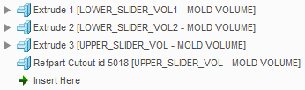

Figure 4 – Reference Part Cutout in Model Tree

### Reference Part Cutout Tips

Consider the following tips when creating a reference part cutout for a mold volume:

* Without creating additional modifications to the volume after the reference part cutout, the system makes the reference part cutout option unavailable. Therefore, you cannot cut out a volume twice.
* When more than one reference part is present, the system prompts you to select one.

1. **Sketching Lifter Mold Volumes**

A lifter is another mold component that helps account for undercuts of the inside of the reference model geometry.

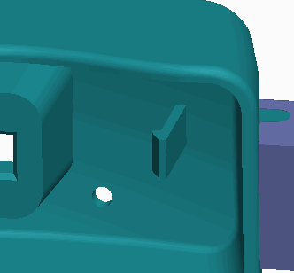

Figure 1 – Viewing the Undercut

Because mold components are ultimately created from mold volumes, you can use sketch-based features to create lifter mold volumes in the mold model.

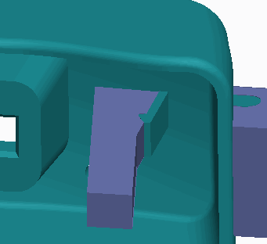

Figure 2 – Lifter Created to Account for Undercut

A lifter is usually attached to the moving side of the mold. It moves at an angle to free the plastic that comprises the undercut inside the model. Due to their function, lifters are normally long and narrow.

# Exercise: Sketching Lifter Mold Volumes

#### Procedure Setup:



**Objectives**

* Sketch a lifter volume.

#### Scenario

Sketch a lifter mold volume that accounts for the undercut in the mold model.

1. Enable only the following Datum Display types: .Graphic
2. Select LIFTER_WRK.PRT.
3. In the ribbon, select the **View** tab.
4. Click the Model Display group drop-down menu and select **Component Display Style > Wireframe**.
5. Select the **Mold** tab.
6. Spin the model, as shown, and notice the undercut.

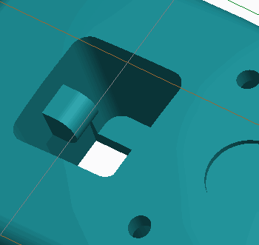

Figure 1

1. Select **Mold Volume Mold Volume ** from the Mold Volume types drop-down list in the Parting Surface & Mold Volume group.
2. Click **Properties** from the Controls group, edit the mold volume Name to **LIFTER_VOL2**, and press ENTER.Properties 
3. Select datum plane MOLD_RIGHT as the Sketch Plane and click **Extrude Extrude ** from the Shapes group.
4. Click **Sketch View Sketch View ** from the In Graphics toolbar.
5. Select **Hidden Line Hidden Line ** from the Display Style types drop-down menu.

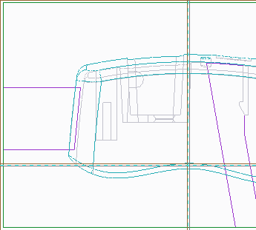

Figure 2

1. Enable only the following Sketcher Display types: .
2. Click **References References ** from the Setup group and select the bottom of the workpiece, the angled line at the bottom edge of the tab, the rounded edge of the tab, and the right edge of the hole as references.

* Click **Close**.

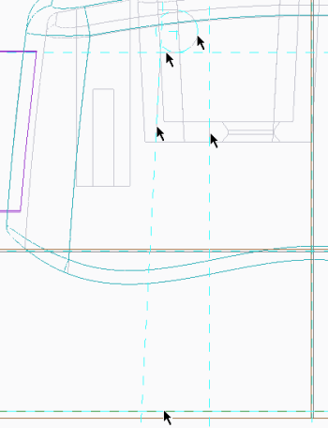

Figure 3

1. Click **Line Chain** and sketch the shape on the references.Line Chain 

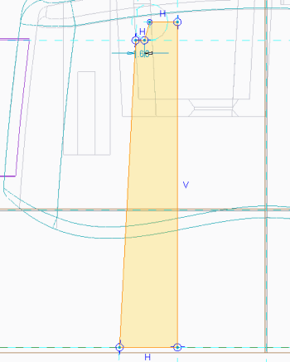

Figure 4

1. Select **Shading Shading ** from the Display Style types drop-down menu.
2. Zoom in on the top of the sketch.
3. Click **Centerline Centerline ** and sketch a vertical centerline through the vertex that is second from the left.
4. Dimension the sketch as shown.

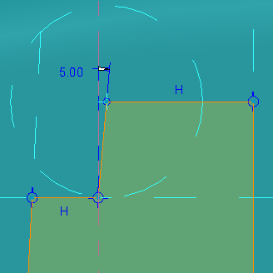

Figure 5

1. Disable **Plane Display Plane Display  **.

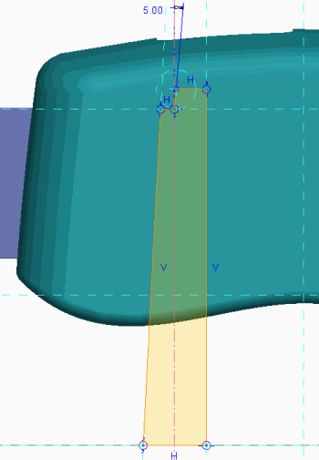

Figure 6

1. Click **OK** .OK 
2. In the dashboard, edit the depth to **To Selected** .To Selected 

* Spin the model so that you can view its underside and select the surface to extrude to.

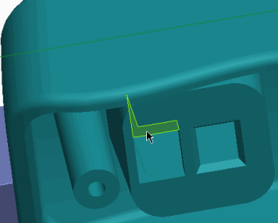

Figure 7

1. In the dashboard, select the **Options** tab.

* Edit the Side 2 Depth to **To Selected** and select the surface to extrude to.To Selected 

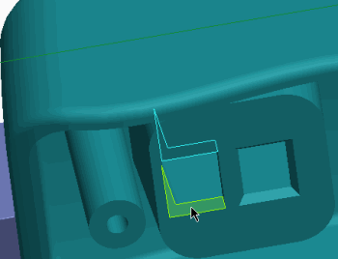

Figure 8

1. Click **Complete Feature** .Complete Feature 
2. Spin the model, as shown, and notice that the lifter accounts for the undercut.

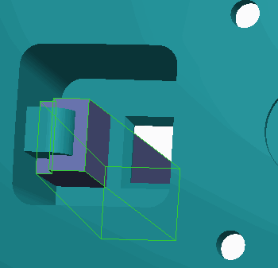

Figure 9

1. Select **Reference Part Cutout Reference Part Cutout ** from the Trim Geometry To types drop-down menu in the Volume Tools group.
2. Click **OK** from the Controls group.OK 

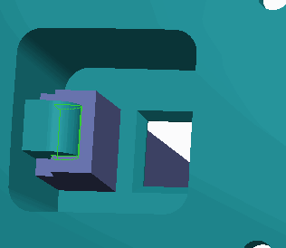

Figure 10

1. Select LIFTER_REF.PRT, right-click, and select **Hide Hide **.
2. Spin the model and view the lifter mold volume

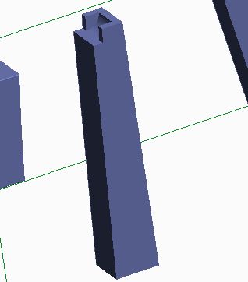

Figure 11

1. Click **Save Save ** from the Quick Access toolbar.
2. Click **File > Manage Session > Erase Current**, then click **Select All** and **OK** to erase the model from memory.Select All 

**This completes the exercise.**

1. **Replacing Surfaces and Trimming to Geometry**

### Replacing Surfaces

You can replace a single-mold volume surface with a quilt surface by clicking the Editing group drop-down menu and selecting **Replace Replace **. You can use the Replace option to add volume, remove volume, or simultaneously add and remove volume. In Figures 2 and 3, the bottom mold volume surface was replaced with the surface quilt.

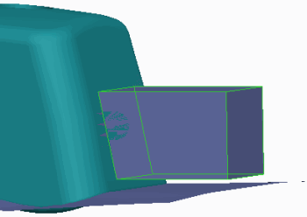

Figure 2 – Mold Volume Before Surface Replace

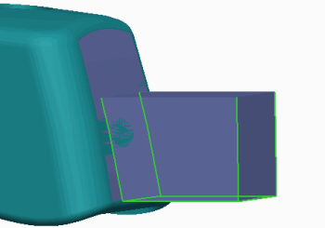

Figure 3 – Mold Volume After Surface Replace

By default, the mold volume is “consumed” by the replaced surface feature. That is, the mold volume is not visible, but still exists previously in the model tree.

When using the Replace option, there is one option available in the Replaced Surface dialog box:

* Keep quilt – This enables the quilt selected for the replace to remain visible after the replace is created. In Figure 3, the quilt was not kept after the surface replace was created.

The Replace option is only available if you are creating a volume or if you are redefining the volume. The resulting replaced surface feature appears in the model tree as a feature called *Replaced Surface id*.

### Trimming to Geometry

You can trim surfaces to other geometry in the mold model by selecting **Trim To**

Trim To Geometry 

**Geometry** from the Trim To Geometry types drop-down menu in the Volume Tools group.

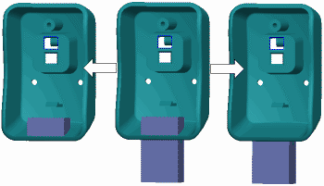

Figure 1 – Trimming a Volume to Geometry

The Trim To Geometry option is only available if you are creating a volume or if you are redefining the volume. The resulting trim to geometry feature appears in the model tree as a feature called *Trim To Geom id*. However, the mold volume for which the trim was applied is also displayed in the model tree.

You can trim to geometry as an alternative to extracting a mold volume up to a surface. However, trimming to geometry has more powerful capabilities than just this use. Trimming can only remove volume, not add it.

When trimming surfaces to geometry, you must specify the following:

* Ref Type – Ref Type specifies what the system uses as the trimming entity. You can specify one of the following:
* Part – This uses a part for trimming.
* Quilt – This uses a quilt for trimming.
* Plane – This uses a plane surface or datum plane for trimming.
* Reference – Reference enables you to specify the item whose geometry will be used for trimming. The item that you can select depends on the Ref Type that was specified. Essentially, the Ref Type acts like a filter for the Reference selection.
* Direction – This enables you to select a trim feature direction. A direction arrow points in the direction that volume will be trimmed at the reference. You can select the following references:
* Plane – Plane makes the direction perpendicular to the specified plane.
* Curve, Edge, or Axis – These make the direction follow the selected curve, edge, or axis.
* Coordinate System – This makes the direction follow the specified axis of the selected coordinate system.
* Trim Type – Trim Type enables you to specify which side of the trimming reference will be used when trimming the mold volume. You can select either of the following:Trim By First Reference 
* **Trim By First Reference** – This trims the item by the first reference surface.
* **Trim By Last Reference** – This trims the item by the last reference surface.Trim By Last Reference 
* Offset – This offsets the trimming reference in the direction currently specified before trimming the geometry.

1. **Sketching Insert Mold Volumes**

An insert is another mold component that is typically used as a cost-saving measure. The mold uses the same core and cavity, but one insert is swapped for another. Different inserts can be used to create different shapes. Thus, you can use the same mold to create similar parts simply by switching inserts. In Figure 1, an insert needs to be created for a square cut in the bottom inset of the reference model.

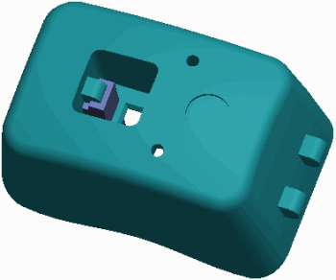

Figure 1 – Viewing the Reference Model

The resulting insert mold volume is shown in Figure 2.

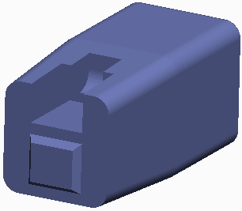

Figure 2 – Viewing the Completed Insert

However, the model could have a design variation where, rather than a square cut in the bottom, there is a round cut in the bottom, which is shown in Figure 3.



Figure 3 – Design Variations That Can Use Same Core and Cavity

In this case, you can create a different insert mold volume, while you use the same core and cavity.

You can also use inserts in areas that are difficult to machine.

Because mold components are ultimately created from mold volumes, you can use sketch-based features to create insert mold volumes in the mold model.

# 7. Parting Surface Creation

#### Module Overview:

In addition to using the Skirt Surface tool to help you automatically generate the parting surface, you can also use the Shadow Surface tool to automatically create a parting surface. You can also use a series of other tools to manually create the different parts of the parting surface. The different parts can be merged together to form the final parting surface.

In this module, you learn about the shadow surface and various manual parting surface tools.

#### Objectives:

After completing this module, you will be able to:

* Explain the various tools you can use to edit and manipulate surfaces.
* Merge surfaces.
* Create a shadow surface.
* Create a parting surface manually.
* Create saddle shutoff surfaces.
* Create fill surfaces.
* Extend curves.
* Fill loops.
* Create shut offs by closing all loops, by selecting loops, and by capping surfaces.

1. **Analyzing Surface Editing and Manipulation Tools**

When working with surfaces, it is often necessary to edit and manipulate quilts to achieve your desired design intent. You can use the following tools to edit and manipulate surfaces.

*Surface editing and manipulation tools are covered in greater detail in PTC's surfacing courses.*

### Extending Surfaces

You can extend a quilt using either of the following methods:

* **Extend Original Surface Extend Original Surface ** — Extends the surface boundary edge chain along the original surface. This option has three additional options that determine how the extension is created:
* Same — Creates the extension of the same type as the original surface (for example, plane, cylinder, cone, or spline surface). The original surface is extended past its selected boundary edge chain, and does not create an additional surface patch. This is the default extend option.
* Tangent — Creates the extension as a ruled surface that is tangent to the original surface. With this option an additional surface patch is created.
* Approximate — Creates the extension as a boundary blend between the boundary edges of the original surface and the edges of the extension. This method is useful when extending the surface up to a vertex that does not lie along a straight edge. With this option an additional surface patch is created.
* **Extend Surface To Plane Extend Surface To Plane ** — Extends the boundary edge chain up to a specified plane in the direction normal to this plane. With this option an additional surface patch is created.

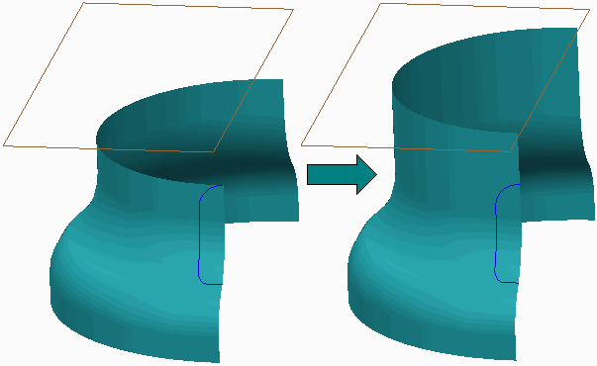

Figure 1 – Extending a Surface to Plane

### Trimming Surfaces

A surface trim is analogous to a solid cut, except that it trims away a portion of a surface. You can create a surface trim as an extrude, revolve, sweep, blend, and so on. You can also trim a selected surface quilt using other geometry such as planes, quilts, and curves or edges.

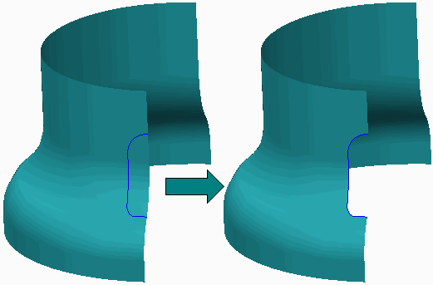

Figure 2 – Trimming a Quilt using Geometry

Once you have specified the surface to be trimmed and the entity to do the trimming, you must specify which side is to be kept. You can opt to keep one side, the other side, or both sides.

### Copying and Pasting Surfaces

Copying and pasting surfaces enables you to create an overlay of a surface so that you can then perform manipulations to the copied surface. You can copy and paste any surface or surface set, either from a quilt or a solid. You can use either CTRL+C and CTRL+V or the **Copy Copy ** and **Paste Paste ** icons from the Operations group in the ribbon. You should only use the Copy functionality in situations where you do not have proper references to create the parting surfaces. The copy functionality can result in a lot of surface features, especially when you are working with a complex design.

### Offsetting Surfaces

You can create a surface quilt offset a distance value from another quilt or a solid surface. The offset surface remains dependent on the original surface. When offsetting surfaces, you can specify the fit type as either Normal to Surface, Automatic Fit, or Controlled Fit.

### Mirroring Surfaces

You can transform a surface quilt by mirroring it. To mirror a quilt, select the quilt and

Mirror 

click **Mirror** , specifying a reference plane for the mirror. A new surface feature is created.

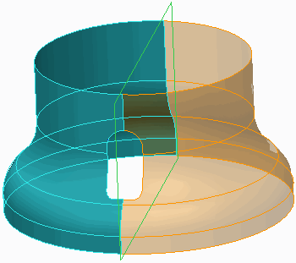

Figure 3 – Mirroring a Quilt

### Merging Surfaces

You can merge two or more intersecting or adjacent quilts to create surfaces with 2-sided edges. Merging surfaces is covered more in depth in other topics.

1. **Merging Surfaces**

You can merge two or more intersecting or adjacent quilts. Merging a quilt makes it selectable as a single entity for other operations, and is required for operations such as creating solids from quilts.

Remember the following:

* Surfaces are shown using orange and purple highlighting on the edges.
* Orange denotes outer or one-sided edges.
* Purple denotes inner or two-sided edges because they border two surface patches. Therefore:
* Merging a surface results in the creation of two-sided edges from one-sided edges. In

Figure 2, the adjacent quilt surface edges are separate, one-sided edges, as they display in orange.

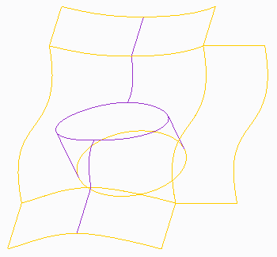

Figure 2 – Surfaces Edge Display of Separate Quilts

In Figure 3, the quilts have been merged to form two-sided, purple edges.

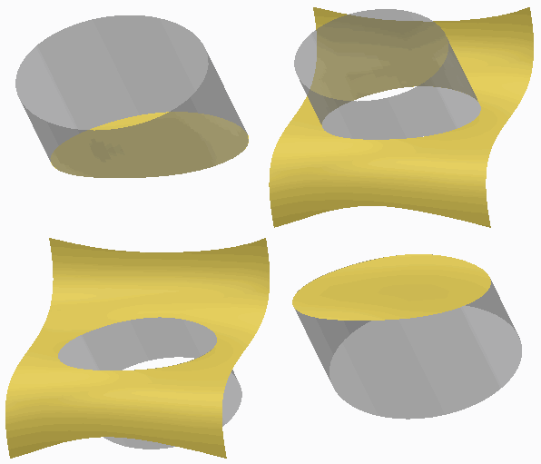

Figure 1 – Surface Merge Keep Options

* Merged surface edges appear in purple.

### Merge Options

There are two types of merge operations, used for different surface geometry:

* Intersect – Primarily used for intersecting quilts, when a trimming effect is desired, although it can be used on adjacent quilts. The Intersect option provides up to two flip arrows, enabling four possible geometry outcomes, as shown in Figure 1.

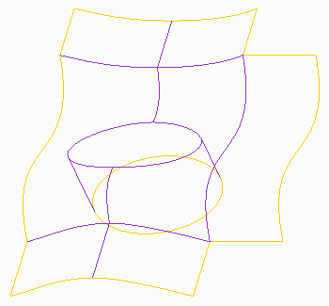

Figure 3 – Surface Edge Display of Merged Quilts Intersect is the default merge option.

* Join – Recommended for use on adjacent quilts. Join can also be used to join surfaces

when no trimming effect is desired. For example, you could join two surfaces that meet in a “T,” without having to decide which sides to keep.

1. **Creating a Shadow Surface**

A shadow surface is another type of parting surface you can create automatically.

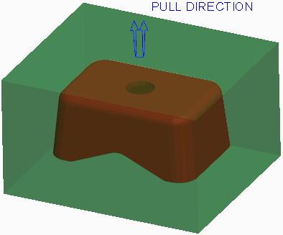

Figure 1 – Viewing Mold Model

The Shadow Surface tool drapes a parting surface on top of the reference part geometry.

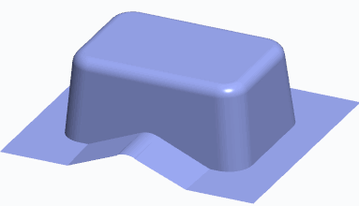

Figure 2 – Viewing a Shadow Surface

The following are prerequisites for creating a shadow surface:

* The workpiece must be visible (it cannot be hidden or blanked).
* The model must be completely drafted.

### Comparison of Shadow Surfaces and Skirt Surfaces

Because both skirt surfaces and shadow surfaces can be used to automatically create a parting, consider the following comparisons:

* The skirt surface requires a silhouette curve while a shadow surface does not.
* The skirt surface may have vertical surfaces because the silhouette curve determines the upper or lower loop of the non-drafted sections. Since the shadow surface does not use a silhouette curve, a design model must be fully drafted.
* With the skirt surface, you can exclude segments that fail. The shadow surface has no option to exclude failed segments.
* There is no extension control with the shadow surface. You cannot extend curves, specify tangent conditions, or modify extension directions.

### Shadow Surface Options

The following options are available when creating a shadow surface:

* Boundary Reference – Defines the outer limits of the shadow surface. Depending on the reference model and workpiece, you may have to specify the workpiece as the boundary reference.
* Direction – Specifies the direction that the shadow surface is draped onto the reference model. By default, the direction is opposite that of the pull direction.
* Clip Plane – Specifies the location where the shadow surface stops.
* Loop Closure – Specifies the loops that the shadow surface closes. By default, the system closes all inner loops of the reference model, but you can select specific loops if desired.
* ShutOff Ext – Enables you to specify the amount of extension toward the boundary references that the shadow surface will undergo before stopping, extending in the pull direction, and finally stopping at the boundary references.

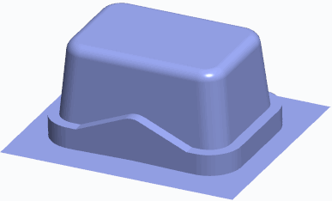

Figure 3 – Specifying a ShutOff Extension

When the shadow surface extends outward, it stops either at the boundary references or a shutoff extension, whichever it encounters first. If the selected boundary falls outside of the boundary references, the shadow surface will stop at the boundary references. There are two methods available for specifying the shutoff extension location:

* ShutOff Dist – Specifies a uniform offset value around the reference model perimeter that the shadow surface will extend.
* Boundary – Enables you to specify your own boundary that the shadow surface will extend out to. You can use either of the following two methods to specify the boundary:
* Select – Enables you to select an existing sketch as the boundary.
* Sketch – Enables you to sketch the boundary on-the-fly by specifying the sketch plane, reference plane, and reference direction.

Regardless of which boundary method is used, the boundary must form a closed loop. It is not necessary for the boundary to be located on a specific sketching plane or even a sketching plane that is perpendicular to the pull direction. However, the boundary is ultimately extended in the pull direction, so if the boundary is created on a plane that is not normal to the pull direction, you may not get the expected result.

* Draft Angle – Used in conjunction with the ShutOff Extension option, the draft angle option drafts the Z-direction surfaces of the shutoff extension by the specified draft angle value. Specifying a draft angle is optional.
* ShutOff Plane – Used in conjunction with the ShutOff Extension option, the shutoff plane is the planar reference that the shutoff extension extends to. The shutoff plane is optional for a shadow surface, but it is a required reference if a shutoff extension is defined.
* Shadow Slides – Enables you to specify mold volumes to attach to the reference model. The resulting shadow surface drapes over the specified mold volumes. Like the reference model, the mold volume must be fully drafted to successfully create the shadow surface.

# Exercise: Creating Parting Surfaces using Shadow Surfaces



#### Procedure Setup:



**Objectives**

* Create parting surfaces using the Shadow Surface feature.
* Create parting surfaces by using basic surface creation tools.
* Modify surfaces by using various editing tools.

#### Scenario

In this exercise, you use manual surface creation techniques to create parting surfaces in the mouse mold model.

#### 1. Task 1. Create the first parting surface.

1. Disable all Datum Display types.
2. Orient to the 3D view orientation.
3. Click **Parting Surface Parting Surface ** from the Parting Surface & Mold Volume group.
4. Rename the parting surface feature by doing the following:

* Click in the graphics window.
* Right-click and select **Properties**.
* Type **INSERT** as the Name of the parting surface and press ENTER.

1. Click the Surfacing group drop-down menu and select **Shadow Surface**.

* In the Shadow Surface dialog box, double-click **Direction**.
* As oriented, select the top workpiece surface.

Figure 1 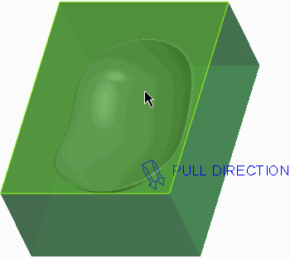

1. Click **Okay** from the menu manager.
2. Click **Preview** from the Shadow Surface dialog box.
3. Click **Repaint Repaint ** from the In Graphics toolbar.

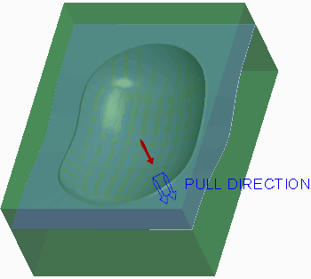

Figure 2

1. In the Shadow Surface dialog box, double-click **ShutOff Ext**.
2. In the menu manager, click **Boundary > Select > One By One**.
3. Zoom in on the reference model, press CTRL, and select the four inner edges.

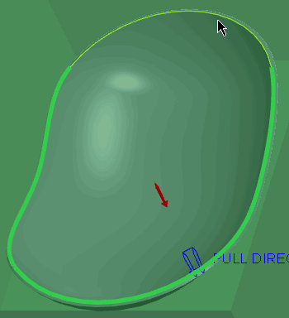

Figure 3

1. Click **Done** from the menu manager.
2. In the Shadow Surface dialog box, double-click **ShutOff Plane**.
3. Click **Plane** from the Datum group.Plane 
4. As oriented, select the top workpiece surface.
5. Drag the datum plane down and edit the Translation value to **25.4**.

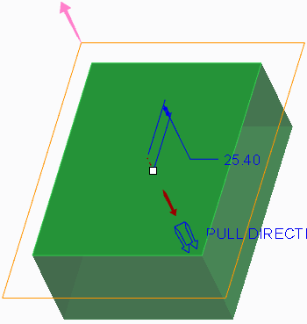

Figure 4

1. Click **OK** from the Datum Plane dialog box.
2. Click **Done/Return** from the menu manager.
3. Click **OK** from the Shadow Surface dialog box.
4. Orient to the **Standard Orientation**.
5. Click in the graphics window to de-select all features.

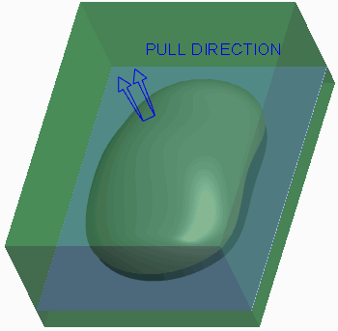

Figure 5

#### 2. Task 2. Create an extruded surface.

1. Click **Extrude Extrude ** from the Shapes group.
2. Query-select the bottom side of the workpiece as the Sketch Plane.
3. Click **References References ** and select datum plane MOLD_FRONT as an additional reference.

* Click **Close**.

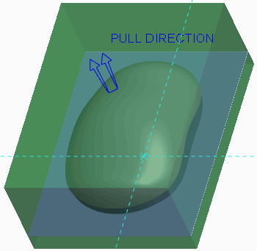

Figure 6

1. Enable only the following Sketcher Display types: .Center Rectangle 
2. Select **Center Rectangle** from the Rectangle types drop-down menu in the Sketching group and sketch a rectangle symmetric about both references.
3. Click **One-by-One One-by-One ** and edit the horizontal dimension to **190.5** and the vertical dimension to **254**.

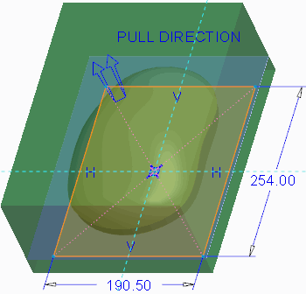

Figure 7

1. Click **OK** .OK 
2. Right-click the depth handle and select **To Selected**.
3. Select the flat surface as the depth reference.

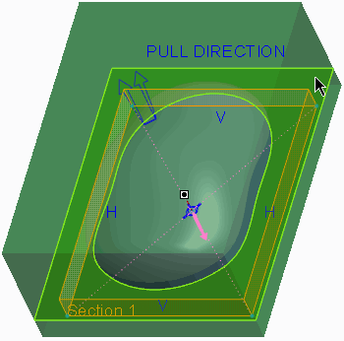

Figure 8

1. Click **Complete Feature** .Complete Feature 
2. Orient to the 3D view orientation to inspect the surface you have created.

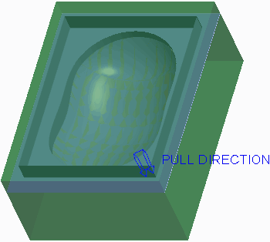

Figure 9

1. Orient to the **Standard Orientation** when finished.

#### 3. Task 3. Merge the two surfaces.

1. Select the shadow surface quilt.

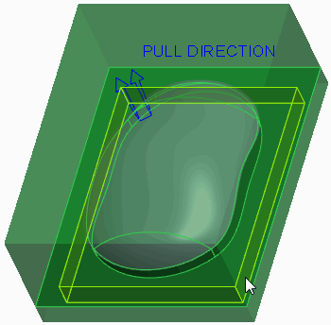

Figure 10

1. Press CTRL and query-select the extruded surface quilt.
2. Click **Merge** from the Editing group.Merge 
3. In the dashboard, select the **Options** tab.

* Verify that the **Intersect** option is selected as the merge type.

1. In the dashboard, click **Change First Quilt Side Change First Quilt Side ** as necessary until the correct final geometry displays, as shown.

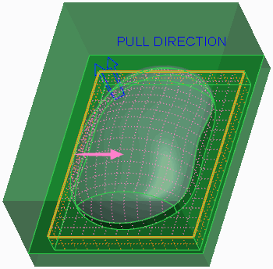

Figure 11

1. Click **Complete Feature** .Complete Feature 
2. Click **OK** from the Controls group.OK 

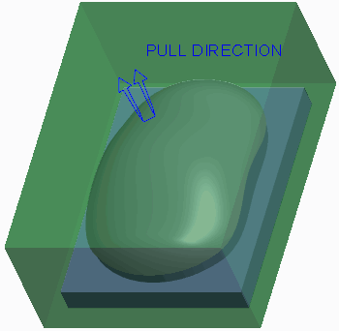

Figure 12

#### 4. Task 4. Create the second parting surface.

1. Click **Parting Surface Parting Surface **.
2. Rename the parting surface feature by doing the following:

* Click **Properties Properties ** from the Controls group.
* Type **MAIN** as the Name of the parting surface and press ENTER.

1. Click the Surfacing group drop-down menu and select **Shadow Surface**.

* Click **OK**.

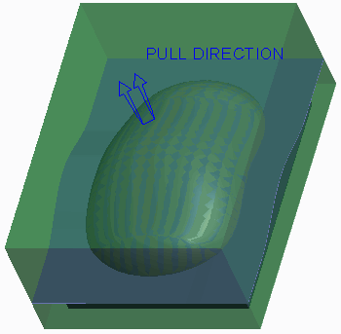

Figure 13

1. Click **OK** .OK 
2. Click **Save Save ** from the Quick Access toolbar.
3. Click **File > Manage Session > Erase Current**, click **Select All** , and click **OK** to erase the model from memory.Select All 

**This completes the exercise.**

1. **Creating a Parting Surface Manually**

Sometimes the silhouette curve and skirt surface features do not provide you the desired parting surface shape.

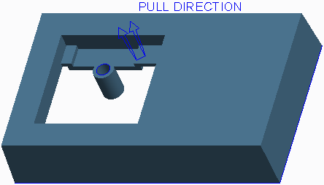

Figure 1 – Mold Model Before Manual Parting Surfaces Created

You can create the parting surface manually in these types of circumstances. You may also use a combination of a skirt surface and manual parting surface for a mold model. The skirt surface can be used for the parting surface in the locations where the proper geometry has been created, and a manual parting surface can be created in areas where the skirt surface does not provide the desired shape.

To create a parting surface manually, you can click **Parting Surface Parting Surface ** from the Parting Surface & Mold Volume group and then use the various basic and advanced surface creation techniques. Each of the surfaces created belongs to the parting surface feature. You can also use the various editing and manipulation tools on the surfaces.

After all surfaces have been created for a given loop area in the mold model, you must use **Merge Merge ** to merge the surfaces together before completing the parting surface feature.

In Figure 2, a total of three surfaces were created to close the loop and create the parting surface.

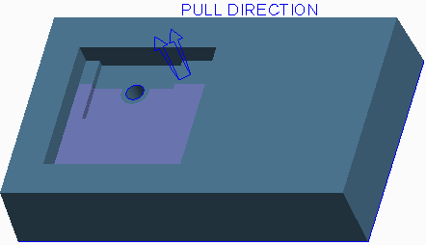

Figure 2 – Manual Parting Surface Created

Two surfaces are fill surfaces, and the third surface is an extruded surface. Once all three surfaces were created they were merged together. At this point the silhouette curve could be used to create the outer loop of the parting surface and to fill the hole shutoff in the boss.

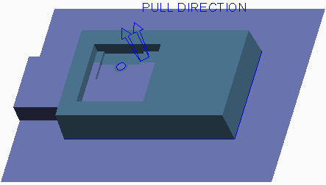

Figure 3 – Skirt Surface Used to Generate Other Parting Surface

## Creating Saddle Shutoff Surfaces

To handle a saddle shutoff within the part, you must create the surfaces which represent the shutoff faces. A saddle shutoff is a bit more challenging than the parting line surface or a face shutoff because you generally need several surfaces to form the required shape. Typically, you create the saddle surface and then create the face surfaces.

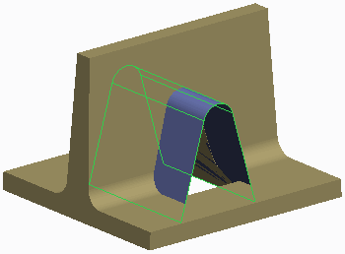

Figure 1 – Saddle Surface Created

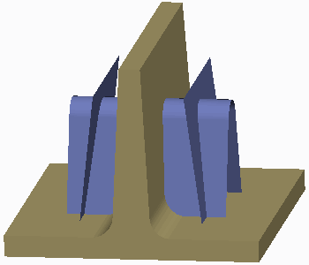

Figure 2 – Face Surfaces Created

You can extrude or revolve the surfaces, or use more advanced geometry creation methods like blended surfaces, depending on the desired geometry. You can even copy existing surfaces and paste them. You can then manipulate these surfaces by extending, trimming, and offsetting them if needed.

Once the saddle surface and face surfaces have been created, you must merge the surfaces together to form the required shape.

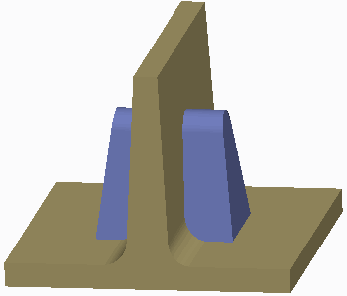

Figure 3 – Final Saddle Shutoff

*To create surfaces for saddle shutoffs, it is beneficial to use existing geometry edges and surfaces as references for your surfaces. However, remember that if you use existing geometry, your surfaces become dependent on that geometry.*

1. **Creating Fill Surfaces**

During parting surface creation, you can fill a sketch to create a planar surface.

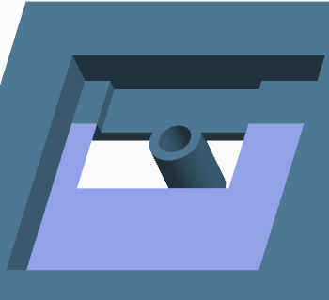

Figure 1 – Creating a Fill Surface

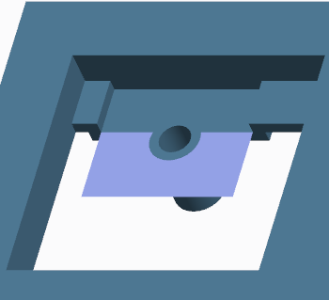

Figure 2 – Creating a Second Filled Surface

You can either select the sketch first and then start the Fill tool, or start the Fill tool and then select the sketch. If you select the sketch first and then start the Fill tool, the feature is automatically completed.

The following are important points about the sketches used by the Fill tool:

* The sketch must be a sketched curve, and it can be either an internal or external sketch.
* The sketch must be closed. However, it can contain multiple loops.
* The sketch can be any shape. That is, it can contain either tangent or non-tangent entities.
* The sketch may reference other geometry.

Because you are using the Fill tool to fill gaps in the reference model during parting surface creation, you will often be referencing other geometry, whether edges or surfaces of the reference model or workpiece, or edges of other parting surfaces. Usually the resulting planar surface is part of a larger parting surface, and thus the filled surface must be merged with the other portions of the parting surface.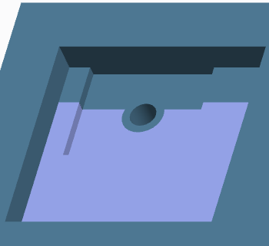

Figure 3 – Final Parting Surface Created

1. **Extending Curves**

You can select curves or edge chains on the reference model to extend and create a parting surface. You must specify the reference model so that the system can identify which curves are available for selection. You must also specify the boundary reference (usually the workpiece) to instruct the system on how far to extend the specified curves.

The following extension directions are available for the selected curves:

* Normal to the Pull Direction – All specified curves are extended normal to the pull direction.

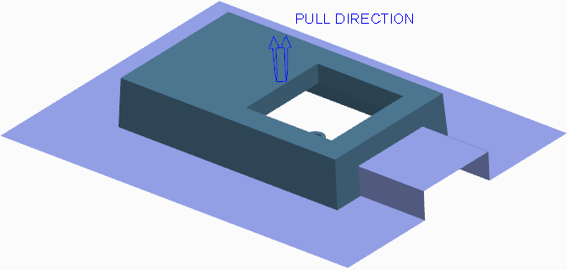

Figure 1 – Extending Curves Normal to Pull Direction

There are two additional options you can select from when curves extend normal to the pull direction:

* Perpendicular to reference model – The specified curves extend normal to the pull direction and perpendicular to the adjacent reference model surfaces.
* Perpendicular to boundary – The specified curves extend normal to the pull direction and perpendicular to the surfaces of the defined boundary reference model (usually the workpiece).
* Parallel to the Pull Direction – All specified curves are extended parallel to the pull direction.
* Tangent to the Model – All specified curves are extended tangent to the adjacent reference model surfaces

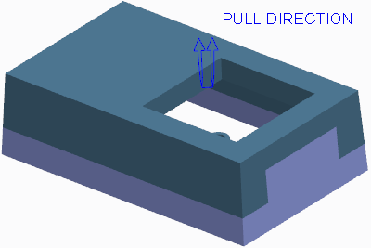

Figure 2 – Extending Curves Tangent to the Model

* Under Defined Direction – All specified curves extend normal to the direction reference you specify.

Optionally, you can enable the system to create surface transitions across gaps in the extended edges.

You can also define multiple extensions for a given operation. You can define one set of edges to be extended in a specific direction and define a different set of edges to be extended in a different direction.

### Shut Off Types

When extending edges, you can choose to add a shut off if desired within the Shut Off tab of the dashboard. The following shut off types are available:

* Boundary – The default type, the Boundary type extends the edges in the specified direction, out to the defined boundary reference model.
* Distance – Enables you to specify a distance outward that the curves extend from the reference model before they stop and extend in the pull direction. With the Distance shut off type, you can also specify a Shut Off Plane. Rather than extending the curves in the pull direction out to the workpiece boundary, the curves instead stop at the defined shut off plane reference.

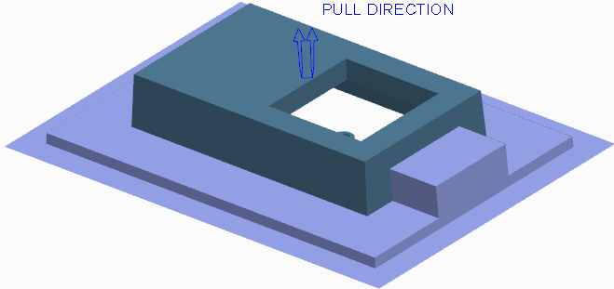

Figure 3 – Adding a Distance Shut Off

Additionally, you can draft the surfaces extended in the pull direction by specifying a draft angle.

* To a Reference – Enables you to specify a sketch that the curves extend from the reference model before they stop and extend in the pull direction. With the To a Reference type, you can also specify a Shut Off Plane. Rather than extending the curves in the pull direction out to the workpiece boundary, the curves instead stop at the defined shut off plane reference. Additionally, you can draft the surfaces extended in the pull direction by specifying a draft angle.

1. **Filling Loops**

You must fill any closed loops in the reference model with a surface that acts as the parting surface for the given loop. You can use the **Fill Loops Fill Loops ** tool to manually specify the reference chain that forms the loop to be filled.

The following types of fill loop surfaces can be created:

* Surface – The system fills in the specified loop with a surface.

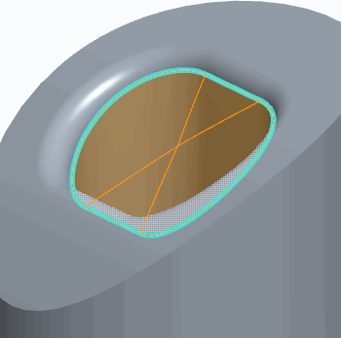

Figure 1 – Surface Loop Type

Depending on the surrounding contours, the resulting surface may not suffice for a parting surface.

* Fit a mid-plane – The system creates a planar surface at the midpoint of the selected loop references. The surface is created parallel to the surface or datum plane you specify.

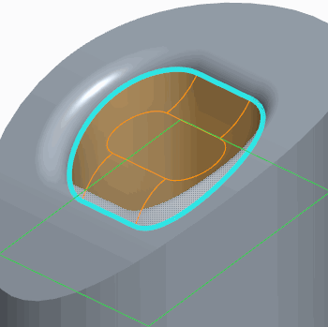

Figure 2 – Fit a Mid-Plane Loop Type

The shape of this surface is based on the loop shape. You can also specify an offset from the references.

* Fit a mid-plane automatically – The system creates a planar surface at the midpoint of the selected loop references, normal to the pull direction.

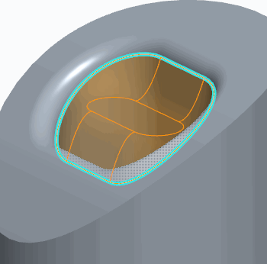

Figure 3 – Fit a Mid-Plane Automatically Loop Type You can specify an offset from the references.

* Fit a mid-surface – The system creates a planar surface at the midpoint of the selected

loop references. The surface is created through the selected surface. The selected surface does not need to be planar. You can specify an offset from the references.

* Extend to plane – The system extends the selected loop reference edges up to the selected planar surface and caps the end.
* Extend to surface – The system extends the selected loop reference edges up to the selected surface and caps the end. The capped end shape takes on that of the selected surface, which does not need to be planar.

1. **Creating Shut Offs**

You must fill any loops in the reference model with a surface that acts as the parting surface for the given loop. You can use the **Shut Off Shut Off ** to fill both open and closed holes in the reference model.

To create the shut off, you must specify the following:

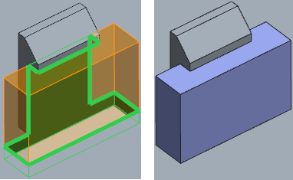

Figure 1 – Creating a Shut Off

* Reference Surfaces – Specifies the surfaces that define the perimeter of the loops you wish to close.
* Shut Off Loops – Enables you to select the edges of the specified reference surfaces that define the desired loop.

### Closing All Internal Loops

You can select the Close all internal loops check box to automatically fill all closed holes within the selected reference surfaces.

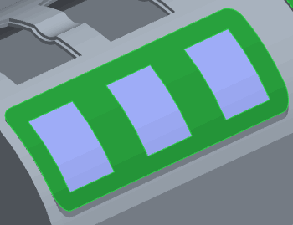

Figure 2 – Closing All Internal Loops

When this option is selected, it is not necessary to select the shut off loop edges. If desired, you can also exclude individual holes from the shut off operation.

### Capping Open Loops

The Shut Off tool enables you to also fill open loops in the reference model by specifying a cap surface. The cap surface closes the open loop so that it can be filled with the parting surface. 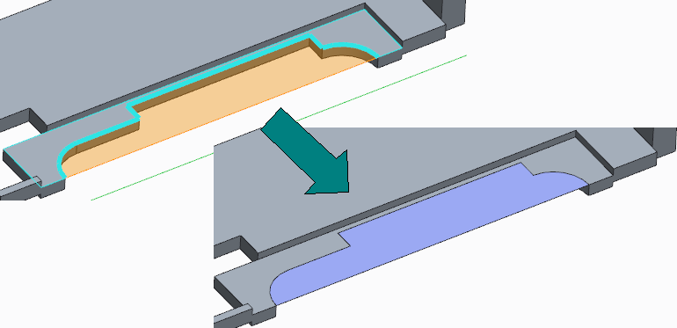

Figure 3 – Capping an Open Loop

The specified cap surface(s) must pass through the ends of the open loop. If a surface is not available, you can create a datum plane to define the cap surface.

# Exercise: Creating Parting Surfaces Manually





#### Objectives

* Create parting surfaces by extending curves.
* Create parting surfaces using the Fill feature.
* Create parting surfaces using basic surface creation tools.
* Modify surfaces using various editing tools.

#### Scenario

In this exercise, you use manual surface creation techniques to create parting surfaces in the mouse mold model.

#### 1. Task 1. Create the first parting surface.

1. Disable all Datum Display types.
2. Click **Parting Surface** from the Parting Surface & Mold Volume group.Parting Surface 
3. Rename the parting surface feature by doing the following:

* Click **Properties Properties ** from the Controls group.
* Type **MAIN** as the Name of the parting surface and press ENTER.

1. Copy the top three rounded surfaces of the mouse mold by doing the following:

* Right-click to query and select the MOUSE_REF.PRT model in the graphics window.

Figure 1 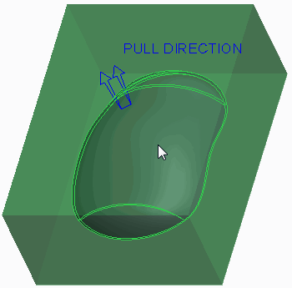

1. Select the top surface, press CTRL, and query-select the two remaining surfaces, as shown.

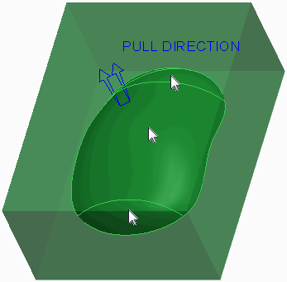

Figure 2

1. Press CTRL+C and press CTRL+V.
2. Click **Complete Feature** .Complete Feature 
3. Click in the graphics window to de-select all features.
4. Extend the edges of the reference model by doing the following:Extend Curve 

* Click **Extend Curve** from the Surfacing group.
* Press CTRL and select the four edges of the reference model.
* Notice the angled edges between the four surfaces in the preview.

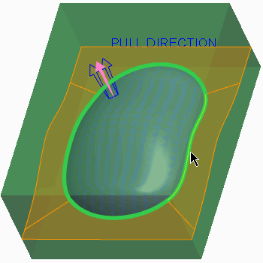

Figure 3

1. In the dashboard, select the **References** tab.
2. Notice that the Boundary Reference is the workpiece.

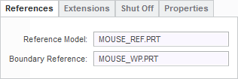

Figure 4

1. In the dashboard, select the **Extensions** tab.
2. Select **Perpendicular to boundary** as the extension type.
3. Notice that the edges of the four surface extensions are now perpendicular to the workpiece (boundary reference) surfaces.

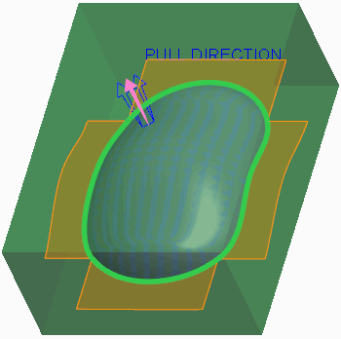

Figure 5

1. In the dashboard, select the **Create Transitions** check box.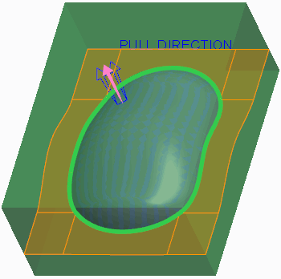

Figure 6

1. Click **Complete Feature** .Complete Feature 
2. Click in the background to de-select all geometry.
3. In the model tree, right-click MOUSE_WP.PRT and select **Hide Hide **.
4. From the In Graphics toolbar, select **No Hidden** from the Display Style types drop- down menu.No Hidden 
5. Notice that the two surfaces are not joined to each other.

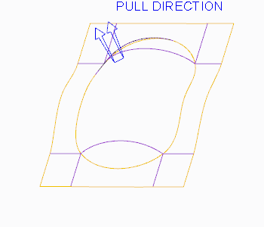

Figure 7

1. Select the rounded quilt from the three copied surfaces.
2. Press CTRL and select the quilt created from the extended curves.
3. Click **Merge Merge ** from the Editing group.
4. Click **Complete Feature** .Complete Feature 

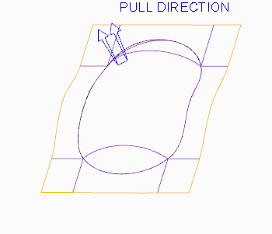

Figure 8

1. Select **Shading** from the Display Style types drop-down menu.Shading 
2. Click **OK** from the Controls group.OK 

#### 2. Task 2. Create the second parting surface.

1. In the model tree, select **Copy 1**, right-click, and select **Hide Hide **.
2. Orient to the 3D view orientation.
3. Click **Parting Surface Parting Surface **.
4. Rename the parting surface feature by doing the following:

* Click in the graphics window.
* Right-click and select **Properties**.
* Type **INSERT** as the Name of the parting surface and press ENTER.

1. Copy the three rounded surfaces on the underside of the mouse mold by doing the following:

* Select the MOUSE_REF.PRT model in the graphics window.

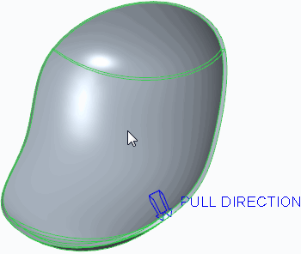

Figure 9

1. Select the top surface, press CTRL, and query-select the two remaining surfaces, as shown.

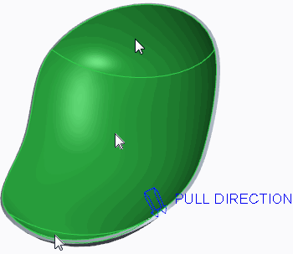

Figure 10

1. Press CTRL+C and press CTRL+V.
2. Click **Complete Feature** .Complete Feature 
3. Click in the graphics window to de-select all features.
4. Extend the edges of the reference model by doing the following:Extend Curve 

* Click **Extend Curve** .
* Press CTRL and select the four inner edges of the reference model.

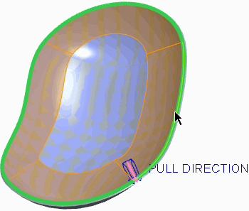

Figure 11

1. In the dashboard, select **Parallel to the Pull Direction** from the Direction drop-down list.

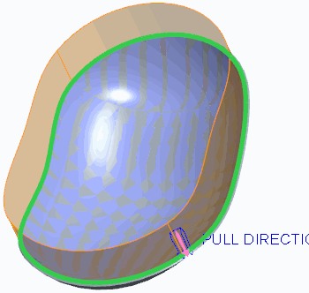

Figure 12

1. Click **Complete Feature** .Complete Feature 
2. Select the rounded quilt from the three copied surfaces.
3. Press CTRL and select the quilt created from the extended curves.
4. Click **Merge Merge ** from the Editing group.
5. Click **Complete Feature** .Complete Feature 

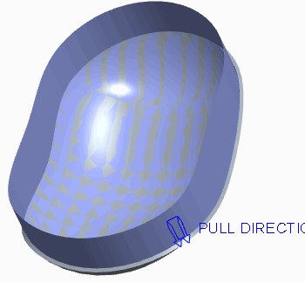

Figure 13

1. Right-click MOUSE_WP.PRT and select **Unhide** .Unhide 
2. Click in the background to de-select all geometry.
3. Click **Fill Fill ** from the Surfacing group.Datum Plane 
4. Click **Datum** from the dashboard and click **Plane** .
5. As oriented, select the top workpiece surface.
6. Drag the datum plane down and edit the Translation value to **25.4**.

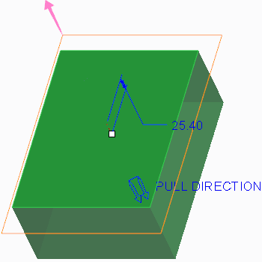

Figure 14

1. Click **OK**.
2. Click **Resume Feature Resume Feature ** from the dashboard.
3. Enable only the following Sketcher Display types: .Project 
4. Click **Project** from the Sketching group.
5. Select all four top edges of the workpiece.

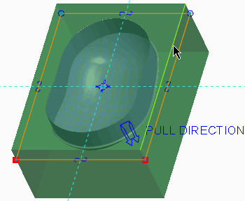

Figure 15

1. Click **OK** .OK 

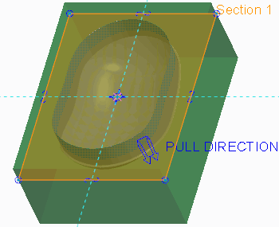

Figure 16

1. Click **Complete Feature**Complete Feature 
2. In the model tree, press CTRL and select **Merge 2** and **Fill 1**.
3. Click **Merge Merge **.
4. Click **Complete Feature** .Complete Feature 

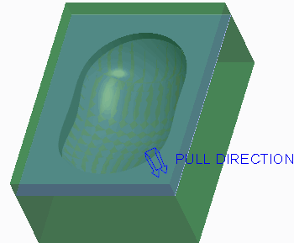

Figure 17

#### 3. Task 3. Create an extruded surface.

1. Click **Extrude Extrude ** from the Shapes group.
2. As oriented, select the top workpiece surface as the sketching plane.

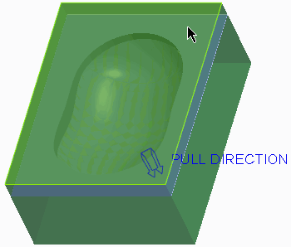

Figure 18

Center Rectangle 

1. Select **Center Rectangle** from the Rectangle types drop-down menu in the Sketching group.
2. Sketch the rectangle so that its center is located on the coordinate system reference.
3. Click **One-by-One One-by-One ** from the Operations group.
4. Edit the rectangle width to **190.5** and the rectangle height to **254**.

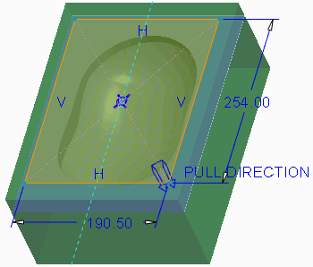

Figure 19

1. Click **OK** .OK 
2. Right-click the depth handle and select **To Selected**.
3. Select the fill surface as the depth reference.

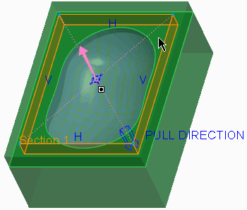

Figure 20

1. Click **Complete Feature** .Complete Feature 
2. Click in the graphics window to de-select all features.
3. In the model tree, press CTRL and select **Merge 3** and **Extrude 1**.
4. Click **Merge** .Merge 
5. Click **Complete Feature** .Complete Feature 

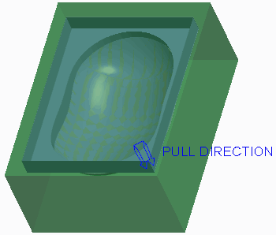

Figure 21

1. Click **OK** from the Controls group.OK 
2. Orient to the **Standard Orientation**.

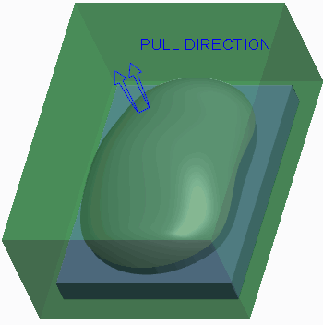

Figure 22

1. In the model tree, right-click **Copy 1** and select **Unhide** .Unhide 



Figure 23

1. Click **Save Save ** from the Quick Access toolbar.
2. Click **File > Manage Session > Erase Current**, click **Select All** , and click **OK** to erase the model from memory.Select All 

**This completes the exercise.**

**8. Splitting Mold Volumes**

#### Module Overview:

After the necessary mold volumes and parting surfaces have been created, you must split the workpiece and mold volumes at the parting surface into the final core, cavity, and slider volumes, as well as any other volumes that are to become mold components in the final mold.

In this module, you learn how to split the workpiece and mold volumes, as well as how to blank and unblank mold items in the mold model.

#### Objectives:

After completing this module, you will be able to:

* Split the workpiece.
* Split mold volumes.
* Split volumes using multiple parting surfaces.
* Blank and unblank mold items.
* Use split classification to generate resulting mold volumes.

## Splitting the Workpiece

You can split or divide the workpiece with the All Wrkpcs split option by using a parting surface or a mold volume. When the workpiece split is performed, Creo Parametric calculates the total volume of the workpiece and creates a mold volume from it. The system then subtracts, or trims, the reference model geometry and any mold features such as gates, runners, and sprues from the workpiece volume and creates a Refpart Cutout feature in the model tree (this Refpart Cutout feature displays in the model tree differently than a reference part cutout operation that is performed on a mold volume).

The remaining mold volume is then split at the specified parting surface or mold volume.

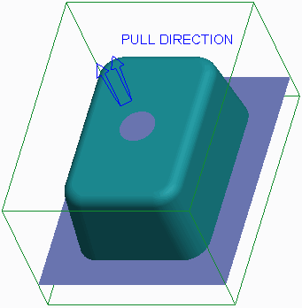

Figure 1 – Mold Model and Parting Surface

The system trims the amount of workpiece volume to one side of the parting surface or mold volume and turns that volume into its own mold volume. If applicable, the system also trims the amount of workpiece volume on the other side of the parting surface or mold volume and turns that volume into its own mold volume. A simple mold model containing only a core and cavity is a typical example. One of the mold volumes becomes the core, and the other the cavity.

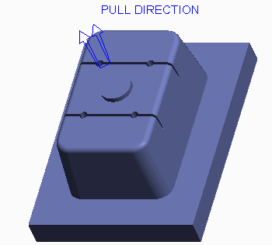

Figure 2 – Split Mold Model Core Volume

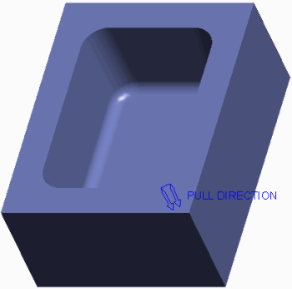

Figure 3 – Split Mold Model Cavity Volume

### One Volume or Two?

For each split operation you must determine how many resultant mold volumes are to be created by specifying one of the following options :

* Two Volumes — Splits the workpiece into two mold volumes.
* One Volume — Splits the workpiece into a single mold volume, discarding the other portion. You must specify which portion you want included in the mold volume. You can do this using the Island List. The Island List enables you to select which portion to include in the new volume. When you cursor over an island in the list, the corresponding geometry highlights blue in the graphics window.

Regardless of how many volumes are created, the system prompts you to name each one. You can determine the volume to be created by shading it. The system hides all the other volumes at this time, and creates a mold volume with the name you specify.

### Workpiece Splitting Guidelines

Consider the following guidelines when splitting the workpiece:

* A split operation in a mold model using the All Wrkpcs option is typically only performed one time.
* Splitting a workpiece does not modify its geometry. Whenever a workpiece is split, the system copies the volume occupied by the workpiece and creates a mold volume from it.
* If you split a workpiece by a parting surface, the system modifies the existing volume. That is, a volume is split and either one or two volumes are created in place of the original volume.
* Splitting the workpiece with parting surfaces ensures that these solid mold components add up to the desired volume, with no extra or missing pieces.
* If you split the workpiece by a parting surface, the parting surface must completely intersect the workpiece.
* If you split a workpiece by another volume, the original volumes are not modified. Rather, the original volumes are copied and then split. For example, if you use the Mold Volume, Two Volumes option and split mold volume A using mold volume B, there will be a total of four mold volumes after the split: original volumes A and B, and new volumes C and

D. One of the new mold volumes C or D will be identical to the splitting mold volume B. As a result, you should use the One Volume option when splitting by a mold volume. This way, when you split mold volume A with mold volume B, you end up with a total of three mold volumes: original volumes A and B, and new volume C. New volume C is equivalent to volume A minus volume B. Using the One Volume option avoids redundant volumes and keeps the number of mold volume features down in the model tree.

* Name all resultant mold volumes appropriately, as this will help you determine which mold volumes to create solid mold components from later on. For example, if the mold volume will become the core mold component, name it “core_vol”.

1. **Splitting Mold Volumes**

You can split an existing mold volume in a mold model using the Mold Volume split option. This option is only available if the workpiece has already been split, or if you have sketched a mold volume slider, insert, or lifter, for example. Unlike the All Wrkpces option, when a mold volume is split, the system does not create a reference part cutout in the model tree.

When you specify the Mold Volume option, the system uses the Search Tool to perform a search for all quilts (mold volumes) in the mold model. You must specify the desired quilt (mold volume) to be split from the list of results found. You should not modify the parameters of the Search Tool to obtain different results.

A mold model containing sliders, inserts, or lifters needs to undergo multiple split operations because multiple mold components will be created from the mold model.

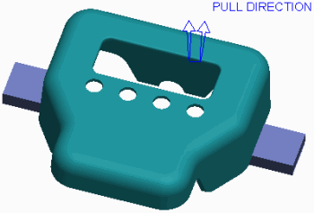

Figure 1 – Mold Model and Slider Volumes

### One Volume or Two?

For each split operation you must determine how many resultant mold volumes are to be created by specifying one of the following options:

* Two Volumes — Splits the mold volume into two mold volumes.
* One Volume — Splits the mold volume into a single mold volume, “discarding” the other portion. You must specify which portion you want included in the mold volume. This is done using the Island List. The Island List enables you to select which portion is to be included in the new volume. When you hover over an island in the list, the corresponding geometry highlights blue in the graphics window.

Regardless of how many volumes are created, the system prompts you to name each one. You can determine the volume to be created by shading it. The system hides all the other volumes at this time, and creates a mold volume with the name you specify.

### Creating Intermediate Mold Volumes

Depending on the mold model and its complexity, not every mold volume created will be used to create a final solid mold component. It may be necessary to create “intermediate”, or temporary mold volumes during splitting operations. For example, if you split the workpiece into the core and cavity volumes, but the core volume must further be split to remove a slider volume, you create an intermediate core volume.

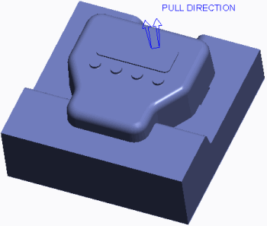

Figure 2 – Core Volume Before it is Split for Slider Volumes

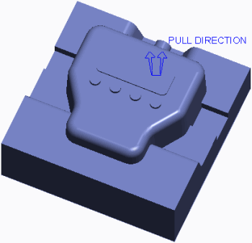

Figure 3 – Core Volume After Splits for Slider Volumes

### Mold Volume Splitting Guidelines

Consider the following guidelines when splitting mold volumes:

* When you split a volume by a parting surface, the volume is split at the parting surface and either one or two volumes are created in place of the original volume.
* When you split a volume by another volume, the original volumes are not modified. Rather, the original volumes are copied and then split. For example, if you use the Mold Volume, Two Volumes option and split mold volume A using mold volume B, there will be a total of four mold volumes after the split: original volumes A and B, and new volumes C and D. One of the new mold volumes C or D will be identical to the splitting mold volume B. As a result, you should use the One Volume option when splitting by a mold volume. This way, when you split mold volume A with mold volume B, you end up with a total of three mold volumes: original volumes A and B, and new volume C. New volume C is equivalent to volume A minus volume B. Using the One Volume option avoids redundant volumes and keeps the number of mold volume features down in the model tree.
* When you split the mold volume by a parting surface, the parting surface must completely intersect the mold volume.
* Name all resultant mold volumes appropriately, as this will help you determine which mold volumes to create solid mold components from later on. For example, if a mold volume is used as an intermediate mold volume, name it “temp_mold_vol1”, or something similar so you know later on that it will not be used to create a solid mold component.

# Splitting Mold Volumes





#### 1. Task 1. Split the workpiece and mold volumes of a mold model.

1. Disable all Datum Display types.
2. Select the SPLIT-VOLUMES_WRK.PRT.
3. In the ribbon, select the **View** tab.
4. Click the Model Display group drop-down menu and select **Component Display Style > Wireframe**.
5. Select the **Mold** tab.
6. Notice the skirt parting surface and the two slider mold volumes in the graphics window and model tree.

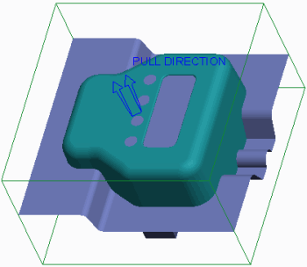

Figure 1

1. Select **Volume Split** from the Mold Volume types drop-down list in the Parting Surface & Mold Volume group.Volume Split 
2. Click **Two Volumes > All Wrkpcs > Done** from the menu manager.
3. Notice that the workpiece has been filled with a mold volume.
4. Select the parting surface from the graphics window and click **OK** from the Select dialog box.

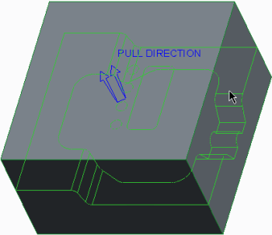

Figure 2

1. Click **OK** from the Split dialog box.
2. In the Properties dialog box, click **Shade**.
3. Click **Wireframe** from the In Graphics toolbar.Wireframe 

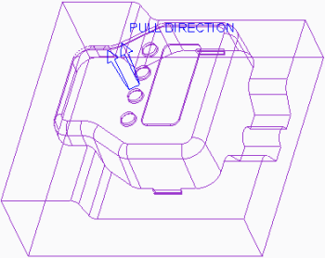

Figure 3

1. Notice that the volume will be the core of the mold, but that it has not taken the slider volumes into account.
2. In the Properties dialog box type **TEMP-CORE_VOL1** and press ENTER.
3. In the Properties dialog box, click **Shade**.
4. Spin the model and notice that this volume will be the cavity of the mold.

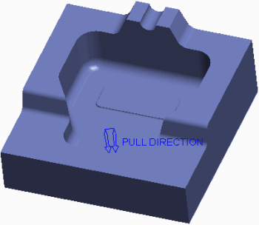

Figure 4

1. In the Properties dialog box, type **CAVITY_VOL** and press ENTER.
2. Orient to the **Standard Orientation**.
3. In the model tree, right-click SPLIT ID 7286 [CAVITY_VOL-MOLD VOLUME] and select **Hide Hide **.Volume Split 
4. Click **Volume Split** and click **One Volume > Mold Volume > Done** from the menu manager.
5. In the Search Tool dialog box, select the TEMP-CORE_VOL1 quilt and click **Add Item**Add Item 

.

* Click **Close**.

1. Query-select the front slider volume and click **OK** from the Select dialog box.

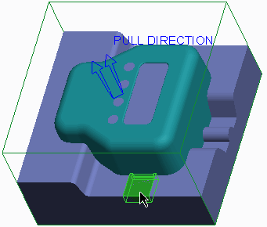

Figure 5

1. In the menu manager, select the **Island 1** check box and click **Done Sel**.

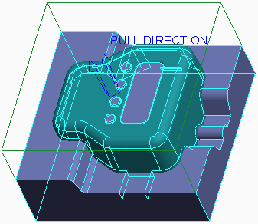

Figure 6

1. Click **OK** from the Split dialog box.
2. In the Properties dialog box, click **Shade** and notice the slider volume has been trimmed from the temporary core volume.

* Type **TEMP-CORE_VOL2** and press ENTER.

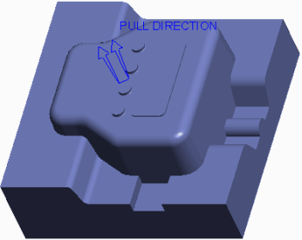

Figure 7

1. Click **Volume Split** and click **One Volume > Mold Volume > Done**.Volume Split 
2. In the Search Tool dialog box, select the TEMP-CORE_VOL2 quilt and click **Add Item**Add Item 

.

* Click **Close**.

1. Query-select the rear slider volume and click **OK** from the Select dialog box.

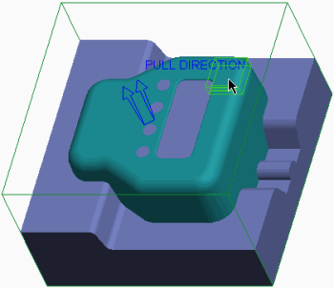

Figure 8

1. In the menu manager, select the **Island 1** check box and click **Done Sel**.

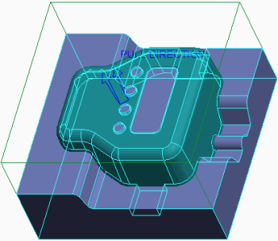

Figure 9

1. Click **OK** from the Split dialog box.
2. In the Properties dialog box, click **Shade** and notice that the slider volume has been trimmed from the final core volume.

* Type **CORE_VOL** and press ENTER.

1. **Splitting Volumes using Multiple Parting Surfaces**

You can use multiple parting surfaces to split volumes in two different ways:

* You can use multiple parting surfaces to split a workpiece or mold volume into multiple mold volumes. You can use one parting surface for one split operation, and specify a different parting surface for a second split operation.

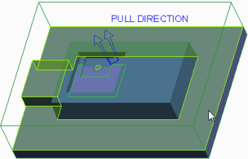

Figure 2 – Selecting Multiple Parting Surfaces

Of course you must also specify the workpiece or mold volume to split and the names of the first and, if applicable, second volumes.

* Sometimes the shape of the reference model and the parting surfaces created require that you specify more than one parting surface during a single split operation. In these circumstances, you can press CTRL in order to select multiple parting surfaces. You can also select multiple mold volumes to split a workpiece or mold volume in a split operation.

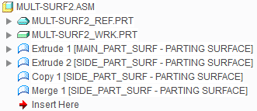

Figure 1 – Model Tree Containing Two Parting Surfaces

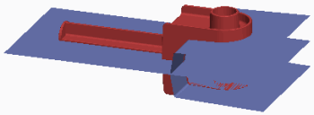

Figure 3 – Viewing Multiple Parting Surface

1. **Blanking and Unblanking Mold Items**

You can blank and unblank mold items at any time during your work in Mold mode. Blank and unblank functionality is similar to hide and unhide functionality. However, unlike the hide-unhide functionality, you do not have to save the blank-unblank status. It is retained for you automatically. Additionally, when a mold item is comprised of multiple features, such as a manually created parting surface, you can blank or unblank the entire parting surface in one operation, rather than having to hide or unhide individual features.

The following items can be blanked and unblanked:

* **Parting surface Parting surface ** — Enables you to blank/unblank any parting surface in the mold model.
* **Volume Volume ** — Enables you to blank/unblank any mold volume, such as sliders, cores, and cavities.
* **Component** — Enables you to blank/unblank the reference model, workpiece, or any other mold component.Component 

You can blank and unblank mold items using the following methods:

* Click **Mold Display Mold Display **, in the View tab, to access the Blank and Unblank dialog box. You can also press CTRL+B to access the dialog box. The Filter Tree in the dialog box enables you to see only the mold item types you want to blank or unblank. You can filter by parting surfaces, volumes, or components. If you click **Parting surface Parting surface **, for example, you will see only the parting surfaces available for selection in the dialog box. When a Component filter option is activated, a series of check boxes becomes available, enabling you to further filter the components displayed in the Blank-Unblank dialog box. The following component items can further be filtered:
* Workpiece
* Ref Model
* Mold Component
* Mold Base Comp
* Gen Assembly
* Molding

The Blank and Unblank dialog box contains a Blank and Unblank tab. Items listed in the Blank tab are those that are visible in the graphics window but available for blanking. If you select an item and click Blank, the item is moved to the Unblank tab of the dialog box. Similarly, the Unblank tab displays all items that are blanked in the graphics window.

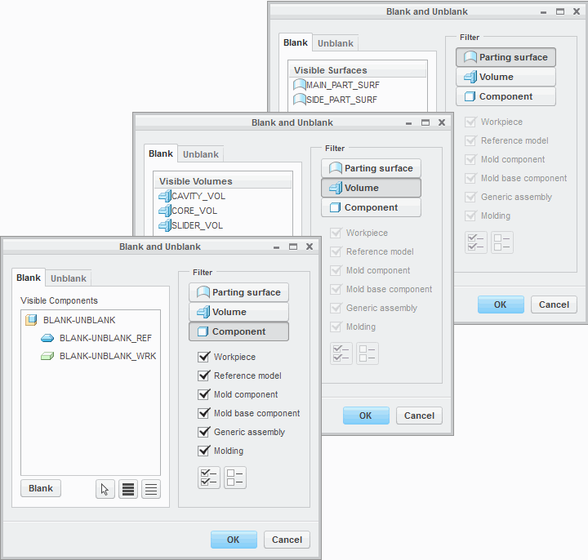

Figure 1 – Blank and Unblank Dialog Boxes

* Select items from the model tree, then right-click and select Blank or Unblank. If the mold item is comprised of numerous features, which can occur for a mold volume or manually created parting surfaces, you must select the first feature to blank or unblank the item. The Blank and Unblank menu selection is only available for the first feature of the mold item.
* Select items from the graphics window, then right-click and select Blank or Unblank.

### Blanking and Unblanking Requirements

Consider the following blanking and unblanking criteria for items in a mold model:

* When splitting the workpiece or mold volume, the parting surface or mold volume used to do the splitting must be unblanked.
* In order to split the workpiece, it must be unblanked. If the workpiece is blanked, the All Wrkpcs split option is grayed out in the menu manager.

1. **Analyzing Split Classification**

When you split a volume, depending upon the shape of the workpiece, the shape of the reference model, and the shape of the parting surface, the split may create several individual closed volumes. When you create a split using the Two Volumes option, each of these volumes must end up as part of one volume or the other. Similarly, when you create a split using the One Volume option, each of these volumes must end up as part of the new volume, or left to remain in the old volume.

Each one of these individual closed volumes occupies an island of space within the mold model. You must specify which islands of space should belong together, or be included, in the resultant mold volume. The process of determining which islands should be included in the resultant mold volume is called *classifying*.

Each of the islands displays in the menu manager Island List. When you hover over a given island in the menu manager, its corresponding volume of space highlights in blue in the graphics window, as shown in Figure 2.

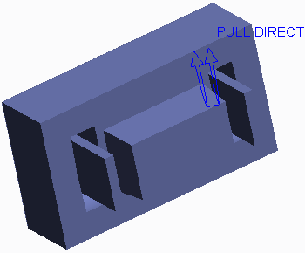

Figure 3 – Resultant Mold Volume

Each of the islands you select from the Island List are included together to comprise the resultant mold volume. The islands that are not selected either end up in the other mold volume (in the case of a Two Volumes split) or discarded (in the case of a One Volume split).

A One Volume split always creates a situation where you must classify the islands to be included in the resultant volume. The reason for this is that regardless of whether you split by a parting surface or by another volume, you must specify which side of the split you want to be included in the resultant volume. You also must classify islands when you specify multiple parting surfaces or mold volumes when splitting a volume.

Classifying islands in a mold model enables you to create simpler manual parting surfaces. In Figure 1, a flat parting surface was used to create the slider mold volume shown in Figure 3.

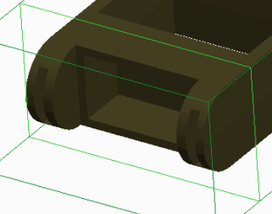

Figure 1 – Viewing Reference Part Geometry

This was done by classifying the islands properly, as shown in Figure 2.

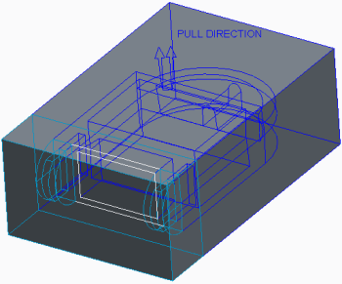

Figure 2 – Classifying Islands

Rather than creating a flat parting surface, you can create a parting surface which completely conforms to the interior of all the cuts in the reference model. You can then split the workpiece using this more complex parting surface and not have to classify islands. The parting surface would look like this:

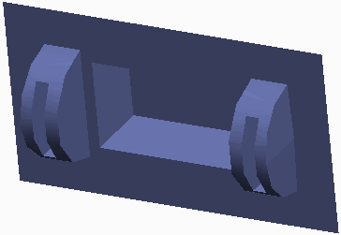

# Exercise: Splitting the Shower Head Mold





#### Objectives

* Split the workpiece and split mold volumes.

#### Scenario

In this exercise you split the shower head mold model workpiece, and further split the mold volumes to account for the slider and insert volumes.

#### 1. Task 1. Split the workpiece.

1. Disable all Datum Display types.Volume Split 
2. Select **Volume Split** from the Mold Volume types drop-down menu in the Parting Surface & Mold Volume group.
3. In the menu manager, click **One Volume > All Wrkpcs > Done**.
4. Select the plug volume from the graphics window and click **OK** from the Select dialog box.

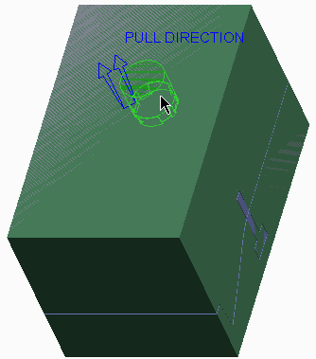

Figure 1

1. In the menu manager, select the **Island 1** check box and click **Done Sel**.

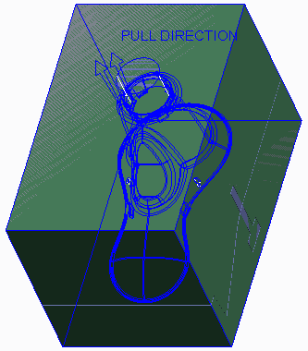

Figure 2

1. Click **OK** from the Split dialog box.
2. In the Properties dialog box, click **Shade**.

* Type **TEMP-MOLD_VOL1** and press ENTER.

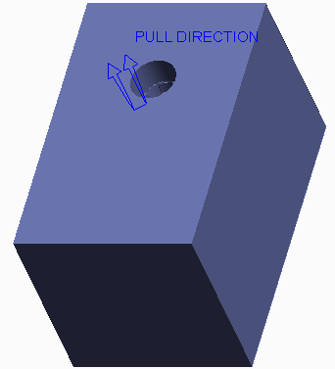

Figure 3

1. Select SHOWER_HEAD_MOLD_WRK.PRT, right-click, and select **Blank**.

Figure 4 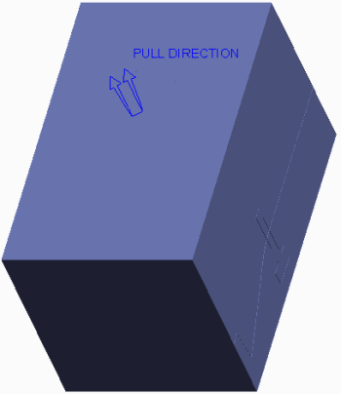

#### 2. Task 2. Split the remaining mold volumes. Volume Split

1. Click **Volume Split** .
2. In the menu manager, click **One Volume > Mold Volume > Done**.
3. In the Search Tool, select TEMP-MOLD_VOL1 as the volume to split and click **Add Item** .Add Item 

* Click **Close**.

1. Press CTRL and query-select the SLIDER_LEFT_TAB and SLIDER_RIGHT_TAB mold volumes.

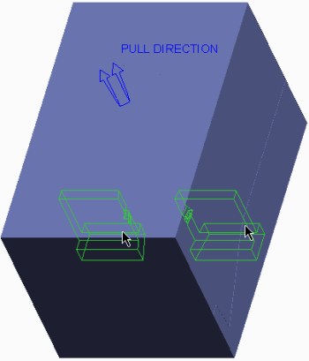

Figure 5

1. Click **OK** from the Select dialog box.
2. In the menu manager, select the **Island 1** check box and click **Done Sel**.

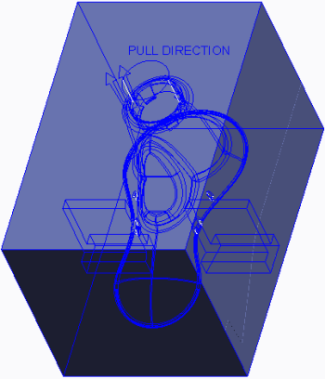

Figure 6

1. Click **OK** from the Split dialog box.
2. In the Properties dialog box, click **Shade**.

* Type **TEMP-MOLD_VOL2** and press ENTER.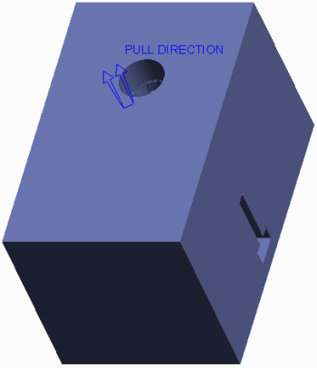

Figure 7

1. Click **Volume Split** .Volume Split 
2. In the menu manager, click **Two Volumes > Mold Volume > Done**.
3. In the Search Tool, select TEMP-MOLD_VOL2 as the volume to split and click **Add Item** .Add Item 

* Click **Close**.

1. Query-select the skirt parting surface and click **OK** from the Select dialog box.

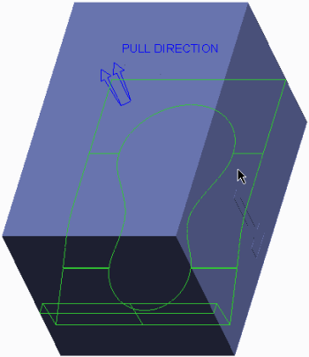

Figure 8

1. Click **OK** from the Split dialog box.
2. In the Properties dialog box, click **Shade**.

* Type **CORE_VOL** and press ENTER.

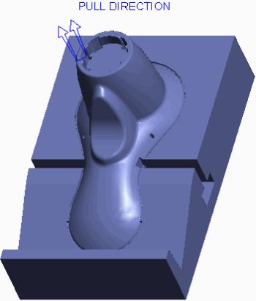

Figure 9

1. In the Properties dialog box, click **Shade**.
2. Spin the model to inspect it.

Figure 10 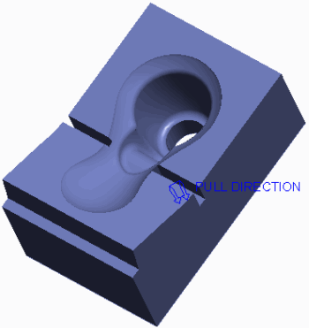

1. In the Properties dialog box, type **CAVITY_VOL** and press ENTER.
2. Orient to the **Standard Orientation**.
3. Press CTRL+B to access the Blank-Unblank dialog box.
4. In the Blank and Unblank dialog box, select the **Blank** tab.

* Select **Parting surface Parting surface ** as the Filter.
* Select PART_SURF_1 and click **Blank**.
* Select **Volume Volume ** as the Filter.
* Select TEMP-MOLD_VOL1 and click **Blank**.
* Select **Component** as the Filter.Component 
* Select SHOWER_HEAD_MOLD_REF and click **Blank**.
* Click **OK**.

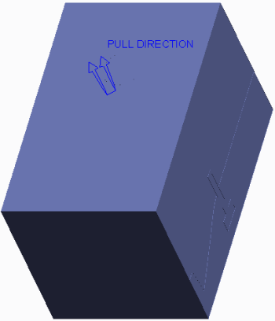

Figure 11

1. Click **No Hidden No Hidden ** and inspect the mold model.

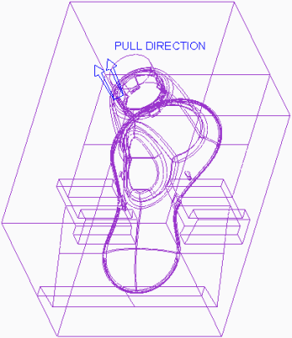

Figure 12

1. Click **Shading Shading **.
2. Click **Save Save ** from the Quick Access toolbar.
3. Click **File > Manage Session > Erase Current**, then click **Select All** and **OK** to erase the model from memory.Select All 

**This completes the exercise.**

# Exercise: Splitting the Mouse Mold





3. Click **File** > **Open** and double-click **MOUSE_MOLD.ASM**.

#### Objectives

* Split the workpiece and split mold volumes.

#### Scenario

In this exercise, you split the mouse mold model workpiece, and further split the mold volumes to account for the core insert volume.

#### 1. Task 1. Split the workpiece.

1. Disable all Datum Display types.Volume Split 
2. Select **Volume Split** from the Mold Volume types drop-down menu in the Parting Surface & Mold Volume group.
3. In the menu manager, click **Two Volumes > All Wrkpcs > Done**.
4. Select the main parting surface from the graphics window and click **OK** from the Select dialog box.

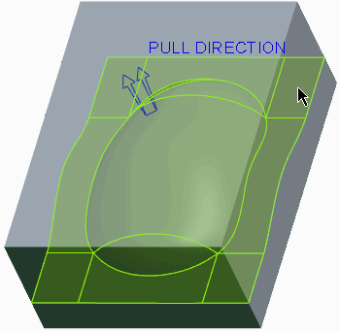

Figure 1

1. Click **OK** from the Split dialog box.
2. In the Properties dialog box, click **Shade**.

* Type **TEMP-MOUSE_CORE_VOL** and press ENTER.

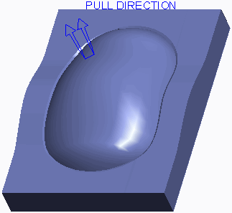

Figure 2

1. In the Properties dialog box, click **Shade**.
2. Spin the model and inspect the mold volume.

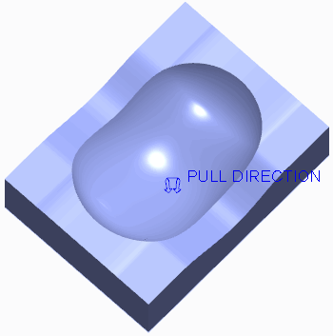

Figure 3

1. In the Properties dialog box, type **MOUSE_CAVITY_VOL** and press ENTER.
2. Orient to the **Standard Orientation**.
3. Select MOUSE_WP.PRT, right-click, and select **Blank**.

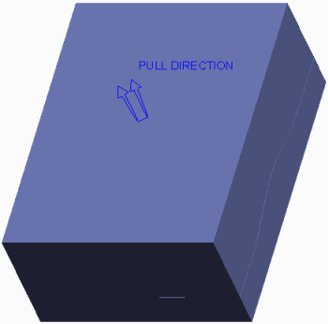

Figure 4

#### 2. Task 2. Split the core into mold volumes. Volume Split

1. Click **Volume Split** .
2. In the menu manager, click **Two Volumes > Mold Volume > Done**.
3. In the Search Tool, select TEMP-MOUSE_CORE_VOL as the volume to split and click **Add Item** .Add Item 

* Click **Close**.

1. Query-select the insert parting surface.

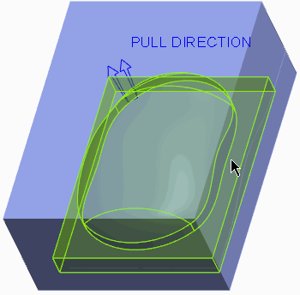

Figure 5

1. Click **OK** from the Select dialog box.
2. Click **OK** from the Split dialog box.
3. In the Properties dialog box, click **Shade**.

* Type **MOUSE_CORE_INSERT_VOL** and press ENTER.

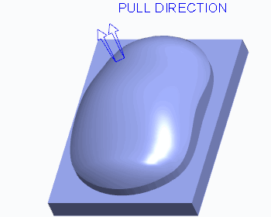

Figure 6

1. In the Properties dialog box, click **Shade**.

* Type **MOUSE_CORE_OUTER_VOL** and press ENTER.

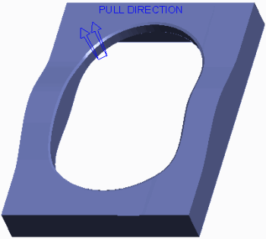

Figure 7

#### 3. Task 3. Blank mold model items.

#### 1.Press CTRL+B to access the Blank and Unblank dialog box.

1. In the Blank and Unblank dialog box, select the **Blank** tab.

* Select **Parting surface Parting surface ** as the Filter.
* Select the MAIN parting surface and click **Blank**.
* Select **Component** as the Filter.Component 
* Select MOUSE_REF and click **Blank**.
* Click **OK**.

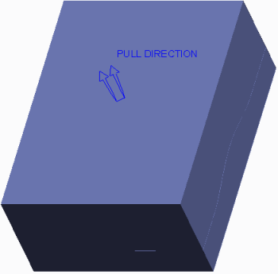

Figure 8

1. Click **No Hidden No Hidden ** and inspect the mold model.

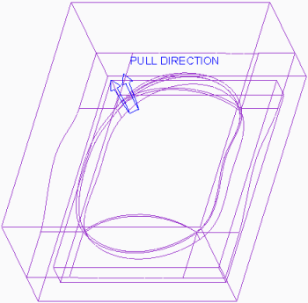

Figure 9

1. Click **Shading Shading **.
2. Click **Save Save ** from the Quick Access toolbar.
3. Click **File > Manage Session > Erase Current**, then click **Select All** and **OK** to erase the model from memory.Select All 

**This completes the exercise.**

**9. Mold Component Extraction**

#### Module Overview:

Once the proper mold volumes have been created and split, you can now create the mold components. You create mold components by filling the mold volumes with material. This process is called extracting, and it automatically converts the mold volumes into fully functional solid parts.

In this module, you learn how to extract the final solid mold components from mold volumes.

#### Objectives:

After completing this module, you will be able to:

* Extract mold components from mold volumes.
* Apply start models to mold components.

## Extracting Mold Components from Volumes

Once the mold volumes are created and the workpiece and mold volumes are split, you can create the final mold components. You can produce mold components by filling the previously defined mold volumes with solid material. This process, performed using

the **Cavity insert Cavity insert ** option, is called *extracting*. Extracted parts can be core and cavity

pieces as well as sliders, inserts, core pins, and so on.

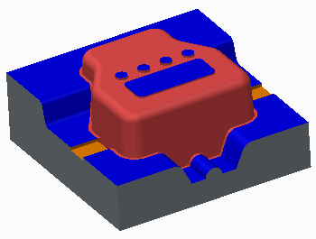

Figure 1 – Extracted Core Mold Component

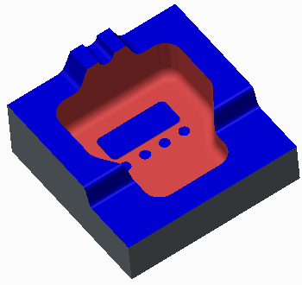

Figure 2 – Extracted Cavity Mold Component

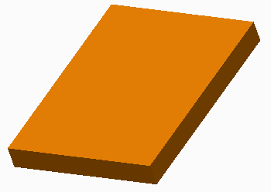

Figure 3 – Extracted Slider Mold Component

The system does not automatically create mold components from every mold volume found in the mold model. Recall that you may have created temporary mold volumes during the split process to create your desired mold volumes. Consequently, you must specify which mold volumes will be extracted into mold components. When the mold components are extracted and created, the corresponding mold volumes are automatically blanked from the graphics window.

The extracted mold components are created in the mold model, and each component contains an *Extract* feature that contains the solid geometry. The extract feature cannot be redefined, but these components are fully functional parts. You can retrieve them in Part mode, and add new features to them. To save the extracted mold components, you must save the mold model before erasing it from memory or exiting your current Creo Parametric session. By default, the extracted mold components are named the same as the volumes from which they were extracted.

Extracted mold components maintain a parent/child relationship with their mold volumes. Therefore, the mold components automatically update when changes are made to the mold volumes. While the mold volumes are assembly features in the mold model, the mold components are assembly components in the mold model.

### Color-Coding of Extracted Mold Components

By default, the extracted mold components are created in the default Creo Parametric gray color. However, the surfaces of the extracted mold components may also display in three other potential colors:

* Reference model color – The mold components’ surfaces that touch the reference model are color-coded the same as the reference model. In the figures, the reference model color is red.
* Blue – Steel-to-steel contact between tooling component shutoffs.
* Orange – Steel-to-steel contact between slider mold component surfaces and mold plates, cores, or cavities. It is important to note that only the slider mold volumes created by calculating undercut boundaries, become orange when the mold components are extracted. Sketched sliders and other components have blue surfaces at their steel-to- steel contact points.

1. **Applying Start Models to Mold Components**

You can apply an existing start model template to components when extracting them from mold volumes in the mold model. This is done in the Advanced section of the Create Mold Component dialog box. As a best practice, you should create extracted mold components using a start model template. Using a start model template when extracting mold components provides you with the following benefits.

* Datums – Includes a set of default datum planes and a default coordinate system
* Layers
* Parameters
* View Orientations

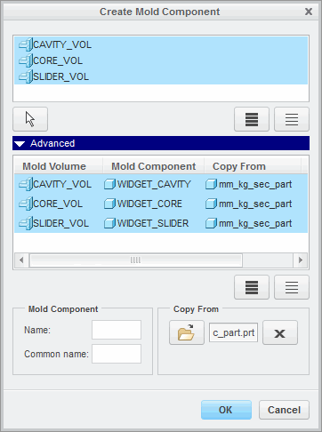

Figure 2 – Renaming Mold Components and Applying Start Model

These are the same benefits that you gain from using a start model template when creating new part models.

### Renaming Mold Components

By default, extracted mold components are named the same as the mold volume from which they are extracted. You can rename the mold component name in the Advanced section of the Create Mold Component dialog box.

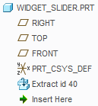

Figure 1 – Extracted Mold Component Model Tree

This section displays the specified mold volumes that you extract. In one column the mold volume name is displayed, and in another column the corresponding mold component name is displayed. As a best practice you should rename the mold components with names that are unique to the mold and to the type of component being extracted. For example, a mold volume named cavity_vol should have its corresponding mold component renamed to widget_cavity, or it should be renamed according to your company's standards. Extracted mold components are not volumes, so the “vol” suffix should be removed. Also, mold components are part models. Therefore, each part model should be given a unique name.

*You can only rename one mold component at a time. If more than one mold component is selected in the Advanced section of the Create Mold Component dialog box, the fields to rename mold components become grayed out.*

# Exercise1: Extracting Shower Head Mold Components



#### Objectives

* Extract solid mold components from mold volumes.

#### Scenario

In this exercise, you extract the solid mold components for the shower head mold.

#### 1. Task 1. Extract the mold components.

1. Disable all Datum Display types.
2. Select **Cavity insert Cavity insert ** from the Mold Component types drop-down menu in the Components group.Select All 

| 3. | In the Create Mold Component dialog box, click **Select All** | . |
| --- | --- | --- |
| ▪  ▪ | Press CTRL and click TEMP-MOLD_VOL1 to de-select it.  Click **Advanced** to expand it. |  |

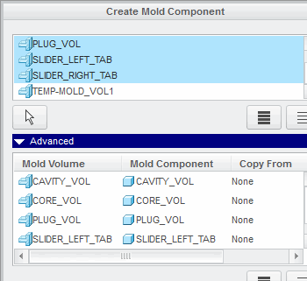

Figure 1

1. In the Advanced section of the Create Mold Component dialog box, select mold volume CAVITY_VOL.

* Edit the Mold Component Name to **CAVITY** and press ENTER.
* Select mold volume CORE_VOL.
* Edit the Mold Component Name to **CORE** and press ENTER.
* Select mold volume PLUG_VOL.
* Edit the Mold Component Name to **PLUG** and press ENTER.

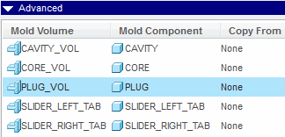

Figure 2

1. In the Advanced section of the Create Mold Component dialog box, click **Select All** .Select All 

* Click **Copy From Copy From **.
* In the Choose template dialog box, double-click MM_KG_SEC_PART.PRT.
* Click **OK**.

1. Notice the five newly created mold components in the model tree.

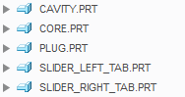

Figure 3

Open 

1. In the model tree, right-click CORE.PRT and select **Open** .
2. Notice the Extract feature in the model tree.
3. Spin the CORE.PRT and inspect it.
4. Notice the surfaces that are blue.
5. Notice the surfaces that are reference model color.

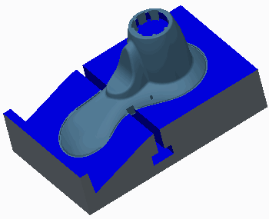

Figure 4

1. Click **Close** from the Quick Access toolbar to return to the mold model.Close Open 
2. In the model tree, right-click CAVITY.PRT and select **Open** .
3. Again, notice the Extract feature in the model tree.
4. Spin the CAVITY.PRT and inspect it.
5. Again, notice the surfaces that are blue.
6. Again, notice the surfaces that are reference model color.

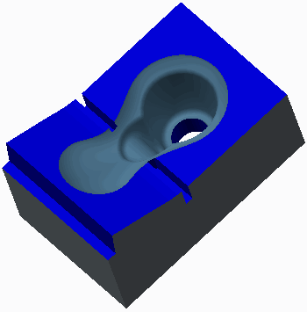

Figure 5

1. Click **Close** to return to the mold model.Close 
2. Click **Save Save ** from the Quick Access toolbar.
3. Click **File > Manage Session > Erase Current**, then click **Select All** and **OK** to erase the model from memory.Select All 

# Exercise2: Extracting Mouse Mold Components





#### Objectives

* Extract solid mold components from mold volumes.

#### Scenario

In this exercise, you extract the solid mold components for the mouse mold.

#### 1. Task 1. Extract the mold components.

1. Disable all Datum Display types.
2. Select **Cavity insert Cavity insert ** from the Mold Component types drop-down menu in the Components group.
3. In the Create Mold Component dialog box, click **Select All** .Select All 

* Click **Advanced** to expand it.

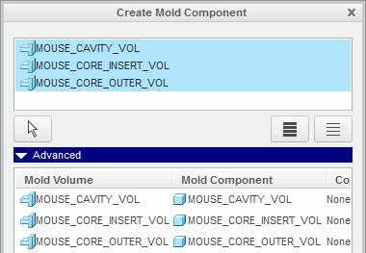

Figure 1

1. In the Advanced section of the Create Mold Component dialog box, select mold volume MOUSE_CAVITY_VOL.

* Edit the Mold Component Name to **MOUSE_CAVITY** and press ENTER.
* Select mold volume MOUSE_CORE_INSERT_VOL.
* Edit the Mold Component Name to **MOUSE_CORE_INSERT** and press ENTER.
* Select mold volume MOUSE_CORE_OUTER_VOL.
* Edit the Mold Component Name to **MOUSE_CORE_OUTER** and press ENTER.

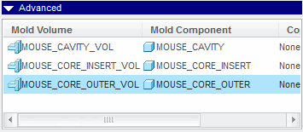

Figure 2

1. In the Advanced section of the Create Mold Component dialog box, click **Select All** .Select All 

* Click **Copy From Copy From **.
* In the Choose template dialog box, double-click MM_KG_SEC_PART.PRT.
* Click **OK**.

1. Notice the three newly created mold components in the model tree.

Graphic

Figure 3

1. In the model tree, right-click MOUSE_CORE_INSERT.PRT and select **Open** .Open 
2. Notice the Extract feature in the model tree.
3. Notice the surfaces that are blue.
4. Notice the surfaces that are reference model color.

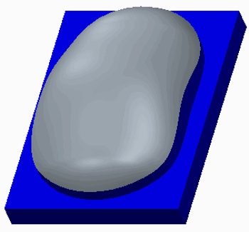

Figure 4

1. Click **Close** from the Quick Access toolbar to return to the mold model.Close Open 
2. In the model tree, right-click MOUSE_CAVITY.PRT and select **Open** .
3. Again, notice the Extract feature in the model tree.
4. Spin the MOUSE_CAVITY.PRT and inspect it.
5. Again, notice the surfaces that are blue.
6. Again, notice the surfaces that are reference model color.

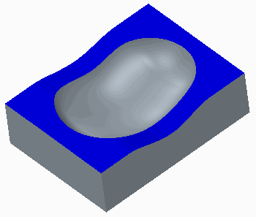

Figure 5

1. Click **Close** to return to the mold model.Close 
2. Click **Save Save ** from the Quick Access toolbar.
3. Click **File > Manage Session > Erase Current**, then click **Select All** and **OK** to erase the model from memory.Select All 

**10. Filling and Opening the Mold**

#### Module Overview:

In this module, you learn how to create the mold result (also known as the molding) after extracting mold components. You create the molding by simulating the filling of the mold cavity with molten material through mold features such as sprues, runners, and gates.

You can then simulate the mold opening process in order to check the correctness of your design. Draft and interference checks can be performed to verify proper mold opening.

#### Objectives:

After completing this module, you will be able to:

* Create a molding.
* Simulate the mold opening sequence.
* Check draft on mold components during the opening of the mold.
* Check interference on mold components during the opening of the mold.
* View mold information.

## Creating a Molding

When a mold is filled, molten plastic is injected into the sprue, and it then travels through the runners and gates to fill the mold cavity. The solidified result is known as the *molding*. There can be only one molding part in the model at a time.

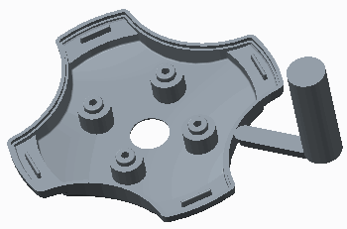

Figure 1 – Molding Part

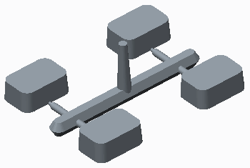

Figure 2 – Another Molding Part

Creo Parametric enables you to simulate the filling of the mold cavity and generate the molding. In addition to the mold cavity, the sprues, runners, and gates are also filled to generate the final molding. The molding part is created by using the following molding formula:

* Molding = sum of all current workpiece geometry - assembly level cuts that intersect the workpiece (waterlines, for example) - all extracted parts (sliders and cores, for example) - ejector pin clearance holes

The molding part is created in the mold model, and it contains a single *Molding* feature that contains the solid geometry.

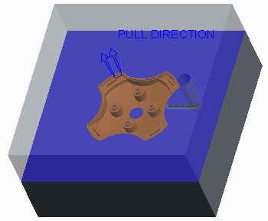

Figure 3 – Mold Model

The molding feature cannot be redefined, but the part is a fully functional part. You can retrieve it in Part mode and perform various operations on the molding part such as removing excess material using Pro/NC, calculating mass properties, and also generating a mesh for flow analysis. To save the molding part, you must save the mold model before erasing it from memory or exiting your current Creo Parametric session.

The molding part maintains a parent/child relationship with the mold components and assembly level features. Therefore, the molding automatically updates when changes are made to the mold components or assembly level features. For example, if the sprue diameter is increased, the molding part automatically updates to reflect the larger diameter.

1. **Opening the Mold**

You can simulate the mold opening process to determine whether your final design matches your original design intent. The mold opening process is a series of steps, containing one or more moves. You can specify moves for any component, or member, of the mold model except the reference model and the workpiece. It is convenient to blank the reference model, workpiece, and all mold volumes, as well as the parting lines and surfaces before opening the mold.

In order to simulate the mold opening process, you must define the following:

* Define Move — An instruction to move one or more members of the mold model. When defining a move, you must specify the following items:
* The members to be moved.
* The direction reference of the movement. You can select a linear edge, axis, or plane to indicate the direction. When the direction reference is specified, an arrow indicates the positive direction.
* The offset value. The members move the amount specified in the direction of the reference specified. The members move parallel to the edge or axis, or normal to the plane. You can specify a positive offset value or a negative offset value to move the member in the opposite direction.
* Define Step — A collection of defined moves for opening the mold.

You can also perform the following operations on the mold opening simulation:

* Delete — Enables you to delete an existing step.
* Delete All — Enables you to delete all existing steps.
* Modify — Enables you to modify an existing step by adding or deleting moves from the step.
* Modify Dim — Enables you to modify the offset value of a given move. You must regenerate the mold model in order for the new value to take effect.
* Reorder — Enables you to switch the order of existing steps. You can specify the step you want reordered, then select the step that you want it to become.
* Explode — Enables you to simulate the mold opening by stepping through the sequence, in order, one step at a time. Members included in the moves of the step are translated according to the specified offsets. You can continue to step through all the steps in the sequence. A message in the message window indicates when all components in the mold model have been successfully exploded. You can also animate the entire opening sequence.

### Rules for Defining a Move

You must remember the following rules when defining moves:

* Each step may contain several moves that are performed simultaneously.
* A member can be included in only one move per step.
* A move may contain several members, but they are all offset in the same direction and by the same value.

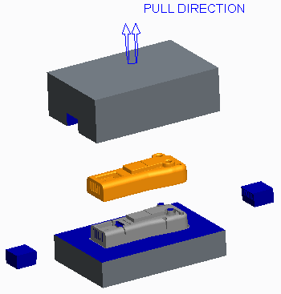

Figure 1 – Fully Opened Mold

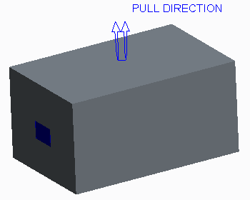

Figure 2 – Closed Mold

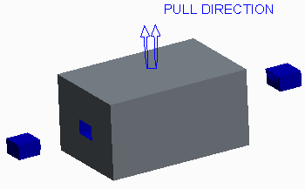

Figure 3 – Partially Open Mold

1. **Draft Checking a Mold Opening Step**

You can perform draft checking on mold components during the mold opening sequence.

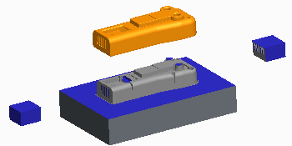

Figure 1 – Opened Mold

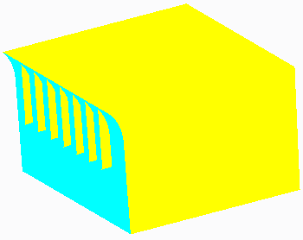

Figure 2 – Draft Check on a Slider

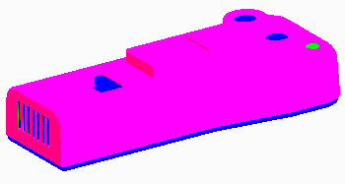

Figure 3 – Draft Check on the Molding

You can use draft checking to determine whether the mold components have the correct surfaces drafted and suitable draft angles in order to facilitate the mold opening process.

In order to perform a draft check, you must first specify on which step of the opening sequence you want to perform the draft check. You must also specify the following items to perform a draft check during the mold opening sequence:

* Pull Dir – Specifies the pull direction to be used for the draft check. You can specify the pull direction using either of the following methods:
* Specify – Enables you to select a pull direction. You can filter the pull direction reference by plane, coordinate system, curve, edge, or axis and specify the proper reference. You can also flip the pull direction to the opposite side of the reference.
* Move Num – Enables you to specify a pull direction reference by specifying a move number in the step.
* Draft Angle – Enables you to specify the desired draft angle to check.
* One Side/Both Sides – Enables you to specify whether the draft check is performed on one or both sides of the direction reference.
* Full Color/Three Color – Enables you to specify whether the display is shown using the full color spectrum or with three colors.
* Part or surface to check for drafting – Once you have specified the pull direction and draft angle, you must specify a part to check for drafting or a surface to check for drafting.

1. **Interference Checking a Mold Opening Step**

Creo Parametric enables you to check moving parts for interference with a static part for each move you define. After you have defined a move, you must select a static part to check for interference with the current part that you have defined for the move. Areas that are interfering either have their curves highlighted, as shown in Figure 1 or, if interference curves cannot be found, the resulting interference is highlighted by a red point, as shown in Figure 2.

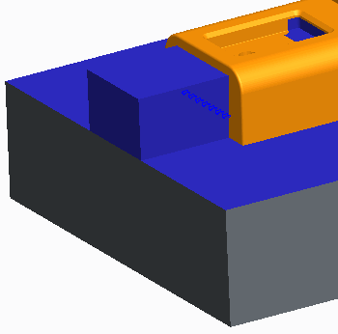

Figure 1 – Interference Curves

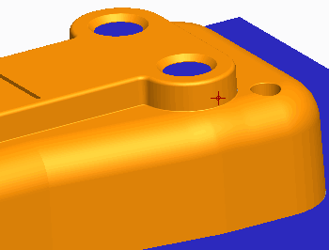

Figure 2 – Interference Point

You can delete the move and try another method of opening the mold to prevent the interference of parts. You may have to redefine your mold components.

1. **Viewing Mold Information**

You can view information about your mold model any time you are in Mold mode by clicking the Analysis group drop-down menu and selecting **Mold Mold **. You can view the following types of information about the mold:

* BOM – Displays a bill of materials of all components found in the mold model.
* Components – Displays information on all the components in the mold model, including reference models, workpiece, extracted components, and the molding.
* Cavity layouts – Displays information on all cavity layouts. You can view the coordinate system references used for placement of the cavity, the layout type, the number of cavities in respective directions, the names and locations of each cavity, and the overall workpiece size.
* Split volumes – Displays all volumes created in the mold model as a result of split operations. You can view the mold volume name, its display status in the mold model, and its feature ID.

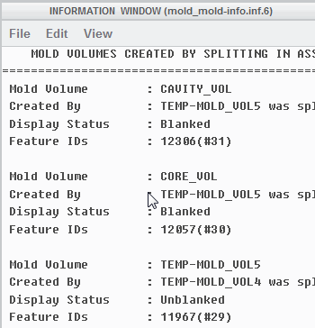

Figure 2 – Viewing Split Volumes Information

* Created volumes – Displays information on all sketched mold volumes in the mold model. You can view the mold volume name, its display status in the mold model, and its feature ID.

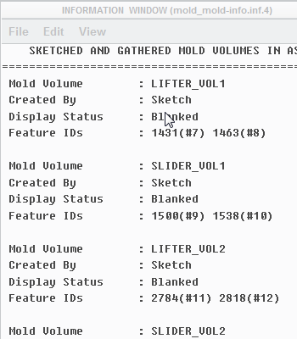

Figure 1 – Viewing Created Volumes Information

* Parting surface – Displays information on all parting surfaces created in the mold model. You can view the parting surface name, its display status in the mold model, and its feature ID.
* Split – Displays all the split operations performed in the mold model. You can view the parent and child feature ID's of the split, the parting surface used, and the resulting volumes created.
* Last volume – Displays the last created volume in the mold model. You can view the mold volume name, how it was created, its display status in the mold model, and its feature ID.
* Shrinkage – Displays any shrinkage applied to the reference model. If the mold model contains more than one reference model, you must specify for which reference model you want shrinkage information. You can view the coordinate system specified for the shrinkage, the shrinkage formula used, and the shrink factors used.

You can specify whether you want the output displayed in an Information window within Creo Parametric, whether you want it written to a file, or both.

# Excercise1:Opening the Shower Head Mold Model





#### Objectives

* Create moldings.
* Define steps and moves to simulate the mold opening process.
* Perform a draft check during the mold opening process.
* Perform an interference check during the mold opening sequence.
* Resolve an interference in the mold component geometry.

#### Scenario

In this exercise, you create the molding and also simulate the mold opening process in the shower head mold model.

#### 1. Task 1. Create the molding.

1. Disable all Datum Display types.
2. Click **Create Molding Create Molding ** from the Components group.
3. Type **Shower_Head_Molding** as the name and press ENTER.
4. Press ENTER to accept the Mold Part Common Name.

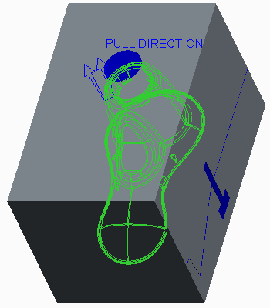

Figure 1

1. Notice that the molding is created.

#### 2. Task 2. Simulate the opening of the mold.

1. Click **Mold Opening Mold Opening ** from the Analysis group to simulate the mold opening process.
2. Click **Define Step > Define Move** from the menu manager.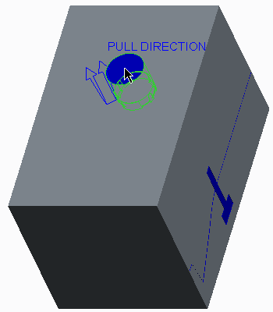
3. Select PLUG.PRT as the member for the first move.

Figure 2

1. Click **OK** in the Select dialog box.
2. Select the left, vertical edge to define the move direction.

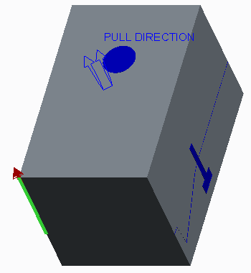

Figure 3

Type **320** as the movement value and press ENTER.

1. Click **Define Move** from the menu manager.
2. Select CAVITY.PRT as the member for the second move.

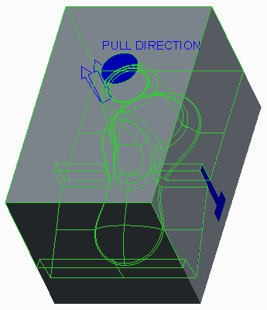

Figure 4

1. Click **OK** in the Select dialog box.
2. Select the left, vertical edge to define the move direction.

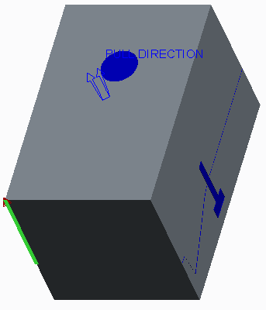

Figure 5

1. Type **230** as the movement value and press ENTER.
2. Click **Done** from the menu manager.

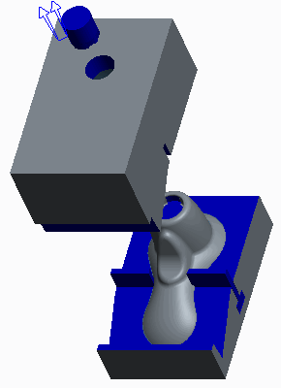

Figure 6

1. Click **Define Step > Define Move** from the menu manager.
2. Select SLIDER_RIGHT_TAB.PRT as the member for the first move.

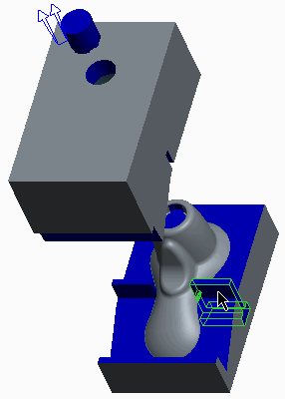

Figure 7

1. Click **OK** in the Select dialog box.
2. Select the front, horizontal edge to define the move direction.

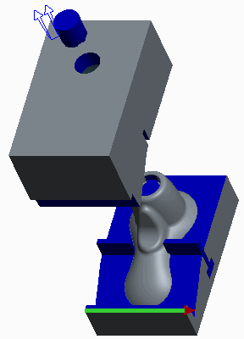

Figure 8

1. Type **130** as the movement value and press ENTER.
2. Click **Define Move** from the menu manager.
3. Select SLIDER_LEFT_TAB.PRT as the member for the second move.

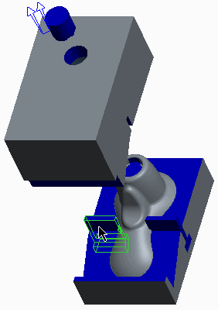

Figure 9

1. Click **OK** in the Select dialog box.
2. Select the front, horizontal edge to define the move direction.

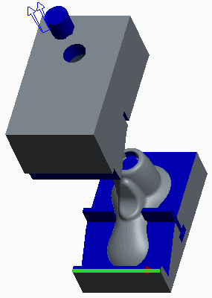

Figure 10

1. Type **-130** as the movement value and press ENTER.
2. Click **Done** from the menu manager.

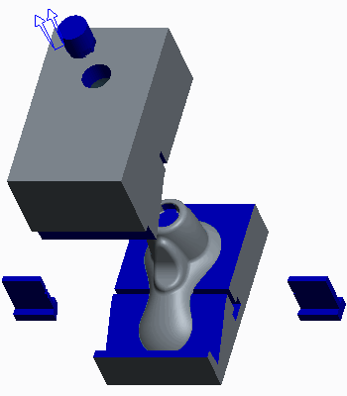

Figure 11

1. Click **Define Step > Define Move**.
2. Select SHOWER_HEAD_MOLDING.PRT as the member for the move.

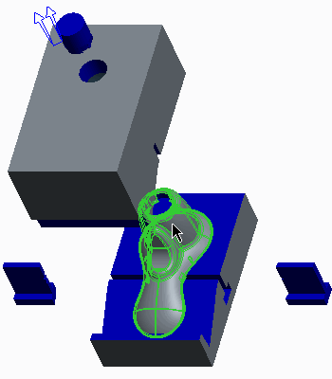

Figure 12

1. Click **OK** in the Select dialog box
2. Select the front, right, vertical edge to define the move direction.

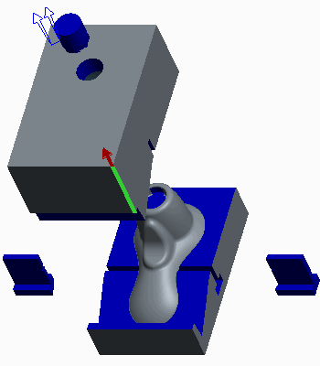

Figure 13

1. Type **100** as the movement value and press ENTER.
2. Click **Done** from the menu manager.
3. Spin the model and observe the mold opening sequence.

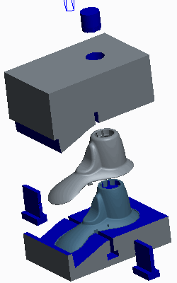

Figure 14

#### 3. Task 3. Perform a draft check on the PLUG.PRT.

1. Orient to the **Standard Orientation**.
2. Click **Modify > Step 1** from the menu manager.
3. Click **Draft Check > Both Sides > Three Color > Done** from the menu manager.
4. Click **Move Num > Move 1** from the menu manager.
5. Type **2** as the draft check angle and press ENTER.
6. Select PLUG.PRT.
7. Notice that in the area of the plug where there is proper negative draft (the cyan color) there is also positive draft (magenta).

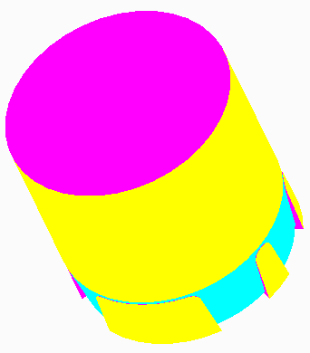

Figure 15

1. Click **Done/Return > Done/Return** from the menu manager.

#### 4. Task 4. Perform an interference check on the PLUG.PRT.

1. Click **Interference > Move 1** from the menu manager.
2. Select SHOWER_HEAD_MOLDING.PRT as the static part.
3. Spin the model and observe the location of the detected interference.

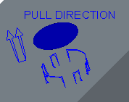

Figure 16

1. Notice that this detected interference is at the same location as the positive draft.
2. Click **Done/Return > Done > Done/Return** from the menu manager.



1. Orient to the **Standard Orientation**.
2. Press CTRL and select SHOWER_HEAD_MOLD_REF.PRT and SHOWER_HEAD_MOLD_WRK.PRT from the model tree.
3. Right-click and select **Unblank**.

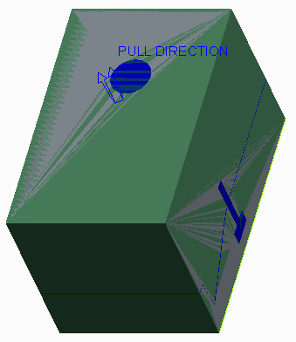

Figure 17

1. In the model tree, edit the definition of **Revolve 1**.
2. In the graphics window, right-click and select **Edit Internal Sketch**.
3. Enable only the following Sketcher Display types: .
4. Click **Sketch View Sketch View ** from the In Graphics toolbar.

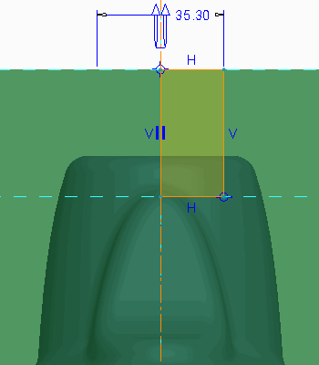

Figure 18

1. Drag a window around the existing sketch and delete it.
2. Click **Centerline Centerline ** from the Datum group and sketch a centerline on the vertical reference.
3. Click **Hidden Line Hidden Line ** from the In Graphics toolbar and zoom in on the top of the sketch.Project 
4. Click **Project** from the Sketching group and select the three edges.

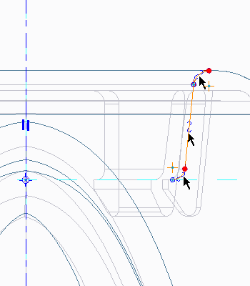

Figure 19

1. Click **Close** from the Type dialog box.
2. Click **Line Chain** from the Sketching group and sketch the four remaining lines.Line Chain 

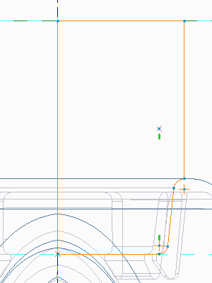

Figure 20

1. Click **OK** .OK 
2. Orient to the **Standard Orientation**.
3. Click **Shading Shading **.

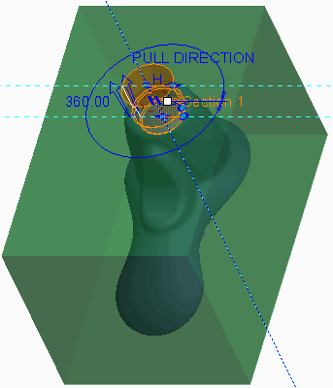

Figure 21

1. Click **Complete Feature** .Complete Feature 
2. Click **Regenerate Regenerate ** from the Quick Access toolbar to update the mold model.
3. Press CTRL and select SHOWER_HEAD_MOLD_REF.PRT and SHOWER_HEAD_MOLD_WRK.PRT from the model tree.
4. Right-click and select **Blank**.Open 
5. Right-click PLUG.PRT and select **Open** .
6. Spin the model and notice the difference in geometry.

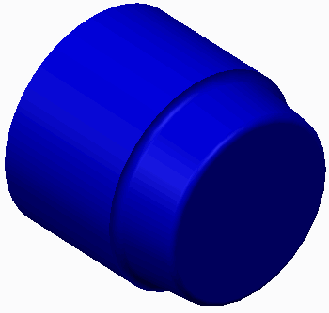

Figure 22

1. Click **Close** from the Quick Access toolbar to return to the mold model.Close 

#### 6. Task 6. Rerun the interference check in the mold opening sequence.

1. Click **Mold Opening Mold Opening **.
2. Click **Modify > Step 1** from the menu manager.
3. Click **Interference > Move 1** from the menu manager.
4. Select SHOWER_HEAD_MOLDING.PRT as the static part.
5. Notice, in the status bar, that there is no longer any interference detected.
6. Click **Done/Return > Done > Done/Return** from the menu manager.

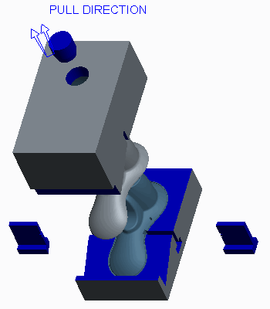

Figure 23

1. Click **Save Save ** from the Quick Access toolbar.
2. Click **File > Manage Session > Erase Current**, then click **Select All** and **OK** to erase the model from memory.Select All 

**11. Introduction to Manufacturing**

1. **Manufacturing Process Overview**

**The manufacturing process can be divided into four high-level steps:**

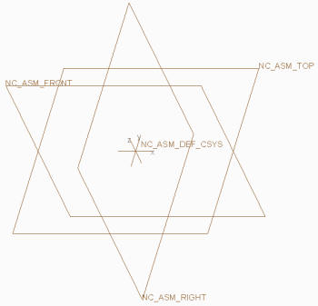

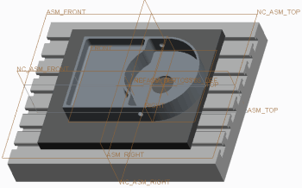

1– Creating the Manufacturing Model 2 – Creating the Manufacturing Environment

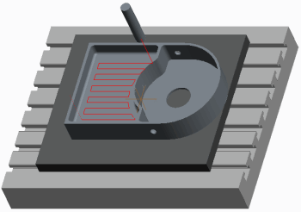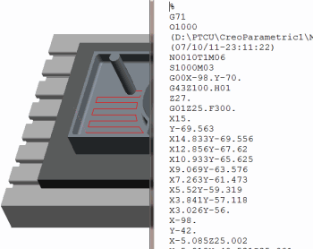

3 – Creating NC Sequences and CL Data 4 – Post-Processing CL Data and Machining

**Creating the Manufacturing Model**

Creating the manufacturing model is the first step in the manufacturing process.

• You can select and copy a template manufacturing model during the creation process.

– By default, the template manufacturing model includes default datum planes and a default coordinate system.

– You can configure many other items in template manufacturing models. For example, you can include fixtures and a configured machine tool.

• Alternatively, you can create an "empty" model. However, the recommended procedure is to create the manufacturing model using a template model.

**Creating the Manufacturing Environment**

Configuring the manufacturing environment is the second step in the manufacturing process. This step involves configuring a number of elements within the manufacturing model. Here is a summary of the most important elements.

• Work Center – This specifies the type of machine tool being used. For example, you can specify a Work Center as a 3-axis milling machine with various machine tool parameters such as feed units, maximum spindle speed, and travel limits in the X-, Y-, and Z-directions.

• Operation – Machining operations are a series of NC sequences that are performed by a particular Work

**Center (machine tool) and reference a particular coordinate system.**

They include the following elements:

– Machine coordinate system – Also referred to as the machine zero position. This specifies the program zero position in X, Y, and Z on the machine tool.

– Retract plane – Also referred to as the retract surface. This specifies the clearance level to which the tool retracts after completing an NC sequence.

– Fixtures – Are parts or assemblies that can be used to hold the component being machined. For example, you can create vise assemblies and use them as fixtures. Note that fixtures are optional elements and are not required to create NC sequences.

• Reference model – You must assemble a reference model before creating NC sequences. The reference model represents the final machined component. Surfaces and edges are selected from the reference model and are used as references when creating NC sequences.

• Workpiece model – This represents the unmachined stock material. It is an optional element and is not required to create NC sequences. However, using a workpiece enables you to simulate the machining of the stock material.

**Creating NC Sequences and CL Data**

The next step in the manufacturing process is to create NC sequences in the manufacturing model; this involves the following:

• Specifying a tool.

• Selecting or creating geometry to machine (for example, a surface to machine or holes to be drilled).

• Specifying how the tool machines the selected geometry by editing machining parameters (for example, specifying cut feed rate and spindle speed).

• When NC sequences have been created, it is then possible to create Cutter Location (CL) data files. These are generated from the tool motions within NC sequences.

Note: Note that NC sequences are made up of a series of tool motions. In addition, you can add specific post-processor commands for correct NC output.

**Post-Processing CL Data and Machining**

CL Data files can then be post-processed to create Machine Control Data (MCD) files. This is done using machine-specific or generic post-processors. You can then use MCD files to machine components on machine tools.

Note: This course covers the necessary steps for creating machine control data. The final step involves machining components on machine tools and is therefore beyond the scope of this course.

**12. Creating Manufacturing Models**

**Creating manufacturing models is the first step in the manufacturing process.**

Manufacturing models contain all manufacturing Models process information, such as: Manufacturing model assembly file – "filename".asm

• Operations

• Work Center

• NC sequences

• Reference models

• Work piece models

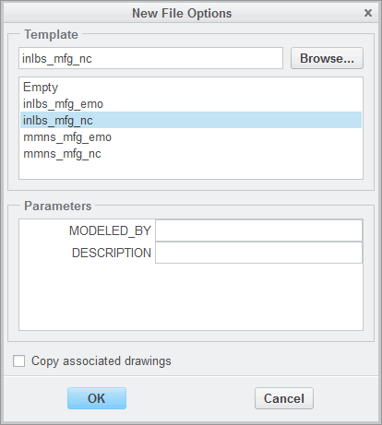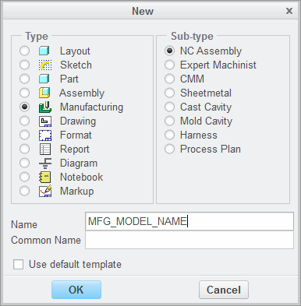

1 – Using Template Manufacturing Models 2 – Template Manufacturing Model

**Manufacturing Models**

As manufacturing models are developed, they contain all manufacturing process information, such as operations, Work Center, NC sequences, reference models, and workpiece models.

The manufacturing model assembly file is created when you create a manufacturing model. It has the filename format "filename".asm.

• The manufacturing model assembly file contains all manufacturing process information, such as

operation information and NC sequence information.

• This file also contains the assembly information for reference models, fixtures, and workpieces assembled into the manufacturing model.

**Template Manufacturing Models**

A template manufacturing model can be selected and copied during the creation process. Using template manufacturing models enables you to standardize on the initial manufacturing model configuration. If a template model is not selected, then the initial manufacturing model is empty.

• By default, the template manufacturing model includes default datum planes and a default coordinate system.

• Template manufacturing models are configured with either metric or imperial units.

• User-defined template manufacturing models can also be configured and selected.

**13. Using Work piece Models**

**It is important to understand how workpiece models are used in manufacturing assemblies.**

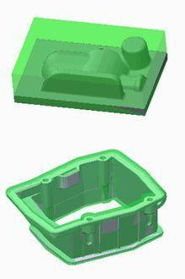

Workpieces represent unmachined stock material,

for example:

• Stock Billets.

• Castings.

**Workpiece Features:**

• Enable machining simulation of workpiece.

• As-machined versions.

• No machining outside workpiece boundaries.

• Workpiece display.

Figure 1 – Workpiece Examples

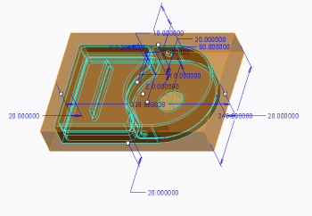

**Workpiece Options:**

• Create an automatic workpiece. Figure 2 – Automatic Workpiece

• Assemble using Same Model option.

• Assemble with inherited features.

• Assemble with merged features.

• Create a manual workpiece.

**Workpiece Models**

Workpieces represent the unmachined stock material. They are optional components within a manufacturing model; however, if they are used, then you can simulate the machining of workpieces when creating NC sequences. Workpieces can be standard stock billets or they can represent castings. Using workpieces provides you with a number of capabilities:

• You can simulate the cutting tool machining the workpiece.

• After creating each toolpath, you can update the workpiece to display an as-machined version of the workpiece.

• Unless you specify otherwise, there is no machining outside the workpiece boundaries.

• The workpiece is displayed in green to help you visually distinguish between the workpiece and the reference model geometry. In addition, when the display style is set to shaded, the workpiece is displayed as semi-transparent. This enables you to view the reference model geometry which would normally be obscured by the workpiece.

**Workpiece Options**

You can assemble or create a workpiece in a manufacturing model. A number of options are available:

• Create an automatic workpiece – This enables you to create a rectangular or round workpiece depending on your requirements. A dashboard interface enables you to easily control the size and position of the workpiece relative to the reference model.

• Assemble a workpiece using the Same Model option – This enables you to assemble an existing part into the manufacturing model as the workpiece.

• Assemble a workpiece with features inherited from a selected part. The new workpiece inherits geometry and feature information from the selected part. At any time, you can specify the geometry and the feature data that you want to modify on the workpiece without changing the original part. Inheritance provides greater freedom to modify the workpiece without changing the original part.

• Assemble a workpiece with features merged from a selected part. In this case, a new workpiece part is created. The new workpiece contains an external merge feature, and this feature contains all geometry and datum features which have been copied from the originally selected part. All layer information is also copied into the new workpiece.

• Create a manual workpiece – This enables you to create a new workpiece in the manufacturing model by manually creating features and geometry as required.

1. **Exercise 1: Creating a Workpiece with Inherited Features**

**Objectives** 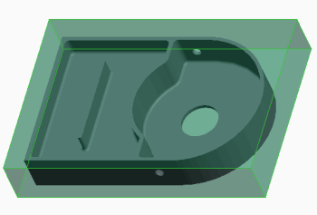

After successfully completing this exercise, you will be able to:

• Create workpiece models using the Inherited Feature option.

• Suppress features in workpiece models with inherited features.

• Add features to workpiece models with inherited features.

**Scenario**

You need to create a workpiece in a manufacturing model using the Inherited Features option. The workpiece represents a casting, so you need to suppress a number of features in the workpiece and add material to the workpiece to ensure the workpiece accurately represents the “as-cast” version of the casting.

**Close Window** **Erase Not Displayed** 

* Milling\Workpiece_Models  GEARBOX_CASTING.ASM

**Task 1: Assemble the gearbox casting as the workpiece model.**

1. Enable only the following Datum Display type: **Csys Display** . 

2. Select **Inherit Workpiece** from the Workpiece types drop-down menu in the Components group.

• Select GEARBOX.PRT, and click **Open**.

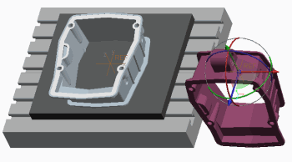

3. Create the assembly constraint.

• Select datum coordinate system **REF** on the

gearbox casting model.

• Select datum coordinate system **REF** on the

manufacturing model.

4. Click **Complete Component**  in the dashboard.

5. In the Create Stock-Workpiece dialog box, note the **Inherited** option is already selected.

• Note the default name GEARBOX_CASTING_WRK in the Name text box.

• Click **OK** to create a new workpiece model.

• Expand the GEARBOX_CASTING_WRK.PRT in the model tree.

• Expand the EXTERNAL INHERITANCE feature in the model tree.

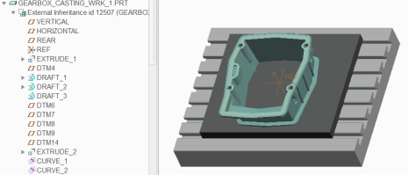

**Note: An external inheritance feature has been created in the new workpiece part. You can edit inherited features in the workpiece part without changing the original part. This is useful if you want to edit the workpiece to represent the as-cast version of the model.**

**Task 2: Edit the workpiece to represent the as-cast version of the casting.**

1. Suppress a number of workpiece model features.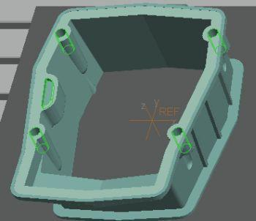

• In the model tree, select feature SLOT_1.

• Press CTRL and select group HOLES.

• Right-click and select **Suppress** .

• Click **OK** to suppress the related round feature.

2. Activate the casting part.

• Select GEARBOX_CASTING_WRK.PRT in the model tree.

• Right-click and select **Activate** .

3. Add material to the top of the casting.

• Click **Extrude**  from the Shapes group.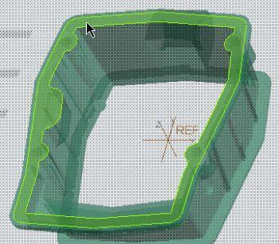

• Right-click and select **Define Internal Sketch**.

• Cursor over the workpiece model, then

right-click and select the hidden surface on

GEARBOX_CASTING_WRK.PRT, as shown.

• Click **Sketch**.

• In the model tree, select the VERTICAL datum

feature, and then select the HORIZONTAL

datum feature as sketching references.

• In the References dialog box, click **Close**.

4. Select the first loop of edges for the sketch.

• Select **Sketch View** from the Setup group in the ribbon.

• Click **Project** from the Sketching group in the ribbon.

• Select the **Loop** option.

• Cursor over the workpiece model, and right-click until the top surface on the GEARBOX_CASTING_WRK.PRT highlights, as shown.

• Select the highlighted surface.

• Click **Accept** to select the outer loop of edges, as shown.

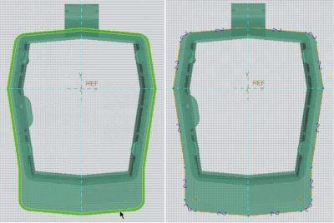

5. Select the second loop of edges for the sketch.

• Cursor over the workpiece model, and right-click until the surface on GEARBOX_CASTING_ WRK.PRT highlights, as shown.

• Select the highlighted surface.

• Click **Next > Accept** to select the inner loop of edges, as shown.

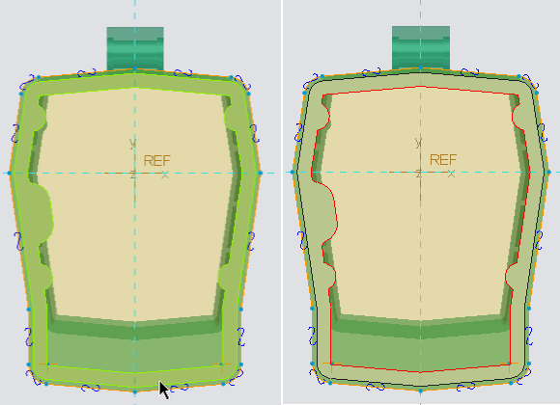

6. Complete the extrusion.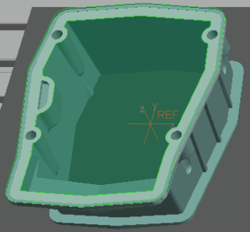

• Click **OK** from the Sketcher toolbar.

• Press CTRL + D to return to the standard

orientation.

• In the dashboard, edit the depth to **2**.

• Click **Complete Feature** .

• Select GEARBOX_CASTING.ASM in the model

tree.

• Right-click and select **Activate** .

• Select the EXTRUDE 1 feature in the model

tree.

• Observe the material added to the top of the

casting, as shown.

7. Click **Regenerate** .

**Note: You could also vary the dimensions of the external inheritance features in the gearbox casting workpiece if required.**

8. Save the manufacturing model and erase all objects from memory.

• Click **Save** from the Quick Access toolbar.

• Click **Close**  from the Quick Access toolbar.

• Click Erase **Not Displayed**  .

• Click **OK.**

This completes the exercise.

**14. Creating and Using NC Model Assemblies**

You can create NC model assemblies that consist of a reference model and a workpiece. You can then use NC model assemblies by assembling them into manufacturing models.

Creating NC Model Assemblies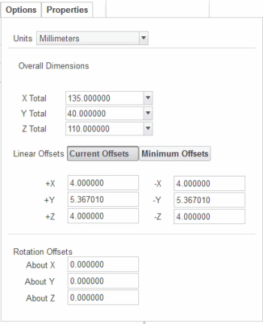

• Create Stock Options:

– Workpiece Shape

– Overall Dimensions

– Offset Dimensions

– Rotation Offsets

Figure 1 – Create Stock Options

Using NC Model Assemblies

• Alternative means of creating manufacturing models.

• Place directly into manufacturing models.

• Components classified automatically.

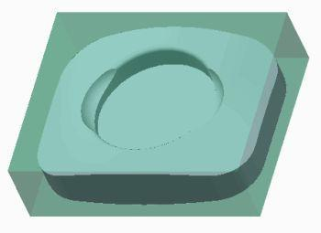

Figure 2 – Configuring the Workpiece Figure 3 – Resulting Manufacturing Model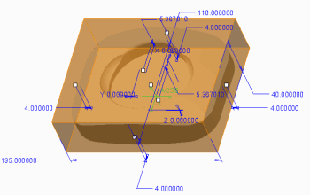

**Creating NC Model Assemblies**

You can create NC model assemblies that consist of a reference model and a workpiece. You must first add a reference model to the assembly. You can then create a workpiece using the Create Stock dashboard.

• Create Stock Dashboard – This dashboard enables you to configure rectangular and round workpiece shapes depending on your requirements. A number of options are available including the following:

– Workpiece Shape – You can specify rectangular or round.

– Overall Dimensions – You can specify the overall dimensions for the workpiece.

– Offset Dimensions – You can specify offset dimensions on the X-, Y-, and Z-axes, for rectangular workpieces, and length and diameter for round workpieces. The offset dimensions can be edited directly or by using drag handles.

– Rotation Offsets – You can rotate the workpiece on the X-, Y-, and Z-axes from its default orientation.

**Using NC Model Assemblies**

NC model assemblies provide an alternative means of creating manufacturing models. You can use previously created NC model assemblies by placing them directly into manufacturing models. There is no need to assemble components within the manufacturing model. The models are automatically classified correctly as a reference model and a workpiece within the NC model assembly.

**15. Using Manufacturing Parameters**

**Manufacturing parameters enable you to control how an NC sequence is generated. It is important to understand the different ways in which you can configure manufacturing parameters.**

Manufacturing Parameters Parameter Types

• Six logical categories:

• Control NC sequences – Cut Depth and Allowances

• Examples: – Cutting Motions – Entry/Exit Motions

– CUT_FEED = 100 – Machine Settings

– SPINDLE_SPEED = 500 – General

– STEP_DEPTH = 2.5 • Required Parameters

– SCAN_TYPE = TYPE_SPIRAL – Must be configured

• Optional Parameters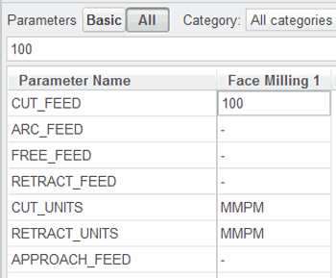

Parameter List Variation

• Based on type of NC sequence

Figure 1 – Feeds and Speeds Category

**Manufacturing Parameters**

• You create NC sequences by selecting or creating geometry to machine. You then determine

how to generate the toolpath by modifying manufacturing parameters?

• There are many different parameters that you can configure, including:

– CUT_FEED – Controls the feed rate of NC sequences during cutting motions.

– SPINDLE_SPEED – Controls spindle speed in NC sequences.

– STEP_DEPTH – Controls the incremental depth of each pass when cutting.

– SCAN_TYPE – Controls the method of scanning the machined area.

**Parameter Types**

• Categories – Parameters are grouped into six logical categories, enabling you to quickly locate

the relevant parameters to configure. The categories are:

– Feeds and Speeds – Parameters such as CUT_FEED and RETRACT_FEED.

– Cut Depth and Allowances – Cut parameters, such as STEP_DEPTH, and stock allowance

parameters.

– Cutting Motions – Parameters that specify the type of the cut, such as SCAN_TYPE and CUT_TYPE.

– Entry/Exit Motions – Parameters that specify the entry and exit path for the tool, such as

plunge angle, lead-in, approach, and exit path.

– Machine Settings – Machine-related parameters, such as spindle speed and coolant options.

– General – Machine and NC data file names.

• Required Parameters – These are parameters that you must set to create an NC sequence.

– Examples include STEP_DEPTH, CUT_FEED, and SPINDLE_SPEED.

– These parameters are highlighted in a light yellow color in the Edit Parameters dialog box until

they have been configured. This enables you to easily identify the parameters required to

create an NC sequence.

• Optional Parameters – Some parameters are optional and you can set them if required. They

provide additional control of the toolpath.

– One example is TOOL_OVERLAP, which you can use instead of STEP_OVER.

**Parameter List Variation**

• The parameters available for configuration can vary depending on the type of NC sequence

that you are creating.

– Some parameters such as feed rate and spindle speed are present in all NC sequence types.

– Some parameters are specific to certain types of sequences. When you create NC sequences,

only the relevant parameters are available for configuration.

1. **Configuring Parameter Values**

**You can configure parameter values using different methods. It is important to understand how these methods work.**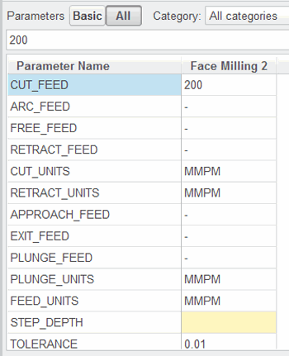

Specifying Parameter Values

• Site Parameter Files

• System Default Values

• Parameter Files

• Edit Parameter dialog box

– Category

– Parameters Basic/All

– Copy from Tool

– Show/Hide Details

• Model Tree

Figure 1 – Specifying Parameter Values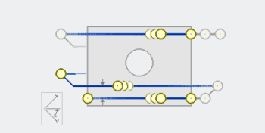

System Default Parameter Values

• Required Parameters

• System Default Values Figure 2 – Parameter Graphic Illustration

• Optional Parameters

• Numeric Assigned Parameters

• Non-numeric Assigned Parameters

**Specifying Parameter Values**

There are several ways to specify parameter values for NC Steps, including the following:

• Site parameter files – Enable you to set the default values for all NC step parameters. When

you create an NC step; these default values are read in as the initial parameter values.

• System default values – If you do not use a site file, standard default values for all parameters

are automatically set.

• Parameter files – When creating NC steps, you have the option to read in parameter values

from a file, or you can copy the parameter values from a previous NC sequence in your model.

• Edit Parameter dialog box – When creating NC steps, you can edit parameter values directly

using the Edit Parameter dialog box. A number of options are available, including:

– Category – You can view any of the six parameter categories. Alternatively, you can view all

categories.

– Parameters basic/all – You can view either the basic set of parameters or all parameters for a

specific category.

– Copy from tool – You can copy tool-cutting data parameters into an NC step.

– Show details/hide details – You can optionally display a graphic illustration for the selected

parameter. The illustration appears for basic parameters only. If the parameter has a

predefined set of values, the graphical illustration corresponding to the specified value appears.

• Model tree – You can configure parameters to display in the model tree. You can then edit the

values directly in the model tree.

**System Default Parameter Values**

When creating NC steps, Creo Parametric assigns a number of default values to parameters.

• Required parameters – If a parameter is highlighted in a light yellow color in the Edit

Parameters dialog box, then it is a required parameter.

– You must specify a value for this type of parameter to calculate a toolpath.

• Optional parameters – If a parameter has a default value of “-,” it is an optional parameter.

– You can leave this type of parameter unchanged if required. For example, APPROACH_FEED =-.

– This type of parameter is not used unless you specify a value.

• Numeric assigned parameters – This type of parameter is assigned a specific numeric value by

default.

– For example, CUT_ANGLE = 0.

– You can change these parameters to other specific values if desired.

• Non-numeric assigned parameters – This type of parameter is assigned a specific non-numeric

value by default.

– For example, COOLANT_OPTION = OFF.

– You can change these parameters to other specific values if desired. You can select the

available values from a drop-down list.

1. **Using Site Parameter Files**

**You can use site parameter files to control default values in NC sequences. They can also control the range of parameter values and the visibility of parameters.**

Site Parameter Files Using Site Parameter Files

• Parameter value control • Activate

– Allowable range of values – Link created

– Parameter visibility • Deactivate

• Links to site parameter files retained – Link broken

• Types • Work Center

– Mill, turn, holemaking, wire EDM – Assign different site parameter files

– General

– Each type contains relevant parameters

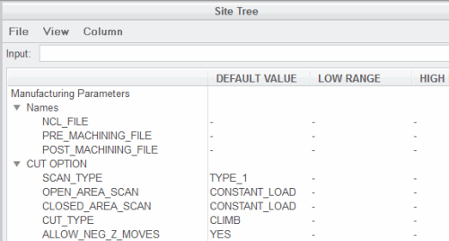

Figure 1 – Site Parameter File Example

**Site Parameter Files**

• You can use site parameter files to control the default parameter values used in NC steps.

• You can also use site parameter files to control the allowable range of parameter values and

control the visibility of parameters when creating NC steps.

– For example, you can set a default value for a parameter, such as CUTCOM = ON, and then turn

off the visibility of this parameter to prevent the value being edited.

• If you use site parameter file values in NC steps and subsequently change a site parameter file,

then you can update parameter values in any referenced NC step.

• You can configure several different types of site parameter files, including mill, turn,

holemaking, and Wire EDM.

– Each type of site parameter file contains the parameters relevant to its NC step types.

– You can also configure a general site parameter file that contains all available manufacturing

parameters.

**Using Site Parameter Files**

• Activate – You must activate a site parameter file to use it to control NC step parameter

values. You can activate a site parameter file manually (or select a different site file) when

configuring NC step parameters.

– After activating a site parameter file, any subsequent edits to NC step parameter values breaks

the link to the site parameter file for the edited parameter.

– Changes made to that parameter in the site parameter file are no longer passed on to the NC

step.

• Deactivate – You can also deactivate site parameter files in NC steps. All of the linked

parameter values are retained, but parameters no longer obtain their values from the site

parameter file.

• Work Center – You can assign one of each type of site parameter file to a Work Center, or you

can assign a single general site parameter file.

– Creo Parametric then automatically uses the correct site parameter file when creating new NC

steps. Parameter values are transferred into the NC step where appropriate.

**16. Creating Face Milling Sequences**

1. **Basic Face Milling**

**Face milling enables you to face down the workpiece. This enables you to define the top surface of the job and a reference surface for other NC sequences.**

Face Milling Using Mill Surfaces and Mill Windows

for Face Milling

• Face down the workpiece.

• Select or create final machining depth and area. • Alternative machining reference.

– Model surfaces • Mill geometry.

– Mill surfaces • Create before or during creation

– Mill volume surfaces of NC sequence.

– Workpiece surfaces • Mill Surfaces

– Mill windows – Fill

• All machining parallel to retract plane. – Extrude

• All inner contours excluded. – Copy

• Material removal after completing NC sequence. • Mill Windows

– Closed outline

– Depth considerations

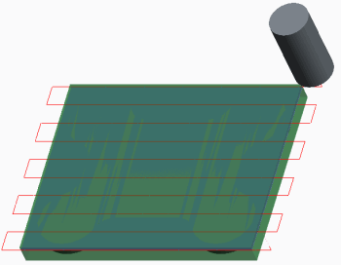 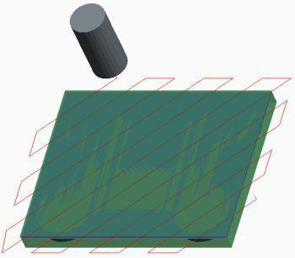

Figure 1 – Basic Face Milling Example Figure 2 – Editing Toolpath Parameter

**Face Milling**

A face milling sequence enables you to face down the workpiece with a flat or radius end mill tool. You configure the final machining depth and area by selecting or creating a planar surface parallel to the retract plane. Alternatively, you can configure a mill window to define the depth and area to be machined. The following features describe face milling NC sequences.

• All machining movements are parallel to the retract plane.

• All inner contours in the configured reference geometry (holes, slots) are automatically excluded from machining.

• If you have a workpiece in the manufacturing model, then you can remove the machined volume from the workpiece by creating a material removal feature. You can do this after you complete the NC sequence.

**Using Mill Surfaces and Mill Windows for Face Milling**

When creating face milling sequences, you can use mill geometry such as mill surfaces and mill windows as alternative machining references when model surfaces are not appropriate, for example, when you face mill multiple model surfaces. You can create mill surfaces and mill windows before creating an NC sequence or during the creation of an NC sequence.

• Mill Surfaces

– Mill surfaces are surface features and are often referred to as mill geometry.

– When referencing surfaces for face milling: ¨ By default, the toolpath completely machines the selected surfaces. ¨ The selected surfaces can be model surfaces, mill surfaces, surfaces from mill volumes, or workpiece surfaces.

– The most common mill surface types are:

• Fill – Use the fill tool to create a flat surface by sketching an outline on a sketching plane

• Extrude – Create an extruded surface by sketching an outline on a sketching plane.

• Copy – Copy existing model surfaces to form a new mill surface.

• Mill Windows

– Mill windows are manufacturing geometry features that you can use when creating face milling sequences. They consist of a closed outline that defines the area to be machined. You can create them before or during the creation of an NC sequence.

b– When referencing mill windows for face milling, the depth of the mill window and the depth of the machined reference geometry are considered in the following way:

• If the highest Z-depth of the reference geometry is lower than the mill window depth, then the final machined depth is defined by the mill window plane.

• If the highest Z-depth of the reference geometry is higher than the mill window depth, then the final machined depth is defined by the highest Z-depth of the reference geometry.

1. **Lateral Control Face Milling Parameters**

**Lateral control parameters are a group of parameters that control the lateral movement of the tool in face milling steps. Lateral movement is also affected by the trim_to_workpiece parameter.**

Lateral Control Parameters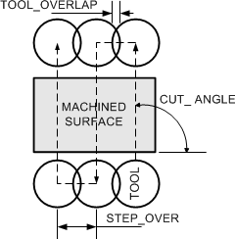

• SCAN_TYPE

– TYPE_1, TYPE_3, TYPE_ONE_DIR, or TYPE_SPIRAL

• CUT_ANGLE

• STEP_OVER

– or NUMBER_PASSES

– or TOOL_OVERLAP

• STEP_OVER_ADJUST Figure 1 – Lateral Control Parameters

• NUMBER_PASSES = 1

– One pass made at center

• ONE_PASS_OFFSET

• INITIAL_EDGE_OFFSET

• FINAL_EDGE_OFFSET TRIM_TO_WORKPIECE Parameter

• With a workpiece – Can adjust to boundary of workpiece.

• No workpiece – Always uses boundary of machined surface.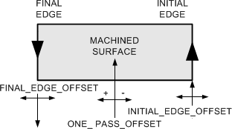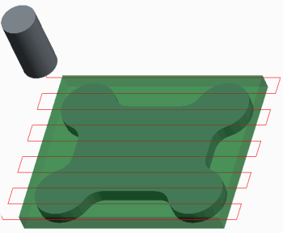

Figure 2 – Offset Parameters Figure 3 – TRIM_TO_WORKPIECE = YES

**Lateral Control Parameters**

The following is a summary of the key parameters that control the lateral movement of the tool in face milling steps.

• SCAN_TYPE

– TYPE_1 – Moves the tool back and forth across the surface.

– TYPE_3 – If there are separate zones, then each zone is machined separately. Otherwise the

same as TYPE_1.

– TYPE_ONE_DIR – Machines in one direction and retracts between passes.

– TYPE_SPIRAL – Creates a spiral toolpath.

• CUT_ANGLE – Is the angle between the cut direction and the X-axis of the NC Step coordinate

system.

• STEP_OVER – Three parameters control the step-over distance. The final toolpath uses the

parameter that produces the smallest calculated ststep-over:

– STEP_OVER – Controls the step-over within a slice.

– Or NUMBER_PASSES – Explicitly sets the number of passes to take in each slice.

– Or TOOL_OVERLAP – An alternative method to control the step-over based on the tool

overlap.

• If NUMBER_PASSES is equal to 1, however, step-over is ignored and one pass is created at the

center of the machined surface for each slice.

• STEP_OVER_ADJUST – Adjusts the passes in the slice to start and finish near the edges of the

surface that you are machining. It only reduces the step-over distance, and adds an extra pass if

needed.

• ONE_PASS_OFFSET – Controls the distance away from the centerline when NUMBER_PASSES is

equal to 1, and a single pass is made.

• INITIAL_EDGE_OFFSET – Enables you to offset the first pass in relation to the edge of the

surface being milled.

• FINAL_EDGE_OFFSET – Enables you to offset the last pass in relation to the edge of the surface

being milled.

**TRIM_TO_WORKPIECE Parameter**

Face milling steps behave differently if a workpiece is in the manufacturing model.

• With a workpiece – The starting height for the cuts is always one cut depth below the top of

the workpiece.

– If TRIM_TO_WORKPIECE is set to NO, then Creo Parametric machines the selected surface

without regard to the workpiece outline.

– If TRIM_TO_WORKPIECE is set to YES, then the toolpath extends or trims to the workpiece

cross-section at the depth of the surface you are machining.

• Without a workpiece – The step parameters exclusively determine the starting height for the

cuts and the toolpath completely machines the selected surface.

1. **Depth Control Face Milling Parameters**

**There are a number of parameters that control the depth of a cut when creating face milling sequences.**

Depth Control Parameters

• STEP_DEPTH

• NUMBER_CUTS

– Smallest resulting depth of cut used.

• If NUMBER_CUTS = 0 or 1 and STEP_DEPTH is greater than depth to be machined.

– One pass taken at full depth.

• BOTTOM_STOCK_ALLOW

– Stock remaining on machined surface.

– Default is zero

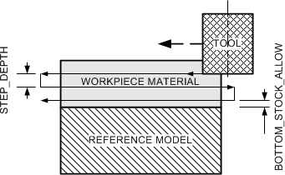

Figure 1 – Depth Control Parameters

**Depth Control Parameters**

When you use a workpiece, the starting height for the cuts is determined by the top of the workpiece. The following parameters control the depth of cut.

• The STEP_DEPTH parameter specifies the depth between each slice, and the NUMBER_CUTS

parameter determines the number of slices.

– The parameter that creates the smallest depth of cut is used.

• If the NUMBER_CUTS equals 0 or 1 and the STEP_DEPTH is equal to or greater than the depth

to be machined, then one pass is taken at full depth.

• The BOTTOM_STOCK_ALLOW parameter determines how much stock is left on the machined

surface. The default dash (-) value leaves zero stock.

1. **Entry and Exit Face Milling Parameters**

**There are a number of parameters that control entry and exit motions when creating face milling sequences.**

Entry and Exit Parameters

• START_OVERTRAVEL and END_OVERTRAVEL

– Offsets for each pass.

• APPROACH_DISTANCE and EXIT_DISTANCE

– Offsets for the first and last passes.

• ENTRY_EDGE and CLEARANCE_EDGE

– Set to LEADING_EDGE, CENTER, or HEEL.

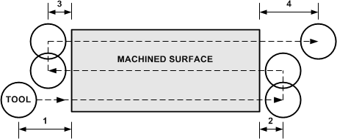

Figure 1 – Entry and Exit Parameters Example

1. APPROACH_DISTANCE and START_OVERTRAVEL

2. END_OVERTRAVEL

3. START_OVERTRAVEL

4. EXIT_DISTANCE and END_OVERTRAVEL

**Entry and Exit Parameters**

The following parameters provide additional control over the entry and exit motions for face milling sequences.

• The START_OVERTRAVEL parameter adds an offset to the beginning of each pass in a slice.

The END_OVERTRAVEL adds an offset to the end of each pass in a slice.

• The APPROACH_DISTANCE parameter adds an extra approach distance to the first pass of

each slice. The EXIT_DISTANCE parameter adds an extra distance to the last pass of each slice.

• You can edit the ENTRY_EDGE parameter to LEADING_EDGE (the default), CENTER, or HEEL.

This parameter controls which point of the tool is used for measuring the approach and over

travel motions when the tool approaches the component being machined during each pass in a

slice.

• You can edit the CLEARANCE_EDGE parameter to HEEL (the default), CENTER, or

LEADING_EDGE. This parameter controls which point of the tool is used for measuring the exit

and over travel motions when the tool leaves the material during each pass in a slice.

1. **Exercise 1: Creating Face Milling Sequences**

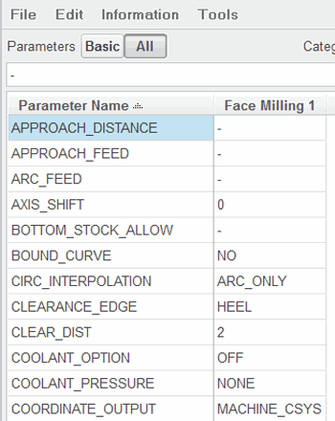

**Objectives**

After successfully completing this exercise, you will be able to:

• Create mill window geometry.

• Create face milling sequences.

• Edit milling parameters to adjust face milling sequences.

**Scenario**

You need to create a face milling sequence to machine the top face of a cover component. During the creation of this sequence, you adjust sequence parameters and references to create a more efficient toolpath.

**Close Window** **Erase Not Displayed** 

Milling\Face_Cover  COVER_FACING .ASM

**Task 1: Create a mill window as a machining reference.**

1. Disable all Datum Display types.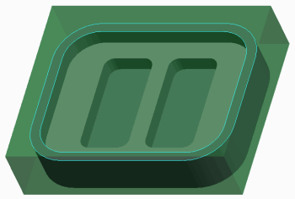

2. Click Mill Window from the Manufacturing

Geometry group.

3. Click Chain Window in the dashboard.

4. To configure the window plane, cursor over the

model, right-click, and select the hidden model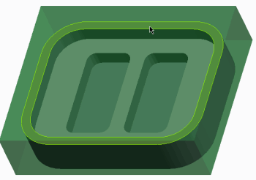

surface, as shown.

5. Right-click and select Chain to active the

selection of edges.

6. Select one of the chain of edges at the top of

the workpiece, as shown.

7. Press SHIFT, cursor over the model, and select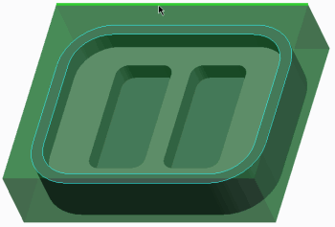

the top surface of the workpiece, as shown.

• Notice that the loop of edges on the top

surface of the workpiece are selected, as

shown.

8. Click Complete Feature in the dashboard.

**Task 2: Create a face milling sequence.**

1. Select the **Mill** tab.

2. Click **Face**  from the Milling group.

• Select the **50_0_E_MILL** tool from the Tool Manager drop-down menu.

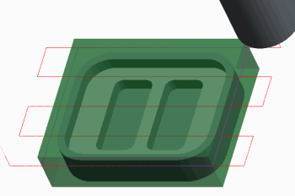

3. Retrieve face milling parameters.

• Select the **Parameters** tab.

• Click **Edit Machining Parameters**  .

• If necessary, click **All**, and select **All**

**categories** from the Categories drop-down

list.

• In the Edit Parameters dialog box, click **File**

**>** **Open**.

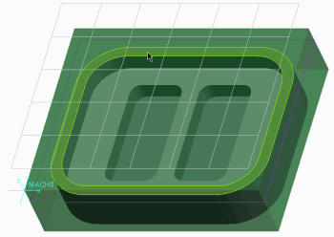 • Select the FACE .MIL parameter file, and click

**Open**.

• Notice that the required parameter values

are now configured. You can retrieve stored

parameter files to expedite the configuration

of manufacturing parameters.

• Click **OK**.

4. Configure the surface for machining.

• Select the **Reference** tab.

• Change Type from Mill Window to Surface.

• Click in the Machining References collector.

• Select the top surface of the model, as shown.

5. Review the resulting toolpath.

• Click **Display Toolpath**  .

• Click **Play**  .

• Notice that the toolpath follows the outline of

the selected model surface. You can change

this by editing the TRIM_TO_WORKPIECE

parameter value.

• Click **Close**.

6. Edit the trim to workpiece parameter.

• Select the **Parameters** tab.

• Click **Edit Machining Parameters**  .

7. Edit TRIM_TO_WORKPIECE to **YES**.

• Click **OK**.

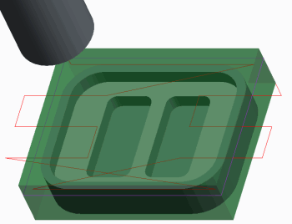8. Review the resulting toolpath.

• Click **Display Toolpath**  .

• Click **Play**  .

• Notice that the toolpath now follows the

outline of the workpiece, as shown.

• Click **Close**.

9. Edit the trim to workpiece parameter to NO.

• Select the **Parameters** tab.

• Click **Edit Machining Parameters**  .

• Edit TRIM_TO_WORKPIECE to **NO**.

• Click **OK**.

**Note: Alternatively, you can adjust the outline of the toolpath by using a mill window.**

**Task 3: Use a mill window as a machining reference for the NC sequence.**

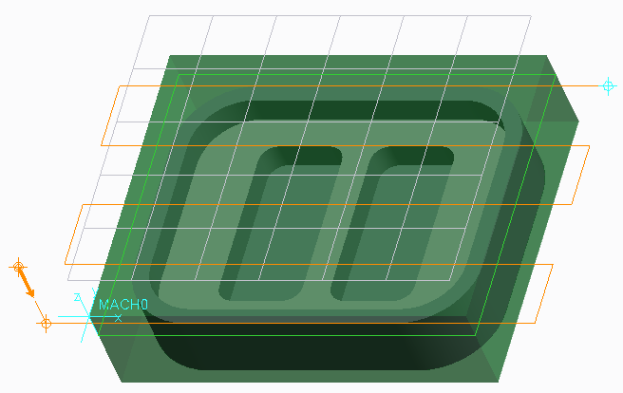

1. Select the **Reference** tab.

• Change Type from Surface to Mill Window.

2. Select the Mill Window in the model tree.

3. Review the updated toolpath. 

• Click **Display Toolpath**  .

• Click **Play**  .

• Notice that the toolpath now follows the

outline of the mill window, as shown.

4. Click **Close**.

**Note: Alternatively, you can adjust the outline of the toolpath by using a mill surface.**

**Task 4: Use a mill surface as a machining reference for the NC sequence.**

1. Select the **Reference** tab.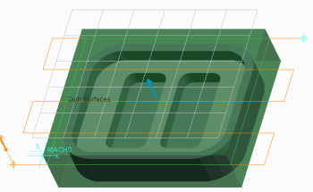

• Change Type from Mill Window to Surface.

2. Select the hidden feature Fill 1 in the model tree.

3. Review the updated toolpath.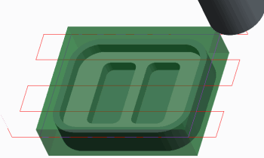

• Click **Display Toolpath**  .

• Click **Play**  .

• Notice that the toolpath now follows the

outline of the mill surface, as shown.

• Click **Close**.

**Task 5: Edit the sequence parameters to adjust the approach and exit moves, the step depth, and the cut angle.**

1. Select the **Parameters** tab.

• Click **Edit Machining Parameters**  .

• Edit the following parameters.

• Edit STEP_DEPTH to **4**.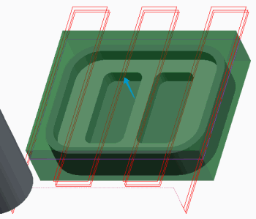

• Edit CUT_ANGLE to **90**.

• Edit APPROACH_DISTANCE to **CUTTER_DIAM/2**.

• Edit EXIT_DISTANCE to **CUTTER_DIAM/2**.

• Click **OK**.

2. Review the updated toolpath.

• Click **Display Toolpath**  .

• Click **Play**  .

• Click **Close**.

**Note: By configuring an APPROACH_DISTANCE and EXIT_DISTANCE, the tool clears the workpiece at the beginning and end of the toolpath. By configuring a STEP_DEPTH of 4, we have three passes (our stock is 10 mm). Notice that the third pass is much smaller than the other two. The CUT_ANGLE makes the toolpath rotate 90 degrees relative to the X-axis.**

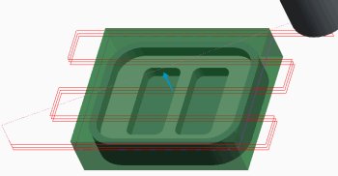

3. Edit the cut angle and number cuts parameters.

• Select the **Parameters** tab.

• Click **Edit Machining Parameters**  .

4. Edit the following parameters.

• Edit CUT_ANGLE to **0**.

• Edit NUMBER_CUTS to **3**.

• Click **OK**.

5. Review the updated toolpath.

• Click **Display Toolpath**  .

• Click **Play**  .

• Click **Close**.

**Note: Configuring the NUMBER_CUTS to 3 computes a smaller step depth, so NUMBER_CUTS overrides the STEP_DEPTH parameter and you get three evenly spaced passes.**

**Task 6: Edit the sequence parameters to adjust the over travel on each pass and the initial and final edge offsets.**

1. Select the **Parameters** tab.

• Click **Edit Machining Parameters**  .

2. Edit the following parameters.

• Edit START_OVERTRAVEL to **25**.

• Edit END_OVERTRAVEL to **25**.

• Edit ENTRY_EDGE to **CENTER**.

• Edit CLEARANCE_EDGE to **CENTER**.

• Click **OK**.

3. Orient the model using a named view.

• From the Graphics toolbar, click **Saved Orientations**  and select TOP from the drop-down

list.

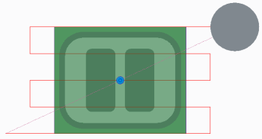

4. Review the updated toolpath.

• Click **Display Toolpath**  .

• Click **Play**  .

• Click **Close**.

**Note: You specify which part of the tool to measure the over travel on each pass by changing the ENTRY_EDGE and CLEARANCE_EDGE to CENTER. Configuring START_OVERTRAVEL and END_OVERTRAVEL to 25 causes the center of the tool to move 25 mm past the machined surface for each approach move and each exit move.**

5. Edit the edge offset parameters.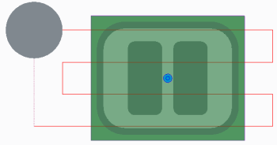

• Select the **Parameters** tab.

• Click **Edit Machining Parameters**  .

6. Edit the following parameters.

• Edit INITIAL_EDGE_OFFSET to **CUTTER_**

**DIAM/4.**

• Edit FINAL_EDGE_OFFSET to **CUTTER_**

**DIAM/4.**

• Click OK.

7. Review the updated toolpath.

• Click **Display Toolpath**  .

• Click **Play**  .

**Note: You can configure the edge offset parameters to move the toolpath toward or away from the initial and final edges (passes). A positive value moves the toolpath into the machined surface. A negative value moves it away from the machined surface.**

8. Click **Close**.

9. Click **Complete Feature** .

10. Press CTRL + D to return to the standard orientation.

**Task 7: Create a material removal feature to cut away the machined volume from the workpiece for the face milling sequence.**

1. Click **Material Removal Cut**  from the Manufacturing Geometry group drop-down menu.

• Select **Face Milling** from the menu manager.

• Click **Done**.

• Select the check box for Automatic Update, at the top of the Intersected Components panel.

• Click **OK**.

**Note: Notice the automatic cut created in the workpiece. This also appears as a feature in the model tree.**

2. Save the manufacturing model and erase all objects from memory.

• Click **Save**  from the Quick Access toolbar.

• Click **Close**  from the Quick Access toolbar.

• Click **Erase Not Displayed**  .

• Click **OK**.

This completes the exercise.

**17. Creating Volume Milling Sequences**

1. **Basic Volume Milling**

**Volume milling sequences enable you to machine material inside a configured volume of material. This is useful for machining mold cavities and machining pockets and slots.**

**Volume Milling**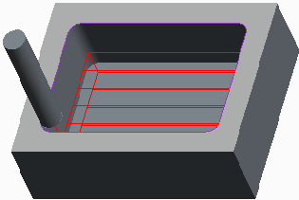

• Remove material inside volume.

• For example

– Mold cavities, mold electrodes, pockets, and slots.

• Toolpath removes material slice-by-slice.

• Slices parallel to retract plane. Figure 1 – Volume Milling Toolpath Example

• Roughing and profiling passes.

• Use manufacturing geometry.

– Mill volume or mill window.

• Tool does not machine outside specified volume.

– Specify approach walls.

• Also use top surfaces.

• Modify default cut motions.

– Volume milling cut.

• Material removal after completing NC sequence.

Mill Volume Configuration Tools

• Add solid features – Extrude a sketched outline.

• Trim – Subtract reference model.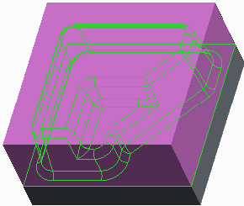

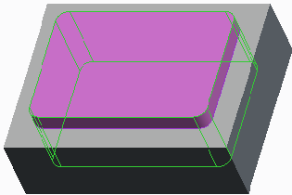

Figure 2 – Extruded Mill Volume Figure 3 – Trimmed Mill Volume

**Volume Milling**

You typically use volume milling sequences to remove large amounts of workpiece material. Examples include machining mold cavities and mold electrodes and machining pockets and slots.

You can use the following features to describe volume milling NC sequences.

• Volume milling sequences remove the material inside a specified volume slice-by-slice.

• All slices are parallel to the retract plane.

• You can create both roughing and profiling passes within a volume milling sequence.

• You use manufacturing geometry to configure the volume of material to machine.

– You can use a mill volume or mill window to represent the volume of material to be

removed.

• By default, the tool does not machine outside the specified volume.

– However, the tool can break through surfaces of a volume if they are specifically selected as

approach walls.

• Top surfaces are surfaces of a mill volume that the tool can also penetrate when creating the

toolpath.

– You only have to use this option if some of the top surfaces of the volume are not parallel to

the retract plane. If you use a mill window, this option is not available. You can use the window

start plane as the top surface.

• You can modify the default cut motions by using the volume milling cut functionality.

• If you have a workpiece in the manufacturing model, you can remove the machined volume

from the workpiece by creating a material removal feature. You can do this after you complete

the NC sequence.

**Mill Volume Configuration Tools**

The following tools enable simple mill volume configuration:

• Add solid features – You can sketch an outline and create an extruded mill volume. If required, you can also create more complex shapes using tools such as revolve, sweep, and blend.

• Trim – You can automatically subtract the reference model material from an existing mill volume. You usually apply this to sketched volumes.

1. **Exercise 1: Creating Volume Milling Sequences: Extrude and Trimming**

**Objectives**

After successfully completing this exercise, you will be able to:

• Create volume milling sequences.

• Create extruded mill volumes.

• Edit mill volumes using trim and offset functionality.

• Configure approach walls for mill volumes.

**Scenario**

You need to create a volume milling sequence to rough out material for an electrode. You use an extruded mill volume which you trim to the reference model. You also extend the mill volume and configure approach walls to get the desired toolpath.

**Close Window** **Erase Not Displayed** 

Milling\Volume  ELECTRODE.ASM

**Task 1: Create a Mill Volume**.

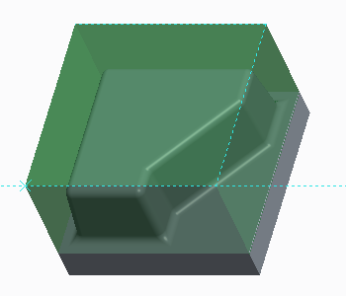

1. Disable all Datum Display types.

2. In the ribbon, click **Mill Volume**  from the Manufacturing Geometry group.

3. Click **Extrude**  .

4. Right-click and select **Define Internal Sketch**.

5. Select the top surface of the workpiece.

6. Click **Sketch**.

7. Right-click and select **References**.

• Select the **edges** shown.

• Click **Close**.

8. Click **Project** from the Sketching group.

9. Select the **Loop** option.

10. Select the top surface of the workpiece model.

11. Click **OK** .

12. Right-click and select **Flip Depth Direction**.

13. Edit the depth to **52**.

14. Click **Complete Feature**  .

**Note: You have created an extruded mill volume. You can now subtract the reference model from the mill volume geometry using the trim functionality**.

15. Click **Trim**  from the Volume Features group. 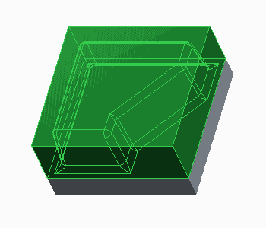

• In the graphics window, query select the

reference model, as shown.

**Note: You can offset mill volume walls to extend the mill volume beyond the edges of the workpiece**.

16. Click **Offset**  from the Editing group.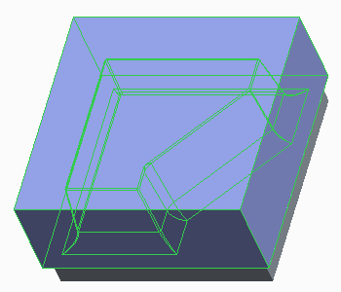

• Edit the offset value to **5**.

17. Click **Complete Feature** . 

18. Click **OK** .

**Task 2: Create the Mill Rough Sequence**.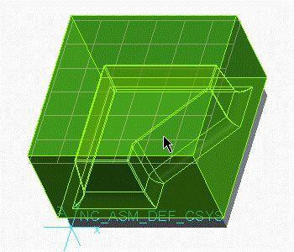

1. In the ribbon, select the **Mill** tab.

2. Select **Volume Rough**  from the Roughing

drop-down menu in the Milling group.

3. Select **20_E_MILL** tool from the Tool Manager

drop-down menu.

4. Select the **Reference** tab.

• Click in the Machining Reference collector,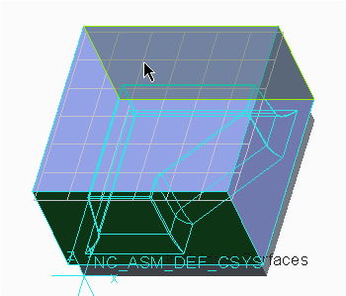

and select the mill volume in the graphics

area as shown.

• Click in the Approach Walls Surfaces

collector.

• Press CTRL and select the front and back

walls of the mill volume.

**Note: You can also configure approach walls to avoid plunging into the workpiece material**.

5. Select the **Parameters** tab.

• Edit CUT_FEED to **60**.

• Edit STEP_OVER to **15**.

• Edit MAX_STEP_DEPTH to **10**.

• Edit CLEAR_DIST to **2**.

• Edit SPINDLE_SPEED to **600**.

6. Click **Complete Feature**  .

7. In the model tree, select EXTRUDE 1, then right-click and select **Hide**  .

8. In the Graphics toolbar, select **Hidden Line**  from the Display Style types drop-down menu.

9. In the model tree, select VOLUME MILLING, then right-click and select **Play Path**  .

10. In the Play Path dialog box, click **Play** .

11. Select **Shading**  from the Display Style types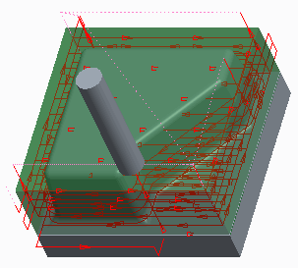

drop-down menu.

12. Review the simulation, and click Close.

**Note: You can hide mill volumes to enable easier viewing of toolpaths. You can unhide mill volumes for editing when required.**

**Task 3: Create a material removal feature to display the machined model.**

1. Select **Material Removal Cut**  from the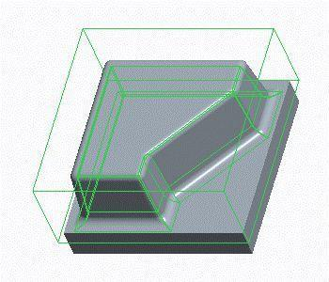

Manufacturing Geometry Group drop-down

menu.

• In the menu manager, click **Volume Milling**.

• Click **Automatic > Done**.

• In the Intersected Components dialog box,

click **AutoAdd**.

• Click **OK**.

**Note: The automatic cut is created in the workpiece. The cut geometry is based on the stock allowance parameter values in the volume milling sequence.**

2. Save the manufacturing model and erase all objects from memory.

• Click **Save**  from the Quick Access toolbar.

• Click **Close**  .

• Click **Erase Not Displayed**  .

• Click **OK**.

This completes the exercise.

1. **Volume Milling with Mill Windows**

**You can use mill windows to specify the volume of material to be machined when creating volume milling sequences.**

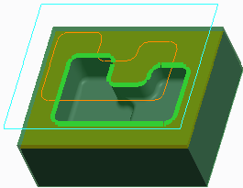

**Mill Windows**

• Closed outline projected onto reference model.

• Configuring mill windows:

– Select a closed outline.

– Sketch a closed outline.

– Use reference model silhouette outline. Figure 1 – Selected Outline

• Reference model geometry within window is

machined.

• Options:

– Placement

– Depth

– Offset Window Uniformly

– Window Contour Options:

• Inside

• On

• Outside

– Inside loops

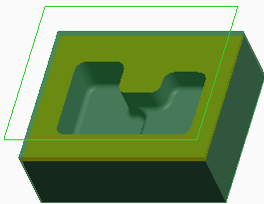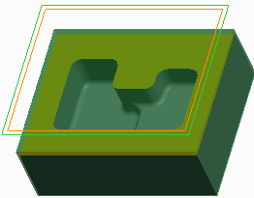

Figure 2 – Sketched Outline Figure 3 – Silhouette Outline

**Mill Windows**

• Mill windows are manufacturing geometry features that you use to create volume milling sequences. They consist of a closed outline projected from the window start plane onto the reference model.

You can then machine the resulting outline in a volume milling sequence. You can create them before or during the creation of an NC sequence.

• You create a mill window by:

– Sketching or selecting a closed outline in an appropriate plane.

– Projecting the silhouette outline of the reference part on the mill window start plane.

• All reference model geometry visible within the window is machined.

• You can configure a number of options.

– Placement – Defaults to the retract plane. Enables you to configure the starting plane.

– Depth – Defaults to reference model geometry. Alternatively you can specify a blind depth

of up to a selected plane parallel to the window start plane.

– Offset Window Uniformly – Enlarge or reduce the window contour by a constant distance.

– Window Contour Options

• Inside – The tool is always within the outline of the mill window.

• On – The tool axis reaches the window outline.

• Outside – The tool goes completely past the window outline.

– Inside Loops – If a reference part used for creating the silhouette contains through cuts or

holes, you can specify if you want to keep or remove these loops by using the Keep Inside Loops

check box.

1. **Exercise 2: Creating Volume Milling Sequences with Mill Windows**

**Objectives**

After successfully completing this exercise, you will be able to:

• Create volume milling sequences.

• Create sketched mill windows.

**Scenario**

You need to create a volume milling sequence to machine the inside of a pocket in the housing component. During the creation of this sequence, you create a sketched mill window to specify the machined volume.

**Close Window** **Erase Not Displayed** 

 Milling\Volume_Mill_Window  HOUSING.ASM

**Task 1: Create a mill window to use as a machining reference.**

1. Disable all Datum Display types.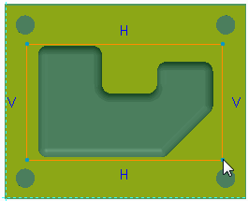

2. Configure a mill window using the Sketch

Window option.

• Click **Mill Window** 8 from the Manufacturing

Geometry group.

• In the model tree, select datum plane

RETRACT as the window plane.

• Click **Sketch Window**  in the dashboard.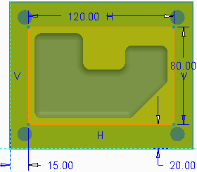

• Click **Sketch**  in the dashboard. 

• Select datum plane NC_ASM_FRONT in

the model tree as the sketch orientation

reference.

• Click **Sketch**.

• Orient the sketching plane parallel to the

screen.

• Select **Corner Rectangle**  from the

Rectangle drop-down menu in the Sketching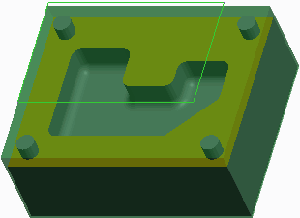

group.

• Sketch a rectangle, as shown.

• Middle-click to finish sketching.

• Edit the sketch dimensions, as shown.

• Click **OK** .

• Press CTRL + D to return to the standard

orientation.

• Click **Complete Feature** .

• Notice that a mill window is created, as shown.

**Task 2: Create a volume milling sequence using the Sketched Mill window.**

1. In the ribbon, select the **Mill** tab.

2. Select **Volume Rough**  from the Roughing drop-down menu in the Milling group.

3. From the Tool Manager drop-down menu, select the **20_E_MILL** tool.

4. Select the **Parameters** tab.

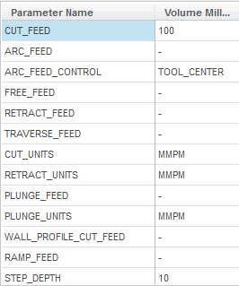 • Edit CUT_FEED to **100**.

• Edit STEP_OVER to **10**.

• Edit MAX_STEP_DEPTH to **10**.

• Edit CLEAR_DIST to **2**.

• Edit SPINDLE_SPEED to **500**.

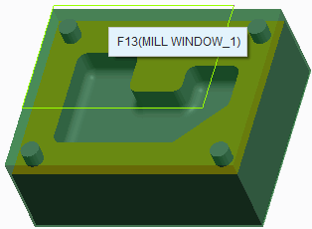

5. Select the **Reference** tab.

• Click in the Reference collector.

• Ensure that the sketched mill window,

F13(MILL_WINDOW_1), is selected.

6. Click **Display Toolpath**  .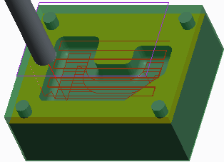

7. In the Play Path dialog box, click **Play** .

8. Click **Saved Orientations**  from the In

Graphics toolbar, and select TOP.

9. Review the simulation and click **Close**.

**Note: Notice that the toolpath machines up to the edge of the mill window outline. You can edit this by changing mill window options.**

10. Click **Complete Feature**  .

11. In the model tree, select the MILL WINDOW 1, then right-click and select **Edit Definition**  .

12. Select the **Options** tab.

• Select the On **window contour** option.

13. Click **Complete Feature** . 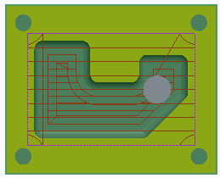

14. In the model tree, select VOLUME MILLING,

then right-click and select **Play Path**  .

15. Click **Play**  .

**Note: Notice that the toolpath now machines onto the edge of the mill window outline, as shown.**

16. Review the simulation and click **Close**.

17. Press CTRL + D to return to the standard orientation.

18. Save the manufacturing model and erase all objects from memory.

• Click **Save**  from the Quick Access toolbar.

• Click **Close**  .

• Click **Erase Not Displayed**  .

• Click **OK**.

This completes the exercise.

1. **Scanning Volume Milling Parameters**

**Scanning parameters are a group of parameters that control how the tool machines each slice in volume milling sequences.**

Scanning Parameters • High speed machining options

• ROUGH_OPTION – CONSTANT_LOAD

– ROUGH_ONLY – SPIRAL_MAINTAIN_CUT_TYPE

– ROUGH_AND_PROF – SPIRAL_MAINTAIN_CUT_DIRECTION

– PROF_AND_ROUGH – FOLLOW_HARDWALLS

– PROF_ONLY

– ROUGH_AND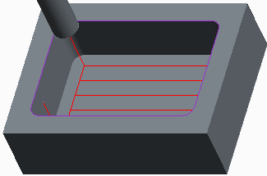

_CLEAN_UP

– POCKETING

– FACES _ONLY

• CUT_ANGLE

Figure 1 – ROUGH_OPTION = ROUGH_AND_PROFILE

• SCAN_TYPE – TYPE_1

– TYPE_2

– TYPE_

– TYPE_SPIRAL

– TYPE_ONE_DIR

– POCKETING

– FACES _ONLY

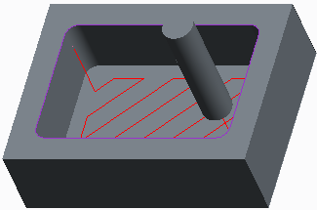

Figure 2 – CUT_ANGLE = 45 degrees

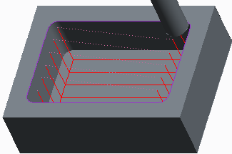

Figure 3 – SCAN_TYPE = TYPE_ONE_DIR

**Scanning Parameters**

The following is a summary of the key parameters that control how the tool scans each slice in volume milling sequences.

• ROUGH_OPTION – Controls whether a profiling and/or roughing pass is created during volume milling.

– ROUGH_ONLY

– No profiling.

– ROUGH_AND_PROF

– Rough then profile.

– PROF_AND_ROUGH

– Profile then rough.

– PROF_ONLY

– Only profiling.

– ROUGH_AND_CLEAN_UP – Cleans up the walls of the volume without creating a profiling pass.

– POCKETING – Profiles the walls of the volume and finish mills all the planar surfaces inside

the volume that are parallel to the retract plane (island tops and bottom of the volume).

– FACES _ONLY – Finish mills only the planar surfaces inside the volume that are parallel to the

retract plane (island tops and bottom of the volume).

• CUT_ANGLE – The angle between the cut direction and the X-axis of the NC Sequence

coordinate system.

• SCAN_TYPE – For volume milling. Refers to the way a milling tool scans the horizontal

cross-section of a milling volume and avoids islands.

– TYPE_1 – Continuously machines the volume. Retracts upon encountering islands.

– TYPE_2 – Continuously machines the volume without retracting, while moving around the

islands.

– TYPE_3 – Removes material from continuous zones defined by the island geometry, machining

them in turn and moving around the islands.

– TYPE_SPIRAL – Generates a spiral cutter path.

– TYPE_ONE_DIR – The tool only cuts in one direction.

– POCKETING – Profiles the walls of the volume and finish mills all the planar surfaces, inside

the volume, that are parallel to the retract plane (island tops and bottom of the volume).

– FACES _ONLY – Finish mills only the planar surfaces, inside the volume, that are parallel to

the retract plane (island tops and bottom of the volume).

• The following SCAN_TYPE parameter values relate specifically to high speed machining

methods.

– CONSTANT_LOAD – Performs high speed roughing (with ROUGH_OPTION set to ROUGH_ONLY)

or profiling (with ROUGH_OPTION set to PROF_ONLY) .

– SPIRAL_MAINTAIN_CUT_TYPE – Generates a spiral cutter path with reverse arc connections

between cuts. This is a high speed machining option, which minimizes retracts.

– SPIRAL_MAINTAIN_CUT_DIRECTION – Generates a spiral cutter path with S-shape connections

between cuts. This is a high speed machining option, which minimizes retracts.

– FOLLOW_HARDWALLS – The shape of each cut follows the shape of the walls of the volume,

maintaining fixed offset between the respective points of two successive cuts. If the cuts are

closed, there are S-shape connections between the cuts.

1. **Depth and Lateral Control Volume Milling Parameters**

**There are many parameters that control the depth of cut and lateral movement when you create volume milling sequences.**

Lateral Control Parameters Depth Control Parameters

• Step-over distance: • STEP_DEPTH

– STEP_OVER • WALL_SCALLOP_HGT

– NUMBER_PASSES • MIN_STEP_DEPTH

– TOOL_OVERLAP

– BOTTOM_SCALLOP_HEIGHT

• STEP_OVER_ADJUST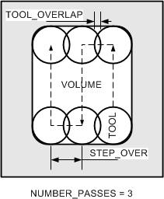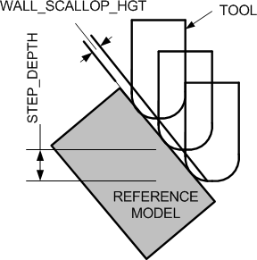

Figure 1 – Lateral Control Parameters Figure 2 – Depth Control Parameters

**Lateral Control Parameters**

• Four parameters control the step-over distance. The final toolpath uses whichever parameter

produces the smallest calculated step-over.

– STEP_OVER – This is the default parameter for controlling the step-over within a slice.

– Or NUMBER_PASSES– This explicitly sets the number of passes to take in each slice.

– Or TOOL_OVERLAP – This is an alternative method to control the step-over based on the tool

overlap.

– BOTTOM_SCALLOP_HEIGHT – This must be less than or equal to cutter radius. You can also

use it to calculate step-over.

• STEP_OVER_ADJUST – This parameter adjusts the passes in the slice to start and finish near

the edges of the volume that you are machining. It only reduces the step-over distance, and

adds an extra pass if needed.

**Depth Parameters**

• You can use the STEP_DEPTH parameter to specify the depth between each slice.

• WALL_SCALLOP_HGT – Also controls the step depth for volume milling.

– WALL_SCALLOP_HGT – Must be less than or equal to the cutter radius. The default value is 0.

– If WALL_SCALLOP_HGT is zero, a scallop height is calculated using STEP_DEPTH.

– If you specify WALL_SCALLOP_HGT > 0, a step depth is calculated using WALL_SCALLOP_HGT. This calculated value is compared to the STEP_DEPTH, and the smallest calculated step-depth is used.

• MIN_STEP_DEPTH – Specifies the minimum allowable distance between slices.

1. **Stock Allowance Volume Milling Parameters**

**There are a number of parameters that control the stock allowance when you create volume milling sequences.**

Stock Allowance Parameters

• ROUGH_STOCK_ALLOW – Stock on walls for rough passes.

• PROF_STOCK_ALLOW – Stock on walls for profile passes. – Used in material removal.

• BOTTOM_STOCK_ALLOW – Stock on bottom faces for rough and profile passes.

– Defaults to PROF_STOCK_ALLOW if set to “-”.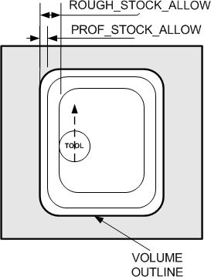

Figure 1 – Stock Allowance Parameters

**Stock Allowance Parameters**

The following parameters control stock allowance when volume milling.

• ROUGH_STOCK_ALLOW – This controls stock on walls for roughing passes.

• PROF_STOCK_ALLOW – This controls the stock on walls for profile passes. You can also use

it to calculate remaining stock when creating material removal features.

• BOTTOM_STOCK_ALLOW – This controls the stock on bottom faces for rough and profile

passes. Defaults to PROF_STOCK_ALLOW if set to “-”.

1. **Gathering Mill Volumes**

**The gathering technique enables you to create complex mill volume shapes by referencing model geometry including surfaces and edges.**

Gathering Mill Volumes Options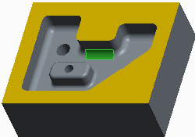

• Select Surfaces

– Form extruded quilt.

– Surf and Bound

– Surfaces Figure 1 – Surf and Bound: Seed Surface

– Features

– Mill Surfaces

• Exclude

– Exclude specified items.

– Surfaces

– Loops

• Fill

– Fill inner loops.

– All

– Loops

• Close – Cap mill volume.

– Specify plane or surface.

– Use retract plane.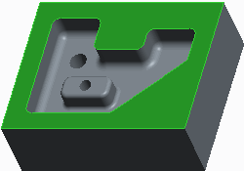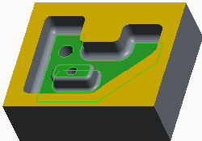

Figure 2 – Surf and Bound: Bounding Surface Figure 3 – Fill Inner Loops

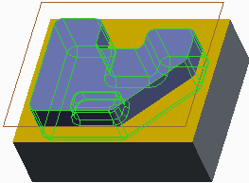

Figure 4 – Cap Plane and Resulting

**Volume Gathering Mill Volumes Options**

The gathering technique enables you to create a mill volume by referencing model geometry including surfaces and edges.

The gathering process involves several steps and the selection of various options:

• Select Surfaces – You select the surfaces to machine. There are several methods available.

With each method, the selected surfaces are sewn together to form a single quilt which is by

default extruded up to the retract plane to form a volume. Alternatively, you can extrude the

quilt to a user-defined plane if required. There are four options for selecting surfaces.

– Surf and Bound – You select one of the surfaces for machining (the seed surface) and then

select bounding surfaces. The seed surface and all neighboring surfaces up to the boundary

surfaces are sewn together into a single quilt. You can also configure boundary loops to add

outer loops of edges to the boundary.

– Surfaces – You select continuous surfaces to machine.

– Features – You select features to be machined. All the surfaces of selected features are

included.

– Mill Surfaces – You select pre-configured mill surfaces.

• Exclude – This option is available only if you gather using an option other than Surf and

Bound (for example, Surfaces). There are two exclude options.

– Surfaces – Exclude some of the selected surfaces by selecting each of them individually. This

is especially convenient when gathering using the Features or Mill Surf options.

– Loops – Exclude outer loops. Use this option to delete unwanted portions of surfaces

selected for gathering.

• Fill – When you fill an inner loop of edges on a surface selected for gathering, it is equivalent

to "patching" the base quilt of the mill volume. The volume is built as if there was a smooth

surface with no perforations. Two fill options are available.

– All – Fill all loops on a selected surface. Select a surface. All inner loops on this surface are

filled, whether they belong to bounding surfaces or not.

– Loops – Select loops to be filled. For each loop to be filled, you must select only one edge. If

you gather using Surf and Bound, the edges must lie on the bounding surfaces. Select additional

bounding surfaces if necessary.

• Close – This enables you to specify the mill volume capping plane.

– The mill volume is generated by extruding the boundaries of the selected surface quilt

vertically up to the specified plane or surface.

– If you create a mill volume during the creation of a volume milling sequence, then by default

Creo Parametric closes the mill volume automatically. This is done by extruding the boundaries

of the surface quilt vertically up to the retract plane.

**Note in this case, you can still specify an alternative capping plane if required.**

1. **Modifying Volume Milling Toolpaths**

**You can use the volume milling cut functionality to modify the default cut motions generated for volume milling sequences.**

Modifying Volume Milling Toolpaths

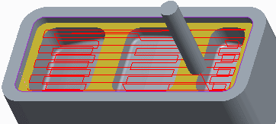

• Modify default cut motions.

• Volume Milling Cut:

– Cut type

• Full Depth Cut

• From-To Depth Cut Figure 1 – Volume Milling Cut – By Default

• To Depth Cut

• One Slice Cut

– Volume approach and exit

– Regions

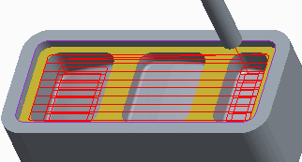

Figure 2 – Volume Milling Cut – By Region

**Modifying Volume Milling Toolpaths**

By default, volume milling cut motions (toolpaths) are generated based on the selected reference geometry and the manufacturing parameters. However, you can use Tool Motions tab to modify these default cut motions.

• Volume Milling Cut – This functionality enables you to modify the default cut motions by

adding or removing slices or editing machining regions. You can also specify approach and exit

paths. It also enables you to change the cut type.

– Full Depth Cut

– Creates cuts across all selected surfaces.

– From – To Depth Cut – Creates cuts in a specified range of depths. The following mandatory

options are available with this type:

• Straight Height.

• Height.

– To Depth Cut – Create cuts up to a specified depth. The following mandatory option is

available with this type:

• Height.

– One Slice Cut – Create a single cut of a specified depth. The following mandatory option is

available with this type:

• Height.

• Volume approach and exit – You can also specify the approach axis and exit axis for the

volume if required.

• Regions – This enables you to specify separate approach and exit paths for each region.

You can perform the following steps to specify regions:

– Show Regions – To display the volume regions in the graphics window.

– Approach and Exit cells – This enables you to select approach and exit paths for a region.

– Change order of machining – Select a region in the table and click the up arrow or down

arrow icons to move the region up or down.

– Remove and Restore – Select a region in the list and click Remove to delete a region

selected for machining or click Restore to include a deleted region in the list.

1. **Exercise 3: Creating Cut Motions using Volume Milling Cut**

**Objectives**

After successfully completing this exercise, you will be able to:

• Use the volume milling cut functionality to modify cut motions.

**Scenario**

You need to make the volume milling sequence more efficient. You can do this using the volume milling cut functionality.

**Close Window** **Erase Not Displayed** 

Milling\Volume_Toolpaths  BLOCK_VOL_MILL_CUT.ASM

**Task 1: Use volume milling cut functionality to create new cut motions and modify machining parameters in a specific cut motion.**

**Note: This manufacturing model does not contain a workpiece to enable easier viewing of the cut motions.**

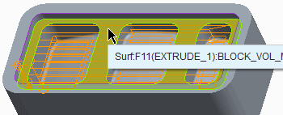1. Disable all Datum Display types.

2. In the model tree, select the VOLUME MILLING

1 [OP010] NC sequence, then right-click and

select **Edit Definition**  .

• Click **Display Toolpath**  from the Volume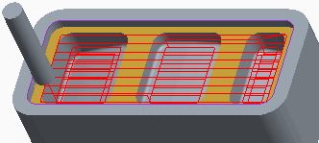

Milling dashboard.

• Click **Play**  .

**Note: The tool machines across each pocket region by region. However, you need to change the CUT_ANGLE to 90 degrees when the tool machines the three smaller pockets. You can do this by editing the toolpath to create new tool motions.**

3. Click **Resume**  from the Volume Milling

dashboard.

4. Create a new cut motion to machine the top

region of the pocket.

• Select the **Tool Motions** tab.

• Click **Volume Milling Cut** tab.

• Select **To Depth Cut** from the Cut type

drop-down list.

• Select the bottom surface of the large pocket,

as shown.

• Click **OK** from Volume Milling Cut dialog box.

• Notice that a new to depth cut motion plus

an auto plunge, and a follow cut have been

added to the Tool Motions, as shown.

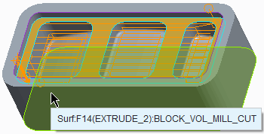5. Create another cut motion to machine the three

lower pockets.

• Click **Volume Milling Cut**.

• Click **From-To Depth Cut** from the Cut type

drop-down list.

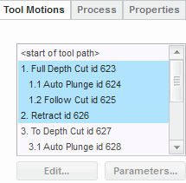 • Select the bottom surface of the large pocket.

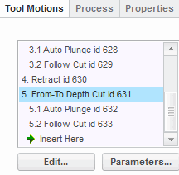 • If necessary, select the reference collector

for Height.

• Select the bottom surface of the reference

model, as shown.

• Click **OK**.

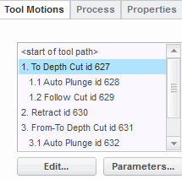

6. Delete the original automatic cut motions.

• In the Tool Motions tab, scroll up and select

the first cut motion 1: **Full Depth Cut**.

• Press SHIFT and select the retract motion **2:**

**Retract,** as shown**.**

• Cursor over the selected toolpath then

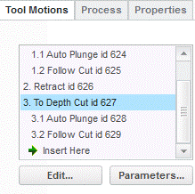 right-click and select **Delete**.

• Click **Yes** to confirm deleting.

• Notice that the new cut motions are

reordered, as shown.

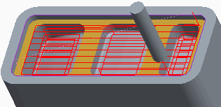

7. Click **Display Toolpath**  .

8. Click **Play**  .

**Note: Notice that the new cut motions supersede the original automatic cut motions and Region 1 from the From-To Depth Cut motion is the same as To Depth Cut motion, which is not required.**

9. Edit the Parameters for the cut motions.

• Click **Resume**  .

• Select the Tool Motions tab and select **From-To Depth** **Cut** motion.

• Click the **Edit** button and then click **Parameters** from the Volume Milling Cut dialog box.

• Edit the CUT_ANGLE to **90**.

• Click **OK**.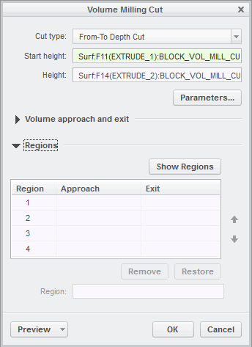

10. Delete region from a cut motion.

• Expand **Regions** from the Volume Milling Cut

dialog box.

**Note: The tool machines each pocket before going to the next pocket using region by region milling. You need to remove region 1 as this is not required.**

11. Click **Show Regions** to view regions in the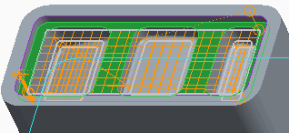

dashboard.

12. Select **1** from the region column and click

**Remove**.

• Observe that region 1 is removed from the cut

motion.

• Click **OK**.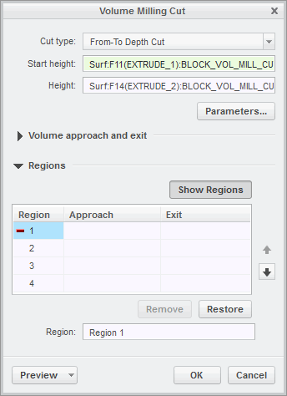

13. Click **Display Toolpath**  .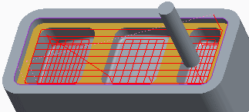

14. Click **Play**  .

15. Click **Close** in the Play Path dialog box.

16. Click **Complete Feature**  .

**Note: Notice that the tool machines the first region of the pocket and then machines the next three regions of the pocket.**

17. Save the manufacturing model and erase all objects from memory.

• Click **Save**  from the Quick Access toolbar.

• Click **Close**  .

• Click **Erase Not Displayed**  .

• Click **OK**.

This completes the exercise.

**18. Creating and Post-Processing CL Data Files**

**When toolpaths have been completed, you can use them to create ASCII format Cutter Location (CL) data files. You can then post-process CL data files into specific machine control data (MCD) files using a post-processor.**

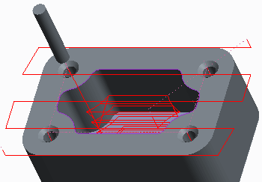

**Post-Processing**

• CL data files generated from toolpaths.

• Post-process CL data files into machine-specific

code. Figure 1 – CL Data File Simulation

• Machine-specific code used to control machine

tools.

Post-Processing Method

• Complete NC Sequences

• Create CL Data Files

– From one or more NC sequences.

– ASCII format. – Filename.ncl.

• Post-Process CL Data Files

– Create MCD files.

– Filename.tap. Changes to NC Sequences

• Recreate CL data files and MCD files. 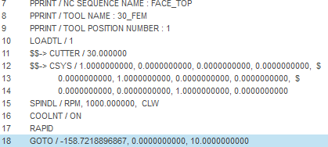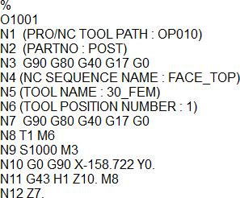

Figure 2 – CL Data File Figure 3 – MCD File

**Post-Processing**

• Cutter Location (CL) data files are generated from the toolpaths specified within NC sequences.

• These CL data files can then be processed by machine-specific or generic post-processors for

NC tape generation or DNC communications.

• You can then use the post-processed files to control machine tools such as a 3-axis milling machine.

**Post-Processing Method**

The following steps describe the method of post-processing data to control machine tools.

• Complete NC Sequences – You first need to complete the operation by creating all necessary

NC sequences.

• Create CL Data Files – When the operation is complete, you can create CL data files.

– You can create CL data files of one or more selected NC sequences, or a whole operation.

– The files are ASCII format files.

– The default filename format is filename.ncl.

• Post-Process CL Data Files – You can then post-process CL data files into specific machine

control data (MCD) files.

– You have the option of creating the CL and MCD files simultaneously.

– The default filename format is filename.tap.

Note, any subsequent changes made to NC sequences means you must recreate the CL data files and MCD files.

**Configuration Options**

A number of configuration options control the post-processing method.

• Each Pro/NC module includes a standard set of NC post-processors that you can use directly or modify using an optional module.

• ncpost_type – You can control which post-processing module to use by setting the configuration option ncpost_type. The values are:

– gpost (default) – Use the G-Post™ post-processors provided by Intercim Corporation.

– ncpost – Use the NC manufacturing post-processors.

• You can also use other post-processors capable of reading APT (automatically programmed tools).

• gpostpp-_dir – Specifies the directory for gpost post-processors.

• pro_mf_cl_dir – Specifies the location to store CL data files.

Thank You